

Doctoral Thesis

Immunity of camera systems against electromagnetic interference

Odolnost kamerových systémů vůči elektromagnetickému rušení

Author: Ing. Stanislav Kovář

Study Program: Engineering Informatics (P3902)
Study Field: Engineering Informatics (3902V023)

Supervisor: doc. Mgr. Milan Adámek, Ph.D.

Zlín, August 2020

© Stanislav Kovář

Published by Tomas Bata University in Zlín in the edition of doctoral thesis.
The publication was released in 2020.

Key words: shielding effectiveness, shielding enclosure, electromagnetic compatibility, security camera, CST Microwave Studio, semi-anechoic chamber.

Klíčová slova: stínící účinnost, stínící kryt, elektromagnetická kompatibilita, bezpečnostní kamera, CST Microwave Studio, polo odrazová komora.

The thesis is available at TBU Library in Zlín.

Abstract

The primary goal of the doctoral thesis is to increase an immunity of security cameras against electromagnetic interference. Security cameras constitute one of the fundamental techniques of physical guarding how to detect and eliminate crime. Unfortunately, increasing use of electronic and electric devices causes an increase in electromagnetic interference which may affect the correct function of the devices. This is particularly the problem for security devices where the great emphasis is placed on the reliability.
The work aimed at the design and implementation of shielding enclosure for security cameras. The draft is verified by CST Microwave Studio electromagnetic simulation software which allows determining expected shielding effectiveness and distribution of electromagnetic radiation. The final product is validated by testing them in both a GTEM cell and in a semi-anechoic chamber.

Abstrakt

Hlavním cílem disertační práce je zvýšit odolnost bezpečnostních kamer vůči elektromagnetickému rušení. Bezpečnostní kamery představují jednu ze základních technik fyzické ochrany, jak odhalovat a odstraňovat zločiny. Nicméně rostoucí používání elektronických a elektrických zařízení způsobilo zvýšení elektromagnetického rušení, které může ovlivnit správnou funkci zařízení. To může být problém obzvlášť pro bezpečnostní zařízení, kde se klade velký důraz na spolehlivost.
Práce je zaměřená na návrh a realizaci stínícího krytu pro bezpečnostní kamery. Návrh je ověřen pomocí elektromagnetického simulačního softwaru CST Microwave Studio, který umožňuje určit předpokládanou účinnost stínění a rozložení elektromagnetického záření. Finální produkt je testováním v GTEM a semi-anechoické komoře.

CONTENT
INTRODUCTION 6
CURRENT STATE OF SOLVED TOPIC 7
OBJECTIVES OF DISSERTATION 16
THEORETICAL BACKGROUND 17
1.1 EUROPEAN STANDARDS FOR SUSCEPTIBILITY TESTS 17
1.2 SHIELDING EFFECTIVENESS 19
1.2.1 Reflection Loss 22
1.2.2 Absorption Loss 23
1.2.3 Loss by multiple reflections 23
1.3 PRINCIPLE OF CMOS SENSORS 25
1.3.1 Complementary Metal-Oxide-Semiconductor 25
1.3.2 Charged-Coupled Device 27
1.4 MEASURING WORKPLACES 30
1.4.1 Gigahertz Transverse Electromagnetic Cell 30
1.4.2 Semi-anechoic Chamber 32
PROCESSING METHODS 34
EXPERIMENT PREPARATION 35
1.1 MATERIALS 35
1.2 SHIELDING GRIDS 38
1.2.1 Circular holes 38
1.2.2 Square holes 40
1.2.3 Triangle holes 41
1.2.4 Pentagon holes 43
1.2.5 Honeycomb holes 44
1.3 EVOLUTIONARY ALGORITHMS 46
1.3.1 Firefly Algorithm 47
1.3.2 Success-History based Adaptive Differential Evolution Algorithm 51
1.3.3 Heterogeneous Comprehensive Learning Particle Swarm Optimization 54
EXPERIMENT 58
1.4 EXPERIMENTS AND RESULTS 62
1.4.1 Experiment – GTEM Chamber 66
1.4.2 Results – GTEM Chamber 67
1.4.3 Experiment - Coaxial Line 70
1.4.4 Results – Coaxial Line 72
CONTRIBUTION OF WORK TO SCIENCE AND PRACTICE 75
CONCLUSION 76
REFERENCES 77
LIST OF ABBREVIATIONS 87
LIST OF TABLES 89
LIST OF FIGURES 90
ATTACHMENT 93
BIBLIOGRAPHY OF AUTHOR 98
CURRICULUM VITAE 101

INTRODUCTION
Currently, electromagnetic compatibility has become to be a severe problem for electronic and electrical devices design and implementation, especially for security devices, where the critical factor is reliability. There are a lot of aspects why eliminate electromagnetic radiation, namely due to electromagnetic field effects on the human body [1], [2], or device signal eavesdropping [3], [4]. These are the reason why the demand for protection against undesirable effects of electromagnetic interference has increased.
Electromagnetic compatibility can be defined as an ability of electronic and electrical product to work as intended in an electromagnetic environment. In other words, it is ability of a product to not generate electromagnetic disturbance, which may affect other devices in its vicinity. According to [5], a device can be perfectly reliable, but it is not usable if it cannot work in the electromagnetic environment. In the case of security cameras, interference can appear as "a loss or disruptions, interruption of communication between components, reset of storage devices or other disruption of device functions that can make its normal usage impossible." [6]
Electromagnetic compatibility includes two other terms, namely electromagnetic interference and susceptibility or immunity. Electromagnetic interference is a signal generation process which is transferred via electromagnetic coupling into a receiver. In essence, disturbance supervene when the receiver works in an undesired manner after the signal reception. [7] Interference aimed at the identification of disturbance sources and parasitic transmission paths as well as signals measurement and description. It means electromagnetic interference deals with disturbance sources and their elimination.
Electromagnetic susceptibility defines the immunity or tolerance of components and circuitry to all sources of interfering electromagnetic energy. In other words, electromagnetic immunity describes an ability of device to works as intended without failures or with precisely defined permissible limits. [5] In comparison with interference, susceptibility deals with techniques on how to protect the device against harmful signals. It means consequence elimination. [5] The way how to protect the device is to pay attention to printed circuit board design or shielding material application.
As mentioned, electromagnetic interference continues to be a significant problem for electronic and electrical devices, especially for security cameras, where the great emphasis is placed on reliability. Therefore, there was born an idea to find a solution to protect cameras. The thesis focuses on finding the solution for the issue of device protection against harmful electromagnetic energy. The way how to make it is in shielding. The thesis describes the shielding enclosure design verified by simulation software and practical measurements.

CURRENT STATE OF SOLVED TOPIC
Currently, the electromagnetic immunity issue of security devices represents a relatively unknown area. Nowadays, there are not many security cameras that can reliably resist electromagnetic interference higher than 30 V/m. The reason is simple because current European standards require meeting device resistance against disturbance level only around 10 V/m for the residential environment. [8] Standards used to electromagnetic susceptibility tests describing the Theoretical background section. There are many research publications, technical instructions, and national standards on how to protect electronic devices in the general sense. However, there are only several publications [9], [10] related to the electromagnetic protection of security devices, especially cameras. Unfortunately, these thesis offer just a limited proposal for a solution based on incomplete information. Other publications focus on interest to increase electronic devices electromagnetic immunity in general [11], [12], [13] or shielding effectiveness tests of existing solutions and offer improvements [14], [15], [16], [17].
For electromagnetic compatibility test, there is necessary to determine the electromagnetic environment where the equipment under test (EUT) works. The environment can differ in classes according to the used European standard, for example, CSN EN 61000-2-4 [18], CSN EN 55011 [19], or CSN EN 61000-4-3 [8]. European standards relating to electromagnetic compatibility describes a chapter called Theoretical Background.
CSN EN 61000-2-4 defines three categories but only for the industrial environment, including:
- Class 1 consists of electromagnetic sensitive devices with a protected power supply as laboratories, computer technology.
- Class 2 covers systems and wiring, including devices with small powers.
- Class 3 involves systems with high power as production lines, mining, or the automotive industry. [18]
Another sorting offers CSN EN 55011 European standard which electromagnetic environmental divides into two classes, namely:
- Class A includes devices and systems using in industrial.
- Class B consists of devices and systems using in household or industrial with low voltage. [19]
The electromagnetic environment can be divided regarding European immunity standards into several categories. CSN EN 61000-4-3 allows distinguishing five environmental classes specifying radiation levels according to the disturbance sources. It characterizes in Table 1.
- Class 1 includes an environment with a low interference level, which generates radio and television transmitters spaced more than 1 km.
- Class 2 consists of the environment like a shopping habitat where transmitters with a power of less than 1 W can occur, but there must be distance limitation from EUT.
- Class 3 involves electromagnetic consuming environment where transmitters with a power of higher than 2 W can occur, including ISM devices, but the distance from EUT must be higher than 1 m.
- Class 4 contains the environment with significant electromagnetic interfering energy sources, which are located less than 1 m from EUT.
- Class X represents an exceptional environment with unlimited electromagnetic radiation levels, which should be adjusted by other normative documents. [8]
Tab. 1. Field Strength Levels Classification regarding CSN EN 61000-4-3 European Standard. [8]
Level | Field Strength [V/m] | Maximum Effective Field Strength [V/m]
1 | 1 | 1.8
2 | 3 | 5.4
3 | 10 | 18
4 | 30 | 54
X | Special Field Strength

The significant fact noted by the standard [8] is that ERP in inner space does not need to correspond with class maximum value because there is the worse coverage. It also mentioned the publications [20], [21], and [22], which describe brick wall shielding effectiveness.
CSN EN 61000-4-4 [23] European standard classifies environment according to electromagnetic levels as follows:
- Level 1 describes a well-protected environment such, as a computer room that suppresses EFT/B and includes filters, shielded, and grounded cables.
- Level 2 defines a protected environment such as power plants, which allows partial EFT/B suppression and cables physical separation.
- Level 3 characterizes an industrial environment where EFT/B is not suppressed, and the separation between the power supply, control, signal, and communication cables is not sufficient.
- Level 4 describes hostile industrial environments such as outdoor industrial facilities, substations up to 500kV, or power plants with no separation between adverse circuits and highly essential circuits.
- Level 5 specifies certain situations that do not meet the mentioned levels and require individual analysis. [23]
European standards are detailed and provide uniform test procedures; however, there are also military standards [24], [25], [26] which apply to all devices or environments and give general test procedures. [26] The military standard [24] states an interesting point claiming that the facility may not be sensitive to a radiated electric field at specific frequencies; nevertheless, it can be susceptible to electromagnetic with the lower limit levels environment at the same frequencies. Another standard [25] describes cameras as a potential inadvertent source of electromagnetic interfering energy; therefore, cameras should be shielded. The electromagnetic environment is not static, so limit levels should be adapted according to current conditions. The standard [25] also claims that levels should cover most situations, including "back door" effects, namely radio-frequency high-power threat.
Tab. 2. Electromagnetic environment for ground systems. [26]
Frequency Range [MHz] |  | Electric Field [V/m]
 |  | Peak | Average
0 | 2 | 73 | 73
2 | 30 | 103 | 103
30 | 150 | 74 | 74
150 | 225 | 41 | 41
225 | 400 | 92 | 92
400 | 700 | 98 | 98
700 | 790 | 267 | 267
790 | 1000 | 284 | 267
1000 | 2000 | 2452 | 155
2000 | 2700 | 489 | 155
2700 | 3600 | 2450 | 219
3600 | 4000 | 489 | 49
4000 | 5400 | 645 | 183
5400 | 5900 | 6146 | 155
5900 | 6000 | 549 | 55
6000 | 7900 | 4081 | 119
7900 | 8000 | 549 | 97
8000 | 8400 | 1095 | 110
8400 | 8500 | 1095 | 110
8500 | 11000 | 1943 | 139
11000 | 14000 | 3454 | 110
14000 | 18000 | 8671 | 243
18000 | 50000 | 2793 | 76

The fundamental factor in shielding enclosure production is the types of material used. Currently, there are several materials [27], [14], [28] suitable for this purpose; unfortunately, not all achieve the required results. Publication [28] includes a few relevant substances for shielding effectiveness increase and are depicted in Tab. 2.
Tab. 3. Conductive Materials, including Relative Conductivity and Permeability. [28]
Material | Relative conductivity | Relative permeability
Copper | 1 | 1
Aluminum | 0.61 | 1
Steel | 0.17 | 1000
Cadmium | 0.25 | 1
Nickel | 0.2 | 100
Zinc | 0.3 | 1
Chromium | 0.65 | 1
Tin | 0.15 | 1
Stainless Steel | 0.02 | 500

Publication [29] claim that the following factors should be taken into account when selecting material:
- operating frequency,
- materials compatibility,
- corrosion,
- EMC compliance specification,
- electromagnetic environment,
- cost,
- attenuation performance,
- cycle life,
- electromagnetic requirements,
- materials or alloy,
- thickness,
- space and weight considerations,
- product safety,
- recyclability.
Although conductive materials are known for their electromagnetic immunity, the listed factors can influence shielding effectiveness; therefore, the scientists have started to develop favorite intrinsically conducting polymers (ICP) [11], [30]. Publication [30] describes ICPs as organic polymers with electrical, magnetic, and optical properties similar to traditional metal materials. Publication [11] completes the explanation by the statement that the ICPs advantage is proper properties combination such as pleasant conductivity, low density, and corrosion resistance. Parameters changing as oxidation state, morphology, or chemical structure can affect final electrical conductivity value. [30] Concerning shielding efficiency, it depends on which ICP variant is selected because there are many types such as polyaniline, polypyrrole, polythiophene, polyphenylene vinylene. [11], [30] Publications [11], [12], and [30] state that ICPs may consist of metal, graphene, graphite, carbon, or another conducted substance. These substances should improve electrical, magnetic, and dielectric properties and ensure non-transparency to electromagnetic radiation. [11], [12] Except for the materials mentioned above, there are also protections in the form of an ultrathin substance that may be applied on the enclosure surface. One of these solutions published the researchers from Drexel University and the Korea Institute of Science and Technology [31] who developed nano-film based on MXene [32], allowing suppressing electromagnetic radiation.
The publication [9] includes a sophisticated suggestion of shielding enclosure; nevertheless, there is not enough information about shielding enclosure, and the author states in conclusion, that the thesis is not complete. The author measured MIP-6430-2 security camera electromagnetic interference located inside of box according to adjusted EN 55022 European standard in the frequency range from 30 MHz to 2 GHz. Publication [33] defines the term shielding enclosure as a structural means to protect inner against electromagnetic interference from extern sources. It means the box should be able to eliminate electromagnetic radiation passing in both directions. In other words, the shielding enclosure should suppress incoming and outcoming interference. If it is taken into a consideration, it is possible to agree with the author's [9] claim that the design shielding enclosure eliminates the electromagnetic radiation level.
Although the thesis does not provide enough information to compare camera interference with or without a shielding box, the author offered an elegant solution. Construction of the structure is created by stainless steel, which is a corrosion-resistant material. It is essential to pay attention to a corrosion-resistant material search because corrosion can significantly affect electromagnetic immunity. The cover thickness is minimal, only 1 mm. It ensures the low weight of the final product. The exciting solution is lens protection because the author chose “microwave ovens” technology, also known as a Faraday cage which is an easy way to interference suppression. Another answer is lead glass or other metallic glasses use; however, there can be a problem with realization and the desired attenuation achievement in the given frequency spectrum. The author used a conductive strip to bind the box with shielding foil. Metal contact strips from Laid Technologies Company ensure the seal between the enclosure and opening cover. [9]
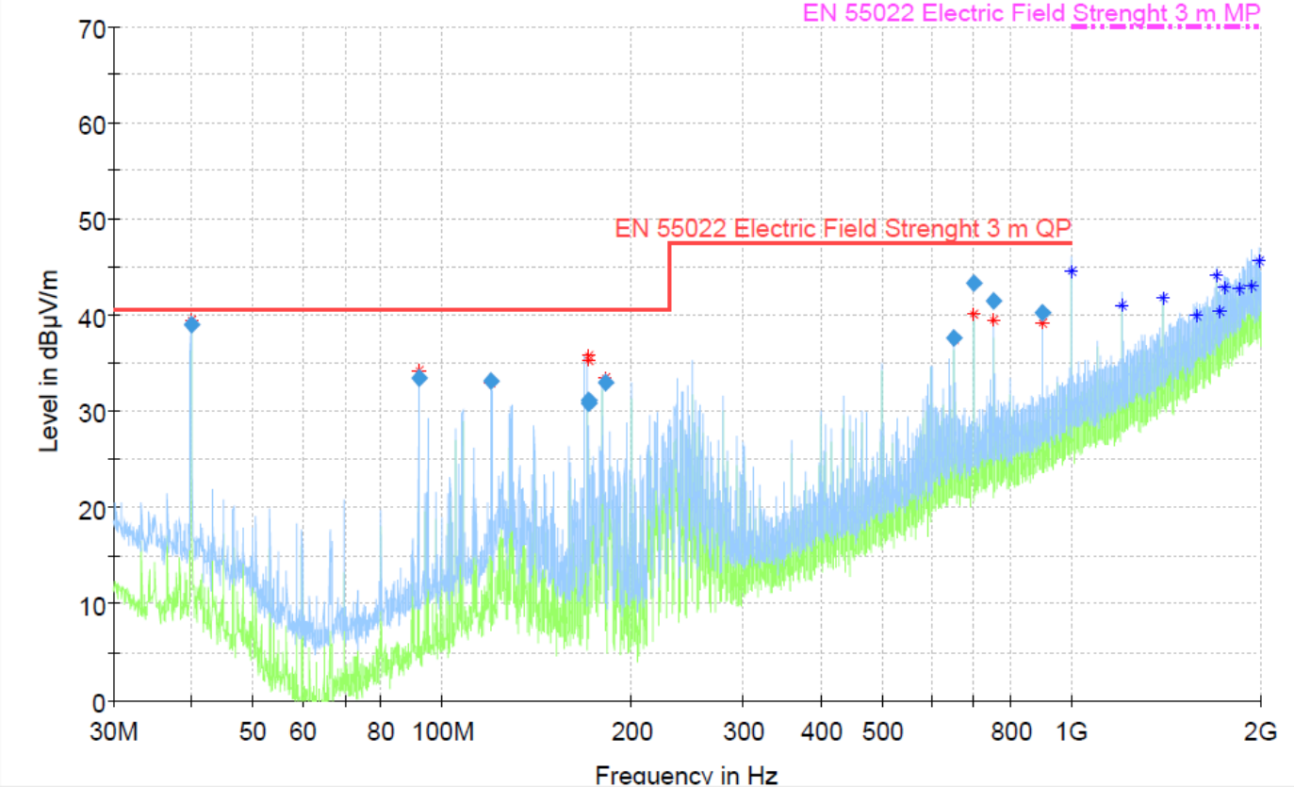
Fig. 1. Measurement Results in the Tested Spectrum. [9]
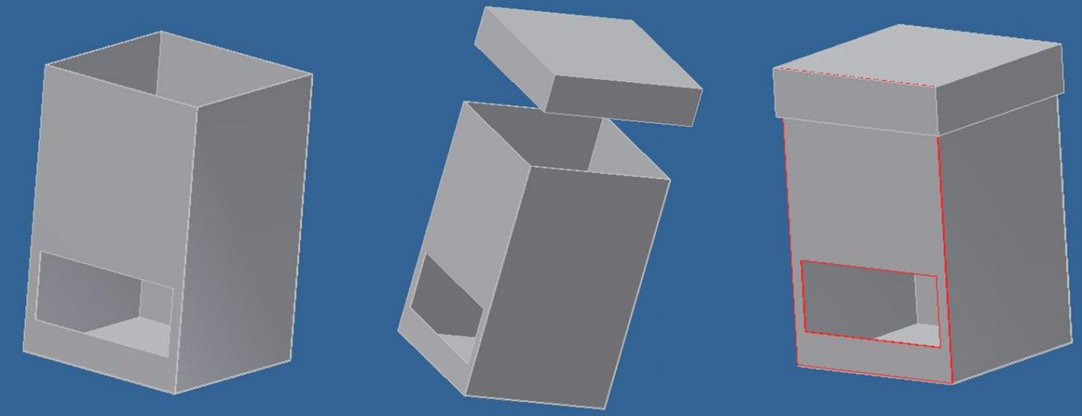
Fig. 2. Final Design of Shielding Enclosure. [9]
Another interesting publication [10] regarding security camera electromagnetic immunity deals with shielding elements rather than a cover design. The thesis combines all shielding technologies available on the market and provides advice on how to use them for this device. The publication uses a trial and error system and pays attention to both radiated and conducted disturbances. Nevertheless, the solution does not solve lens protection, but only plastic parts are covering by metallic material as the foil. The author [10] mentioned several notes about shields for devices, which are better and cost-effective if electromagnetic interference generated by printed circuit boards cannot be eliminated during the design. [10] Author used ferrite beads to protect cabling against disturbance, which is the easy way to defend any commonly used unshielded cable. It was a great idea because there are many security cameras using cables sensitive to electromagnetic radiation. The thesis includes the results of two shielding material, namely Pure Copper Polyester Taffeta and ShieldIt Super, which are applied in layers on the Panasonic-WV-CP470 camera surface. It is necessary to mention that this improvement is not focused on security cameras but for cameras working in high electromagnetic interference level area, such as the GTEM chamber. [10]
Other publications [16], [34] focus on the general shielding enclosure, not on camera protection. The paper [16] is aimed at the shielding effectiveness prediction based on the absorption cross-section technique [16], [35], which is realized using the reverberation chamber and is defined as a ratio of average absorbed power to average power density. The publication [16] bases on the theory that almost everything can absorb electromagnetic radiation even so by PCBs. In this case, the brass enclosure has a dimension of 600x500x300 mm, and it is equipped with a rectangular aperture with a size of 140x40 mm. There were several measurements performed with and without PCBs, as Fig. 3 shows. The results indicate that an empty enclosure suppresses electromagnetic radiation by 4 dB; conversely, the box with PCBs has effectiveness approximately 8 dB. The contribution of paper [16] is a finding that the content shielding enclosure should be included in prediction and measurement.
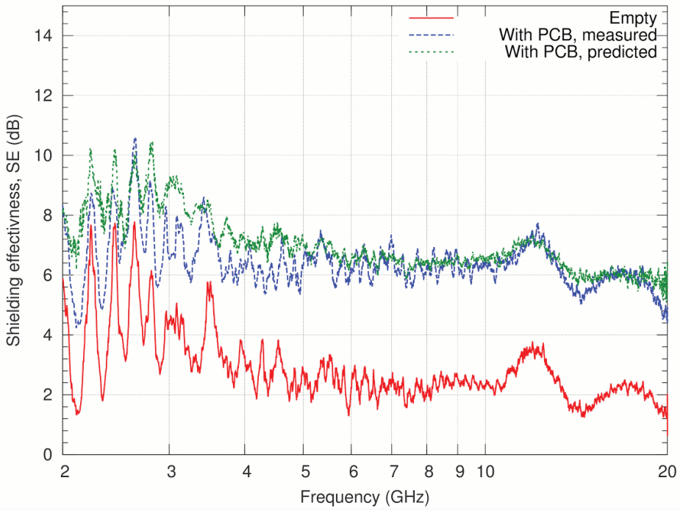
Fig. 3. Shielding Effectiveness Comparison of Empty Enclosure and Enclosure with PCBs. [16]
The publication [34] focuses on a hybrid technique based on the method of moments and the finite-difference method for shielding effectiveness prediction. The author [34] uses field equivalence principle [36] for internal and external space isolation on which FD or MoM methods can be applied. This solution is advisable when an electromagnetic problem can be divided into subparts.
Because the object of this thesis is not to create ideal shielding enclosure, it means box without apertures but a practical product for security cameras, there should be mentioned something about electromagnetic interference elimination through holes. This topic is relatively favorite among scientists since it can apply to a broad spectrum of the industry [15], [17], [37], [38], [39]. There are only two ways how to determine proper aperture shapes and diameters, namely calculation [38], [39], or practical measurement [13], [37]. The problem can appear during the implementation, as [14] mentions because various inaccuracies may arise, and the result does not have to coincide with calculations [15]. Publication [38] deals with a finding of the optimal shape of the hole. The paper claims that the best shielding effectiveness achieves the pentagon-shaped aperture, which Fig. 4 confirms. Paper [38] describes the situation using CST Microwave Studio when there are more than one holes. As Fig. 5 illustrates shielding effectiveness is worse at higher frequencies because of the wave’s changes.
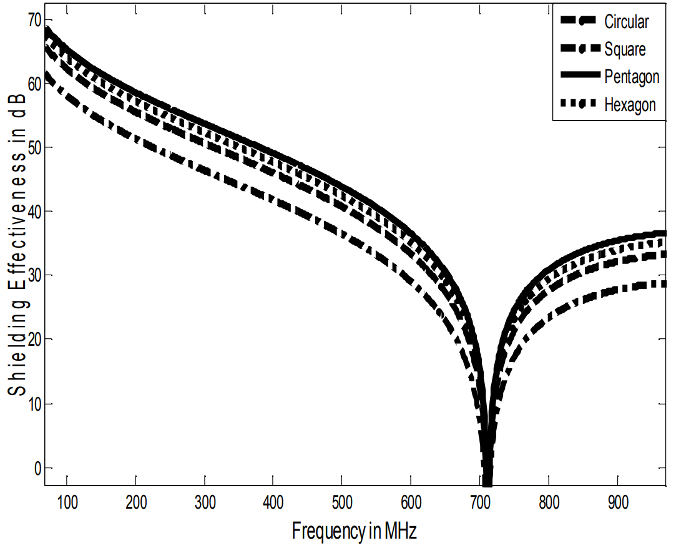
Fig. 4. Shielding Effectiveness Calculated for Various Apertures. [38]
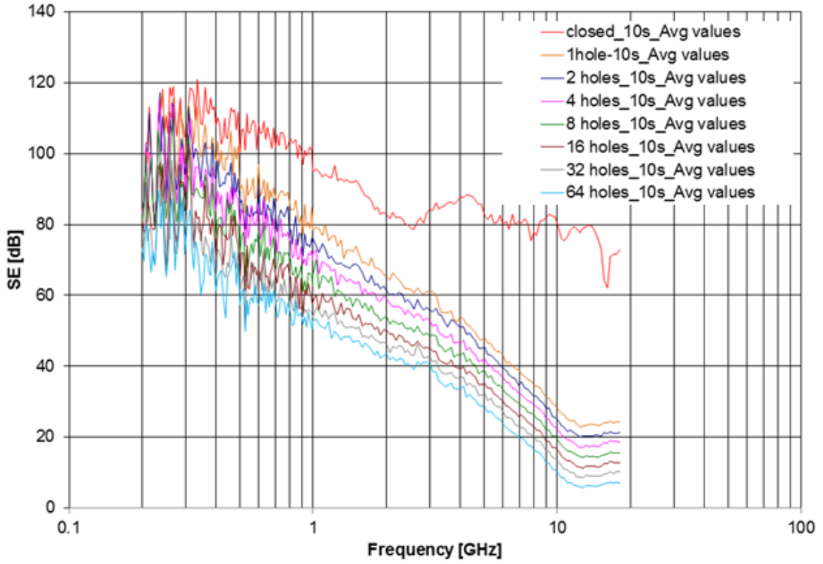
Fig. 5. Shielding Effectiveness Calculated for Various Number of Apertures. [37]
The knowledge described in the mentioned publications expands the information in papers [40], [41] and [42]. The findings interpreted in these articles help develop proper protection for the security camera’s objective, which allows passing electromagnetic interference into the image sensor. Publication [43] states that image sensors represent the most sensitive part of a camera; therefore, the great emphasis should place on their protection. Currently, security cameras available on the market can almost permanently resist electromagnetic radiation about 10 V/m; however, they can report failures or errors at higher field strength. [44] Picture freeze, false sound alarm, or transmitted paths disruption can occur. The problem could also be a long-term exposure of the device to electromagnetic fields. There are situations when the permanent presence of field reduced devices life cycle. The manufactures are trying to produce devices resistant to electromagnetic radiation, but it does not always happen. The author of this thesis performed several experiments with CMOS modules in the treatise on doctoral dissertation [6]. The published results indicate that image sensors are sensitive already to field strength in the range from 10V/m to 30V/m.

OBJECTIVES OF DISSERTATION
The basis for the doctoral thesis is the author's experiences and consultations with experts in the field of electromagnetic compatibility; therefore, it was decided that the work will be focused on:
- proposing a shielding enclosure for security cameras based on electromagnetic simulations results,
- shielding enclosure practical implementation and testing its electromagnetic immunity.

Security cameras represent one of the most sensitive devices against electromagnetic radiation; therefore, the author decided to improve the current state by creating a shielding enclosure. Currently, security cameras should be able to reliable resist electromagnetic radiation about 10 V/m for the residential environment specified by European standards. In the industrial environment, the level of radiation is higher, approximately 30 V/m. However, immunity depends not only on the environment but also on the type of cameras and transmission medium. The application of the shielding enclosure ensures long-term device protection because there are cases when the security camera was not able to resist permanent electromagnetic radiation for a longer period. It is expected that a shielding box to protect security cameras in buildings will be used, particularly those with an increased danger of the jammer's use.
Except for sections describing the theoretical background and current state of solved issues, the doctoral thesis in essential consists of several parts. The first part depicts the shielding enclosure design process, followed by the simulation software results and recommendations for implementation. CST Microwave Studio provides information about electromagnetic field distribution and gives a clue to reveal proposed vulnerabilities. The section is an essential prerequisite for future work as the application of the evolutionary algorithm in the grid design and evaluation of the sub-results. GTEM chamber helps with a comparison of the real products with simulation. Except for this part, the thesis also includes the determination of the threshold value of the grid structure disturbance at which there is a significant shielding effectiveness decrease.

THEORETICAL BACKGROUND
The section about theoretical background describes the fundamental information for understanding doctoral thesis content. This part of work describes European standards for electromagnetic immunity tests which are necessary for the practical testing of the product, followed by narration about shielding effectiveness on which the work builds. Moreover, the thesis explains the principles of light-sensitive sensors that represents cameras vulnerability. And finally, the measuring facilities and workplaces description using in the course of the practical experiment ends this section.

EUROPEAN STANDARDS FOR SUSCEPTIBILITY TESTS
To ensure uniform procedures for electromagnetic compatibility measurement, a set of standards was developed which include testing methods requirements. Regarding electromagnetic immunity, the collection consists of mainly the harmonized Czech standards CSN EN 61000-4 (Electromagnetic compatibility: Testing and measurement techniques), which is based on international norms, namely IEC 1000-4. These rules are called basic standards, and they describe the requirements for resistance to electromagnetic interference. During the process of design and subsequent verification of electromagnetic immunity of the device, it is necessary to adhere to these standards, since only then it is possible to compare the proposed apparatus with current facilities relevantly. Electromagnetic susceptibility specific requirements for camera systems testing are given in the EM 50130-4 ed. 2 (Electromagnetic compatibility: Product family standard: Immunity requirements for components of fire, intruder, hold up, CCTV, access control and social alarm systems) standard. [45] These requirements are supplemented by the specifications in the aforementioned EN 61000-4 standard. [6]
- EN 50130-4 (List of the susceptibility tests for CCTV)
Standard describes immunity requirements for security devices including CCTV in residential, commercial and industrial environments. [45]

- EN 61000-4-1 (Overview of the susceptibility tests)
Standard describes a necessary information about electromagnetic immunity tests for electric and electronic equipment and systems. [46]

- EN 61000-4-2 (Electrostatic discharge)
Standard explains immunity requirements relates to electrostatic discharges with the human body or metal objects as a source of static charge. [47]

- EN 61000-4-3 (Radiated, radio-frequency, electromagnetic field)
Standard describes requirements and immunity test procedure against radio-frequency electromagnetic fields of any sources. [8]

- EN 61000-4-4 (Electrical fast transients/burst)
Standard describes an essential information for requirements and immunity tests against fast electrical transients/burst on power, signal, control and grounding inputs/outputs. [23]

- EN 61000-4-5 (Surge pulse)
Standard specifies recommendations and immunity tests for devices and systems against surge pulses caused by switching overvoltages and lightning. [48]

- EN 61000-4-6 (Immunity to conducted disturbances induced by radio-frequency fields)
Standard describes requirements and immunity tests against conducted interference induced by high-frequency fields originating from transmitters in the frequency range 150 kHz to 80 MHz. [49]

- EN 61000-4-7 (General guide on harmonics measurements and instrumentation for power supply system and connected equipment)
The standard defines requirements for measuring equipment designed to measure spectral components in the frequency range up to 9 kHz. It distinguishes between harmonic, interharmonic and others. [50]

- EN 61000-4-8 (Power frequency magnetic field)
The standard describes requirements and devices and systems immunity tests for households, shops and industrial applications against magnetic interference at frequencies of 50 Hz and 60 Hz. [51]

- EN 61000-4-9 (Pulse magnetic field)
The standard defines immunity requirements and test methods against conducted pulsed magnetic fields caused by switching and lightning effects. [52]

- EN 61000-4-10 (Damped oscillatory magnetic field)
Standard describes operating immunity requirements for measuring equipment against damped oscillatory magnetic interference. [53]

- EN 61000-4-11 (Voltage dips, short interruptions and voltage variations)
Standard specifies requirements and measuring equipment immunity tests for electrical and electronic equipment connected to low voltage distribution networks against voltage dips, short interruptions and voltage variations. [54]

- EN 61000-4-12 (Oscillatory waves)
Standard describes requirements and immunity tests for electrical and electronic devices damped sine wave which may occur in a low voltage power supply, control and signaling lines in both public and non-public networks. [55]

- EN 61000-4-14 (Voltage fluctuation)
Standard describes requirements and immunity tests for electrical and electronic devices with nominal input phase current up to 16 A against voltage fluctuations of both positive and negative low amplitudes. [56]

SHIELDING EFFECTIVENESS
Electromagnetic interference can be limited in three main areas, namely at the source of the disturbance, at the receiver and in the transmission route. For this thesis goals, it is necessary to restrict noise coming into the receiver because there are many interference sources and it is not readily possible to eliminate all of them. Depending on the method of interference propagation, the means to reduce unwanted noise fall into two categories, namely disturbance by conduction and radiation. In the case of conducted interference, the device is equipped with EMI filters, chokes, capacitors; it is also possible to change the transmission medium or arrangement of circuits. Radiated interference is reduced by selecting a suitable shielding. Shielding can be defined as a structural means to reduce interfering electromagnetic fields within a designated area. In other words, it protects the devices against unwanted external electromagnetic interference, and simultaneously it prevents leakage of electromagnetic disturbance from the device. Publication [57] enhances the definition by the statement that shield design should pay attention to aspect as electromagnetic interference, electrostatic discharge or environmental effects. The same publication also states the terms as shielding effectiveness and shielding enclosure.
The significant parameter in this area is aforesaid term shielding effectiveness that describes how the material eliminates the effects of electromagnetic radiation from the interference source. [6] Publication [58] defines SE stands for shielding effectiveness as a ratio of a signal received from transmitter without the shield to a signal gained from a radiation source with the shield protection. Shielding effectiveness essentially explains a material inserted loss and decide how shielding material eliminates the electromagnetic interference effect from a source. Publication [58] defines a shielding enclosure as a mechanical means to protect inner space from the external electric or magnetic field and simultaneously it secures electromagnetic environment around construction against an internal electric or magnetic field effects. Shielding enclosure should consist of a metallic material with continuous electrical contact between adjacent parts of the structure.
The following equation may characterize shielding effectiveness for the electrical and magnetic field. [7] [43] [59]
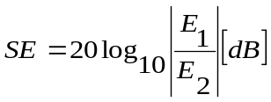 (1)
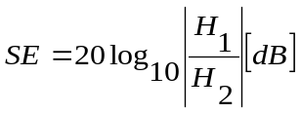 (2)
Individual characters indicate:
P₁ – power generated by interference source;
P₂ - power passing through the shielding material.

It can be adjusted into a form which better corresponds to the physical mechanisms of the shielding effect. [5], [7]
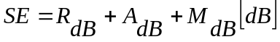 (3)
Individual characters indicate:
R_{dB} - reflection losses caused by reflections between the interfaces;
A_{dB} - absorption losses caused by passing waves through the material;
M_{dB} - losses by multiple reflections passing through the material.

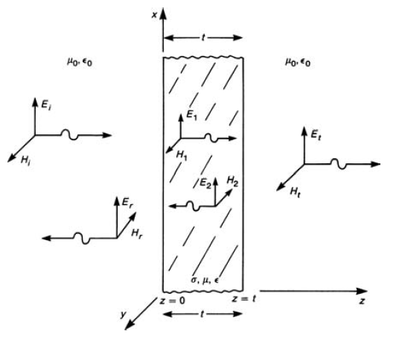
Fig. 6. Shielding effectiveness of material in a uniform plane wave which is normal to surface. [7]
If there exists a metallic barrier as Fig.1 shows, then there can occur three situations how the material may protect against electromagnetic field effects. All of them are described by equation (3). When the electromagnetic field strikes at the barrier surface then there arises effect known as reflection. It causes that portion of the field is reflected according to reflection coefficient. The amplitude of wave which passed through the material surface is attenuated by the attenuation constant. This effect is called absorption loss. As soon as the wave arrives at the second material surface, there occurs reflection effect again. It means part of wave returns back to the first surface and portion of the wave goes through the material to an external medium. The attenuation constant weakens the coming back wave. At the left material side, there supervenes reflection effect again. The process of repeating these impacts is called losses by multiple reflections. [7]
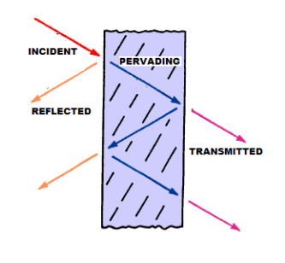
Fig. 7. Principle of Attenuation Caused by Multiplied Reflection. [7]

Reflection Loss
The publication [7] claims that if a skin depth at the incident wave frequency is much lower than the barrier thickness, then the incident wave is divided into several portions after strikes on the barrier surface. Fig. 6 illustrates this situation. The left interface separates incident wave on reflected wave E_{r}(H_{r}) and E₁(H₁), it causes that only E₁ can continue to travel throughout the barrier. This portion of the incident wave is attenuated by the material and divided at the right interface on E₂(H₂) and transmitted wave E_{t}(H_{t}). The E₂ wave moves back to left interface, but it is attenuated by passage again. Publication [7] also states that in case of infinite barrier thickness, the E₂ is equal or approaches 0. It helps to define transmission coefficients for left and right interfaces in following forms.
$\frac{E_{1}}{E_{i}}≅\frac{2η}{η+η_{0}}$ (4)
Individual characters indicate:
E_{i} - incident wave;
E₁ - wave after passage throughout the left interface;
η - intrinsic impedance for incident wave;
η₀ - intrinsic impedance for medium.
$\frac{E_{t}}{E_{1}}≅\frac{2η_{0}}{η_{0}+η}$ (5)
Individual characters indicate:
E_{t} - transmitted wave;
E₁ - wave after passage throughout the left interface;
η - intrinsic impedance for medium;
η₀ - intrinsic impedance for incident wave.

The ratio of incident and transmitted wave defines the following form according to equations (4) and (5).
$\frac{E_{t}}{E_{i}}=\frac{2η_{0}}{η_{0}+η}∙\frac{2η}{η+η_{0}}=\frac{4ηη_{0}}{{\left(η+η_{0}\right)}^{2}}$ (6)
Final calculation for reflection loss combines equations (6) and (1) for the electrical field or (2) for the magnetic field, but instead of E₁ and E₂ is appointed E_{t} and E_{i}. [7]
$R_{dB}=20\log_{10}\left|\frac{E_{i}}{E_{t}}\right|≅20\log_{10}\left|\frac{η_{0}}{4η}\right|\left[dB\right]$ (7)

Absorption Loss
The previous case assumed the same E₁ amplitude at both barrier sides; however, that does not apply to the E₁ magnitude which differs at both interfaces by the absorption factor. [7]
$A=20\log_{10}{e^{\frac{t}{δ}}}\left[dB\right]$ (8)
$δ=\sqrt{\frac{2}{ωμσ}}$ (9)
Individual characters indicate:
δ - skin depth;
t - thickness of material or barrier;
ω - wavelength;
μ - permeability;
σ - conductivity.

Loss by multiple reflections
According to publication [7], multiple-reflection loss extends reflection loss which says that the reflected wave has no consequences. That is true only if barrier thickness is much higher than a skin depth. In this case, there assumes that skin depth is not much lower than barrier thickness. The total loss is affected by multiple-reflection factor $e^{-γt}$. Publication [7] claims that electric field passing through the right side of barrier describes following equation:
$E_{t}=\frac{2η_{0}}{η_{0}+η}∙E_{in}$ (10)
Individual characters indicate:
E_{t} - transmitted wave;
E_{in} - incident field;
η - intrinsic impedance for medium;
η₀ - intrinsic impedance for incident wave.

The same publication [7] states equation for reflection wave as follows:
$E_{r}=\frac{η_{0}-η}{η_{0}+η}∙E_{in}$ (11)
Individual characters indicate:
E_{r} - reflected wave.

The reflected wave is attenuated, and phase shifted; hence, the wave coming on the left interface has a form completed with the multiple-reflection factor. The wave propagating back at the right barrier side looks like this:
$\left(\frac{η_{0}-η}{η_{0}+η}\right)∙E_{r}∙e^{-γt}$ (12)
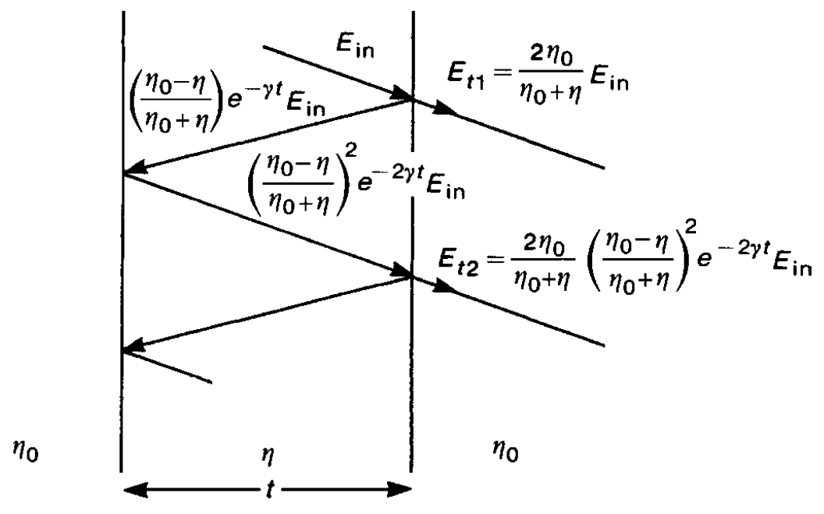
Fig. 8. Multiple Reflections Principle within Barrier Including Transmission and Reflection Coefficients. [7]
Other reflected waves have similar forms, as Fig. 11 illustrates. Publication [7] also claims that the total transmitted field equals to a sum of all reflected waves at the right interface.
$E_{t}=E_{t1}+E_{t2}+ ... +E_{tn}=E_{t1}\left(1+∆_{2}+ ... +∆_{n}\right)$ (13)
The final multiple-reflection loss equation is based on knowledge of (1), (13) and multiple-reflection factor.
$M=20\log_{10}\left|1-{\left(\frac{η_{0}-η}{η_{0}+η}\right)}^{2}e^{-2γt}\right|\left[dB\right]$ (14)

PRINCIPLE OF CMOS SENSORS
This section of doctoral thesis describes the principles of image sensors used for security cameras, namely CCD and CMOS sensors. The fundamental principle of image sensors consists in light conversion by exploiting the photoelectric effect into electrons which are suitable for processing in a printed circuit board. The photoelectric effect is a physical phenomenon in which electrons are emitted from substance because of electromagnetic radiation absorption by a matter. [60]

Complementary Metal-Oxide-Semiconductor
The complementary metal-oxide-semiconductor (CMOS) sensor is one of the image sensors used in cameras. Unlike other sensors, CMOS integrates most of the functioning parts into a single circuit; therefore, data can be addressed and read directly. Each cell of the chip is sensitive to light and it generates a charge proportional to the energy of the incident light rays. That means that each cell or pixel of the sensor contains a light sensor and an active amplifier. Other important components are located directly in CMOS sensor. [60]
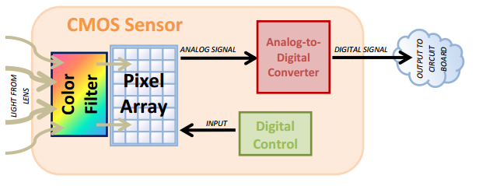
Fig. 9. CMOS Sensor. [60]
Over the pixel sensor array, another array of color filters is located to capture color information. That is a critical factor because each cell of the sensor receives only the intensity of incident light but not its frequency. And frequency is the carrier of color information. Without color filters, the output of the CMOS sensor includes a grayscale image. The filters should be constructed to permit the transmittance of any single color; however, the most effective colors are red, green, blue (RGB) or cyan, magenta, yellow (CMY) often even black (CMYK). The most frequently used color filter is called Bayer filter which is located over each cell of the sensor, and it allows just one spectral component of the light (red, green or blue) to pass through. Distribution of transmittance is given by the sensitivity of the human eye; thus, because the human eye is most sensitive to green color, the number of green filters is twice as high than others. [60]
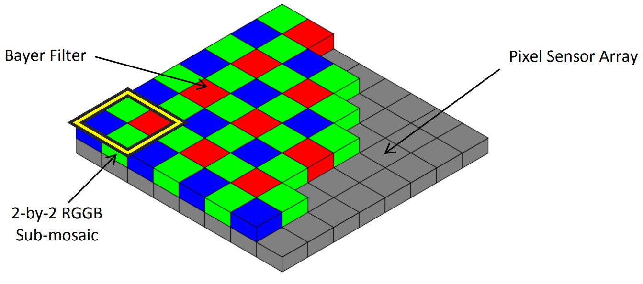
Fig. 10. Bayer Filter. [60]
As mentioned before, the CMOS sensor contains a pixel sensor array that captures the intensity of light passing through the color filters. These sensors detect the level of intensity and subsequently, the level is converted into a voltage signal that travels into an analogue-to-digital converter. [60]
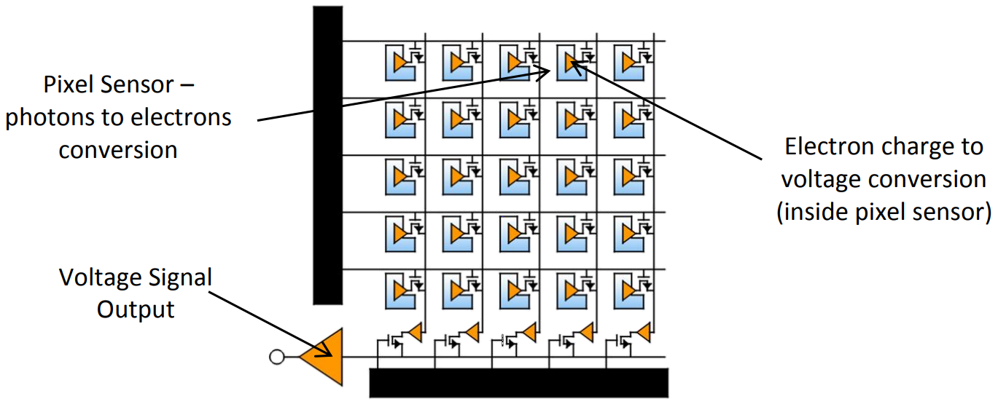
Fig. 11. Pixel Sensor Array. [60]
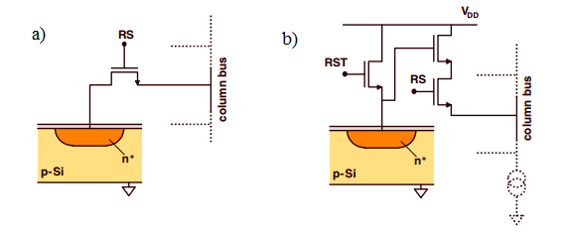
Fig. 12. a) Passive Pixel Sensor, b) Active Pixel Sensor. [61]

Charged-Coupled Device
A charge-coupled device (CCD) is another type of image sensor for cameras. CCD is a photosensitive semiconductor component consists of a large number of cells to convert light into electrical charge. The principle works with an internal photoelectric effect which releases electrons from substances by electromagnetic radiation. The electrodes of CCD are separated from the semiconductor by a thin layer of silicon dioxide; thus electrons cannot be taken away of the semiconductor. The size of the electrical charge affects incoming light intensity and capture period. [62]
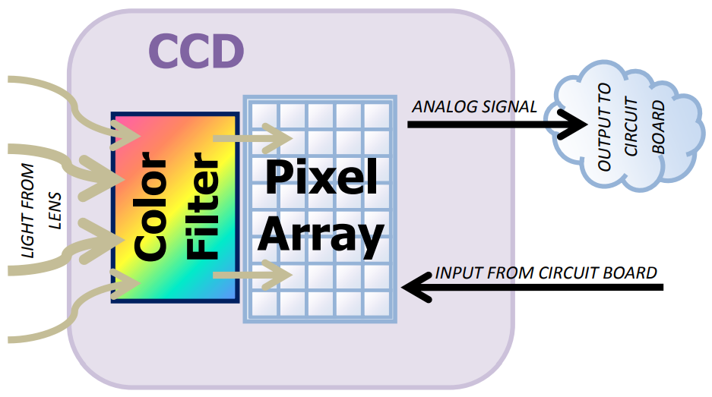
Fig. 13. Charged-Coupled Device. [60]
According to publication [62], the principle can be divided into three main steps:
- Preparatory phase - the step resets CCD chip into default setting. The sensor is not exposed to incoming light. [62]
- Image exposure - some of the electrodes are connected to the voltage source, and detector changed into the state which allows detecting of incoming light. This phenomenon causes the electrons to be released towards the positively charged electrodes and to move the holes towards the negatively charged electrode as Fig. 14 illustrates. [62]
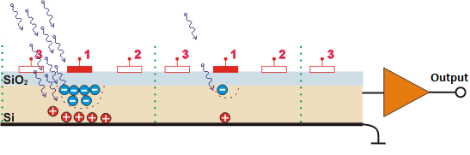
Fig. 14. Image Exposure. [62]
- Image capturing - three-phase clock signal is gradually applied to electrodes which causes a voltage increase on one electrode and a drop on other electrodes. In other words, the voltage increase on the electrode 2 causes a voltage drop on the electrode 1 causing the electrons and holes to move toward the electrode 3 or the output amplifier as Fig. 15 illustrates. The amplifier strengthens a small current corresponding with the number of captured electrons from individual cells. [62]
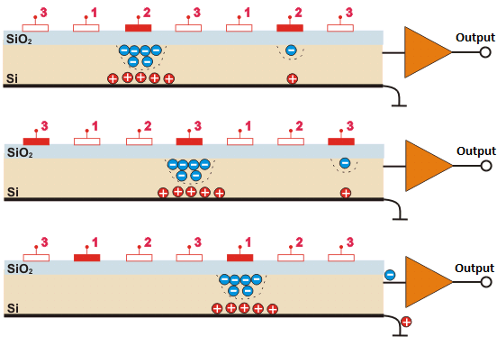
Fig. 15. Image Capturing. [62]
According to [60], CCD chip pixel array consists of the number of passive pixel sensors capturing incoming light intensity. Each cell of array registers just intensity not frequency; therefore, CCD is combined with color filters as well as CMOS. [62] The received data are converted into an analog voltage signal suitable for further processing. [60]
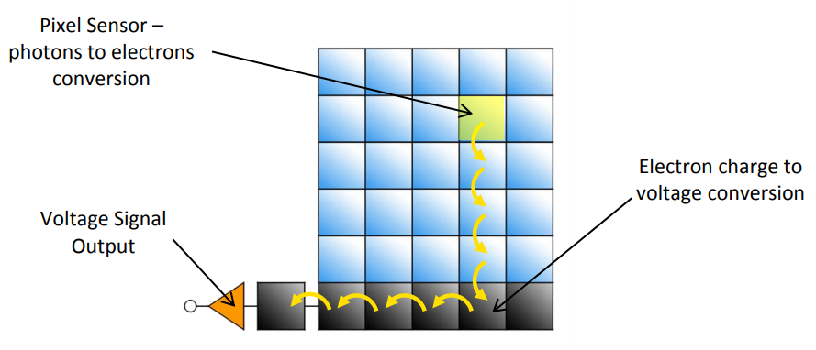
Fig. 16. CCD Sensor Pixel Array. [60]

MEASURING WORKPLACES
This section describes measuring workplaces used for experiments of testing and measurement that are described in the practical part of this thesis. At the Faculty of Applied Informatics, there are two basic facilities for tests of electromagnetic immunity and measurement of electromagnetic emissions. Both of them are specified in following lines.

Gigahertz Transverse Electromagnetic Cell
The TEM test chamber offers a practically perfect EMS solution, enabling the generation of a homogeneous transverse field without unwanted emissions into the environment. TEM chambers are specially designed electromagnetically shielded spaces developed for EMC purposes, both for testing electromagnetic immunity and for measurement of disruptive emissions. [5], [6]
The chamber is formed by a closed space in the shape of a long pyramidal widening section of coaxial lines with an inner stripline conductor. The characteristic impedance along the entire length is constant and equal to 50 ohms. A broadband impedance matching of the GTEM chamber at high frequencies provides absorbent material while an internal resistor network ensures anechoic properties at lower frequencies at the end of the inner stripline conductor. The progressive electromagnetic wave propagates with a slightly spherical wavefront. [5], [6]
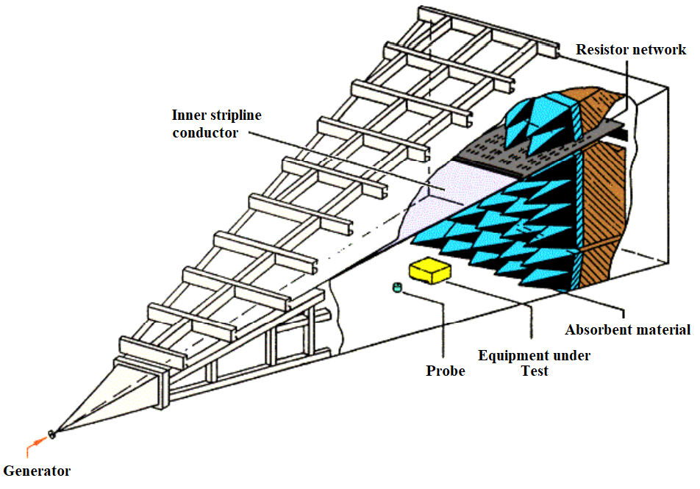
Fig. 17. GTEM Structure. [5]
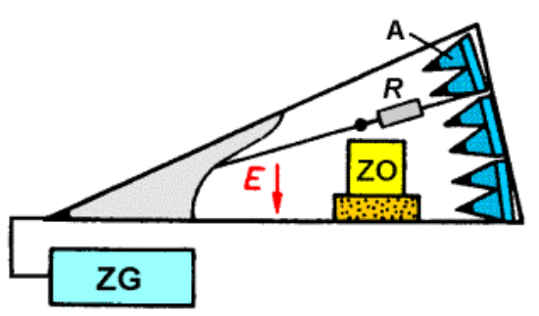
Fig. 18. Cutting of GTEM Chamber. [5]
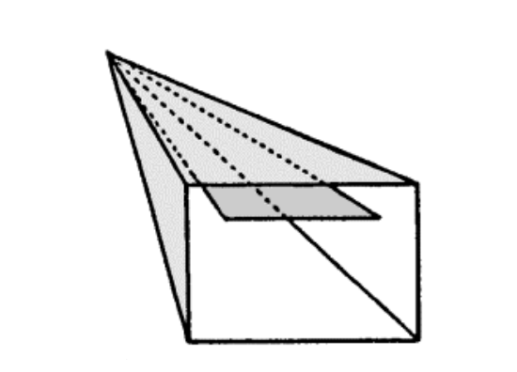
Fig. 19. Cross Section of GTEM chamber. [5]

Semi-anechoic Chamber
A semi-anechoic chamber presents another solution for the EMS test. A semi-anechoic chamber is a special room designed to absorb reflections of electromagnetic waves completely. The chamber is also insulated from exterior sources of EM noise. The combination of both aspects means that the semi-anechoic chamber simulates a quiet open-space of infinite dimension, which is useful when exterior influences would otherwise give false results. [63] The interior of the chamber is also equipped with absorbent materials, i.e., materials specially developed and formed to absorb incident electromagnetic radiation. Unlike the GTEM chamber, the semi-anechoic chamber can be equipped with different kinds of antennas depending on the required task.
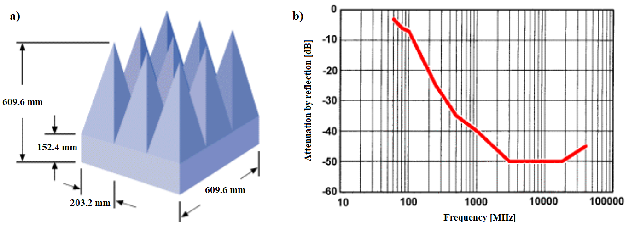
Fig. 20. Design, Dimension and Absorption Properties of Absorbent Material in Range from 80 MHz to 40 GHz. [5]
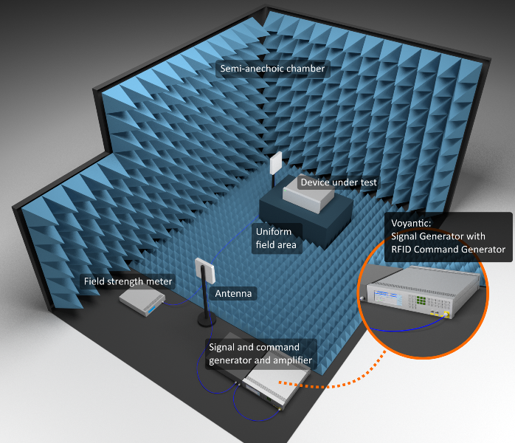
Fig. 21. Illustrative Image of Semi-anechoic Chamber. [64]

PROCESSING METHODS
This section describes the methods used for doctoral thesis completion. In addition to primary methods like analysis, synthesis, and experimental methods, the author uses a more advanced approach, namely numerical modeling, or multi-criteria evaluation. All processing methods are listed in the following lines.
- Analysis method - this method is used in the process of design. Electromagnetic immunity testing is a complicated process; therefore, it is necessary to decompose solved problems into smaller units, i.e., conducted, and radiated susceptibility.
- Synthesis method - this method is suitable for the progress of camera design. Knowledge gained during individual processes of electromagnetic immunity tests and electromagnetic interference measurement serves as a support to design the final product.
- Induction method - this method provides general rules based on specific cases. The application method is suitable for the process of shielding material selection; however, there is only weak induction due to a small number of material representatives.
- Numerical modeling - method provides electromagnetic compatibility information about distribution and levels before the camera proposal realization. The result of the technique advises what kind of changes should be performed.
- Multi-criteria evaluation method - this method finds the ideal solution that helps to increase the shielding enclosure electromagnetic immunity. The box design process is sophisticated; therefore, there can be more than one solution, and the method finds its application.
- Experimental method - this method searches the right solution pursuant experiments. The trial and error approach helps verify or disprove the hypothesis and knowledge from electromagnetic immunity assays.

EXPERIMENT PREPARATION
The Experiment chapter reports electromagnetic tests description divided into two subchapters deal with simulation and practical measurements and tests. The experiment is based especially on the simulation which provides a great idea about electromagnetic field distribution. The simulation process contains several subprocesses including apertures and material shielding effectiveness calculations. Because the dissertation thesis aims at the ideal shielding enclosure finding, the evolutionary algorithms are applied. These algorithms help to find the best output based on input parameters optimization. However, the entire enclosure calculation using evolutionary algorithms takes a lot of time, the algorithms are applied only to the part of the product, on the grid.

MATERIALS
The first step includes a suitable material searching for shielding enclosure which is a significant part of the thesis. As chapter about the current state claims there is a lot of solutions namely ICPs or classical conductive metals such as steel, copper or brass. However, the published results indicate that ICPs do not seem to be a suitable choice for a shielding enclosure; therefore, the work focuses mainly on conventional conductive materials. In this area, properties such as weight or corrosion that limit the possibilities should be considered.
The process of shielding effectiveness calculation is performed using CST Microwave Studio simulation software which offers an extensive database of materials suitable for this experiment. CST Microwave Studio is a research tool for the 3D electromagnetic simulation which gives an insight into the electromagnetic behavior of the solved task. According to publication [65], CST offers a lot of solver modules, such as Time Domain (TD) solver including Finite Integration Technique (FIT) and the Transmission Line Matrix (TLM) method or Frequency Domain (FD) consisting of Finite Element Method (FEM). Both mentioned solvers work with different meshes; it means hexahedral mesh for TD, tetrahedral mesh for FD. There is also triangular mesh for FD which is useful for integral methods. [65] The advantage of the software is the applicability in a wide range of research activities, besides electromagnetic simulations, CST Studio also allows to perform thermal or mechanical simulations of required tasks. Despite these benefits, the hardware requirements limit this tool because users need to use powerful computer for calculations. CST Studio also disposes of the Fast Perfect Boundary Approximation (FPBA) for TD enhancing the accuracy of the component geometry approximation and speed of solution. In other words, there is a correlation between the number of meshes and the speed, the lower the number of meshes, the higher the speed. Thus, FPBA can work accurately and quickly even with a small number of meshes. [65] CST Microwave Studio offers basically two approaches on how to create, set and run the electromagnetic simulation. The first one is a manual setting which is the most user-friendly but slow. The second approach uses a unique function called macro allowing the user to set project using Visual Basic for Application (VBA) programming language based on Visual Basic (VB). This option is less user-friendly but more suited to more complex projects.
The experiment meets the standards requirements for shielding effectiveness; the tested material is placed between the measuring field probe and the source of radiation as Fig. 22 shows. The figure illustrates more than one probe in the vicinity of the sheet, the reason for this is verification of results before and after the passage through the material. It helps to calculate shielding effectiveness around the center and edges of the shield. The wave plane serves as the source of the electromagnetic radiation. The plane wave represents the ideal solution for this task because the mathematical description is simple which simplifies electromagnetic calculations. The publication [66] describes the surface of the wave is infinite plane perpendicular to the wave propagation direction. The experiment consists of open boundary condition in all axis, except of z-axis which includes open boundary condition with adding space because of the radiation source, as Fig. 23 shows. The probes are located 10 cm from the center of the material in the z-axis. The distance between the center and the probes in the x and y-axis is 45 cm. The plane wave is 50 cm away from the sample.
The experiment focuses on the materials shielding effectiveness comparison which are suitable for shielding enclosure. There are especially typical conductive materials such as copper, aluminum, or brass, recommended by the publications or scientists. The significant factors for selection are material longevity, acceptable electrical conductivity, price, and corrosion resistance. For comparison, the experiment includes an Indium tin oxide (ITO) - unique plastic material as the representative of conductive polymers, which provides transparency to offer the optimal option for the lens protection against harmful electromagnetic energy.
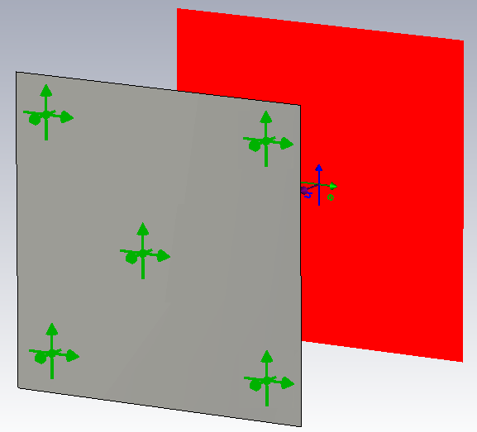
Fig. 22. Illustrative Layout of Shielding Material, Wave Plane and Measuring Probes.
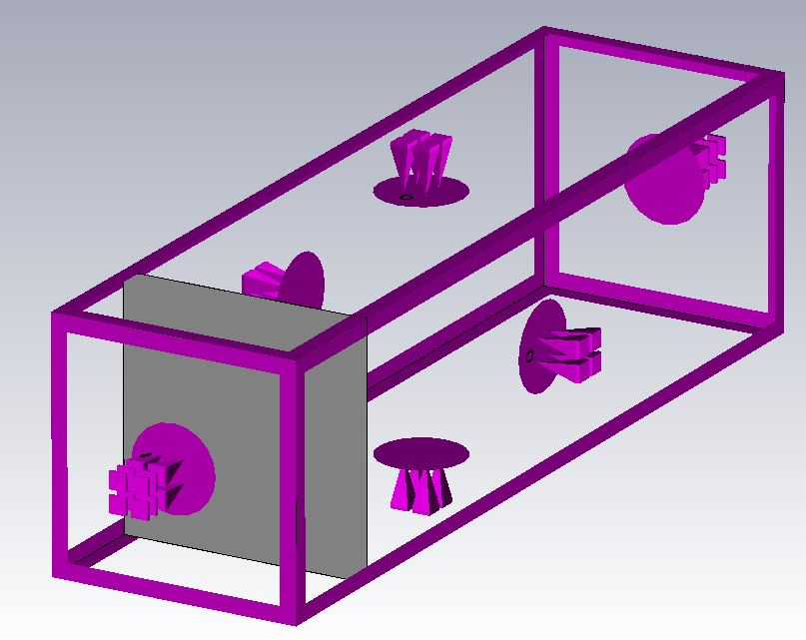
Fig. 23. Boundary Conditions with Open Space for Wave Plane.
The results indicate that the best attenuation reaches the copper followed by the aluminum and 91% of brass. The conclusion is expected because copper has the best electrical conductivity from these materials; however, the corrosion resistivity is better in case of the steel and its alloys. Unfortunately, the steel shielding effectiveness does not reach such satisfactory results as copper and its alloys. The worst outputs are reported by the ITO, the shielding effectiveness is around 20 dB, which is insufficient for the task being solved. In practice, tin-doped brass is used to increase corrosion resistance, wherein the percentage content of substances may vary. The differences between copper, aluminum and brass are practically negligible they are about 5 dB.
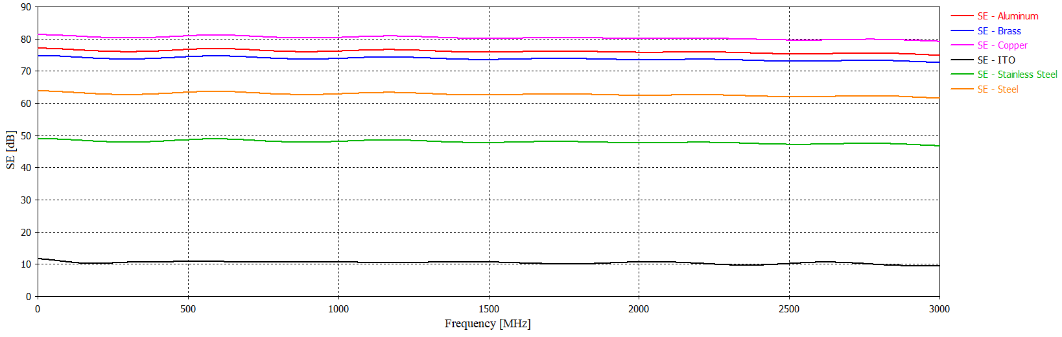
Fig. 24. Shielding Effectiveness in Center of Materials.
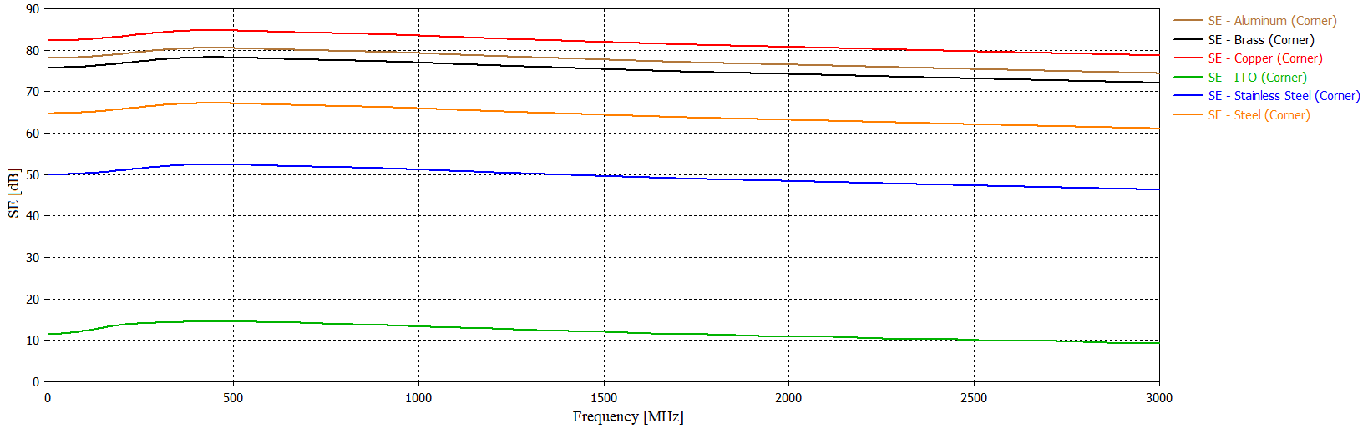
Fig. 25. Shielding Effectiveness in Edge of Materials.

SHIELDING GRIDS
As the chapter about current state mentioned; there is a lot of options how to protect the device or which shape of holes should be used. This section aims at the searching and comparison of apertures suitable for application in the security camera shielding. The core of the experiment is brass sheet with the dimension of 1000x1000x1 mm. The holes occupying an area of 850 mm² are situated into this material. The measuring probes with a fixed location are placed in the space around the brass sheet as Fig. 22 illustrates. The probes serve to shielding effectiveness calculation. Wave plane is 3 m away from the material. The experiments described in following lines have the same conditions as the one listed in the previous section.

Circular holes
The first shield version includes the simplest shape, the circular holes with a diameter of 10 mm and the distance between of holes is 5 mm in x and y-direction. The holes are evenly distributed to provide the best possible visibility for practical use. This variant seems to be the best option regarding production; however, the grid transparency need not be satisfactory due to the shape of the hole. There is a lot of non-transparency material between the holes in the diagonal direction.
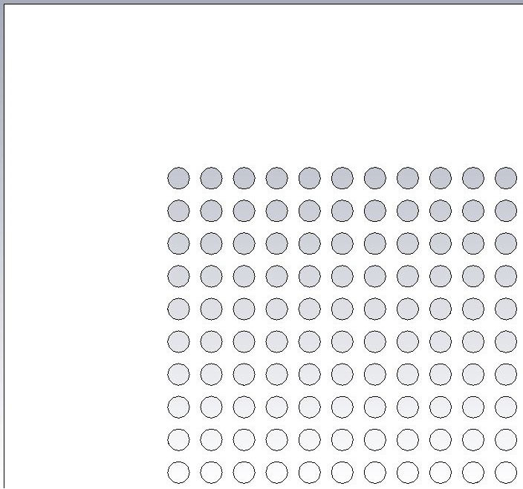
Fig. 26. Shield with Circular Holes.
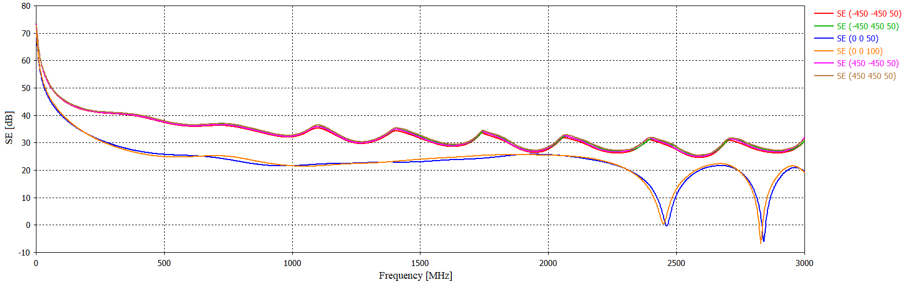
Fig. 27. Shielding Effectiveness of Material with Circular Holes.
The legend states the SE calculated according to the probes' positions in the x, y, and z axes. The results indicate that the design shield with circular holes reduces the electric field impact by an average of 33dB. The results of other probes located in the material edges are not reported because they are copying the waveform shown in Fig. 27. For a more precise idea, Fig. 28 offers a view of shielding effectiveness decrease dependence on the hole size. The difference between holes with 0.5 mm and 4 mm diameter is almost 70 dB at the frequency of 1000 MHz.
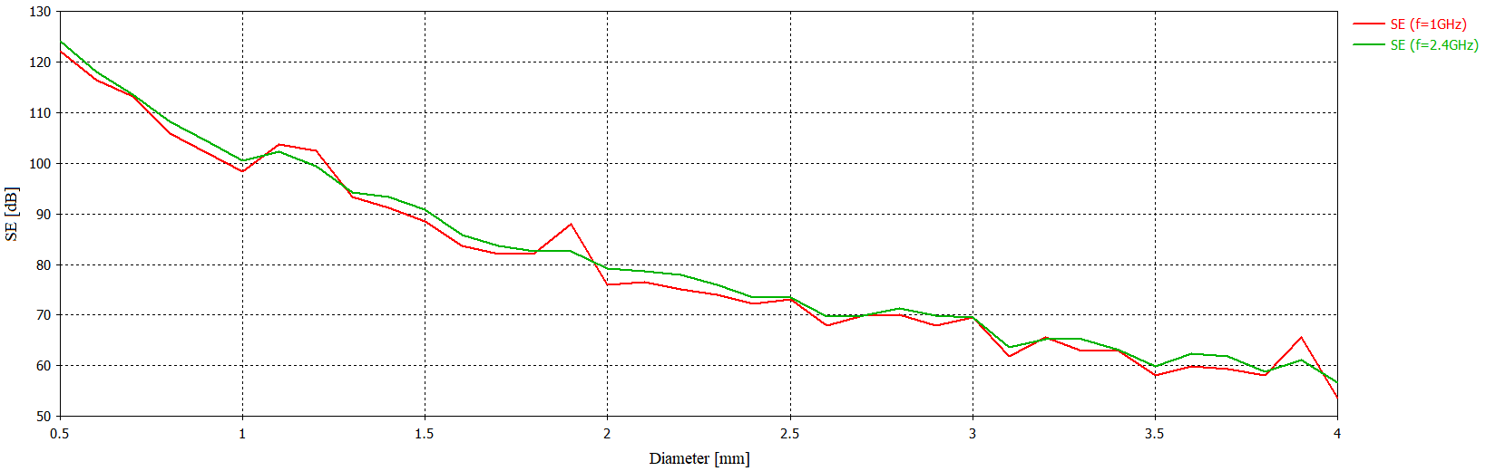
Fig. 28. Dependence of SE on Circular Hole Size.

Square holes
The second version consists of square holes which should be a better solution regarding visibility. The square side length is 10 mm, and the gap between the holes is 5 mm. The traditional quadrilateral apertures are also simple shape suitable for production, but the attenuation would be worse in comparison with other shapes, as Fig. 4 illustrates.
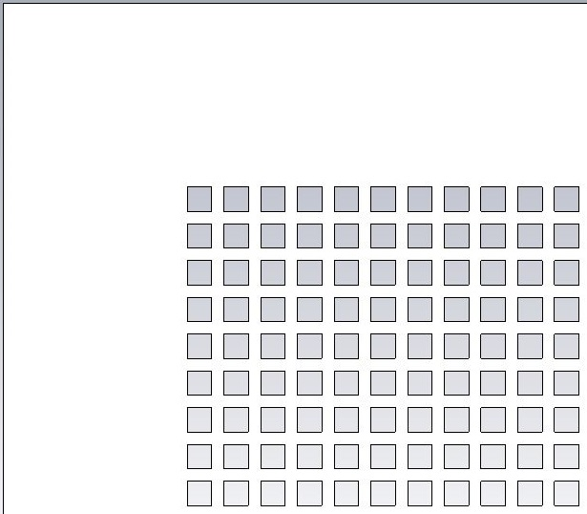
Fig. 29. Shield with Square Holes.

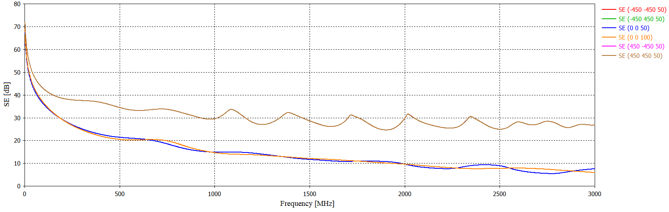
Fig. 30. Shielding Effectiveness of Material with Square Holes.
The results of shielding effectiveness for the shield with square holes are like one present in the section about the circular holes. The differences are visible in Fig. 31 which illustrates that the higher amount of interfering electromagnetic energy penetrates through the shield. The conclusion of the comparison circular and square holes is a little bit expected because the surface of transparent areas has increased; that is the reason why the values of SE decreased.
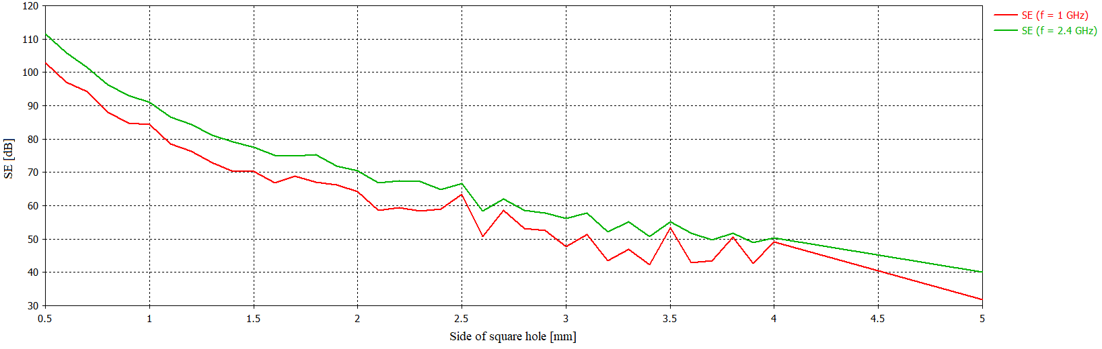
Fig. 31. Dependence of SE on Square Hole Size.

Triangle holes
This version contains triangular holes with the lengths of 10 mm and 14.14 mm. The distance between holes is 5 mm in the y-axis and 2.5 mm x-axis. This layout improves visibility through holes.
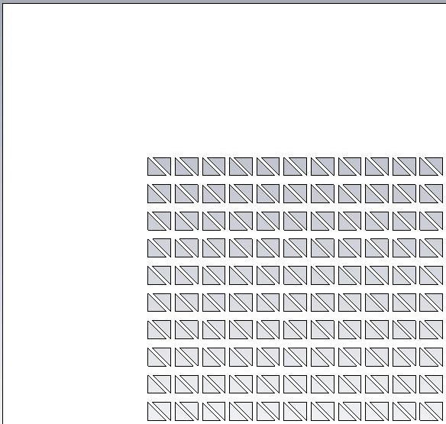
Fig. 32. Shield with Triangle Holes.
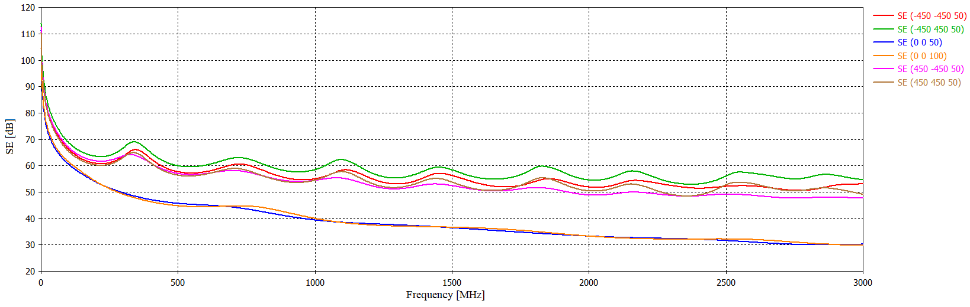
Fig. 33. Shielding Effectiveness of Material with Triangle Holes.
The attenuation in the center of the shield reach up to 35 dB on average; despite this fact, the waveforms are similar to the previous cases. The differences in attenuation at the corners of the material are particularly pronounced at higher frequencies; however, there are mostly differences in amplitude size. Fig. 33 indicates similar results as in the case of circular holes; despite the fact, that the shape looks more like a square hole.
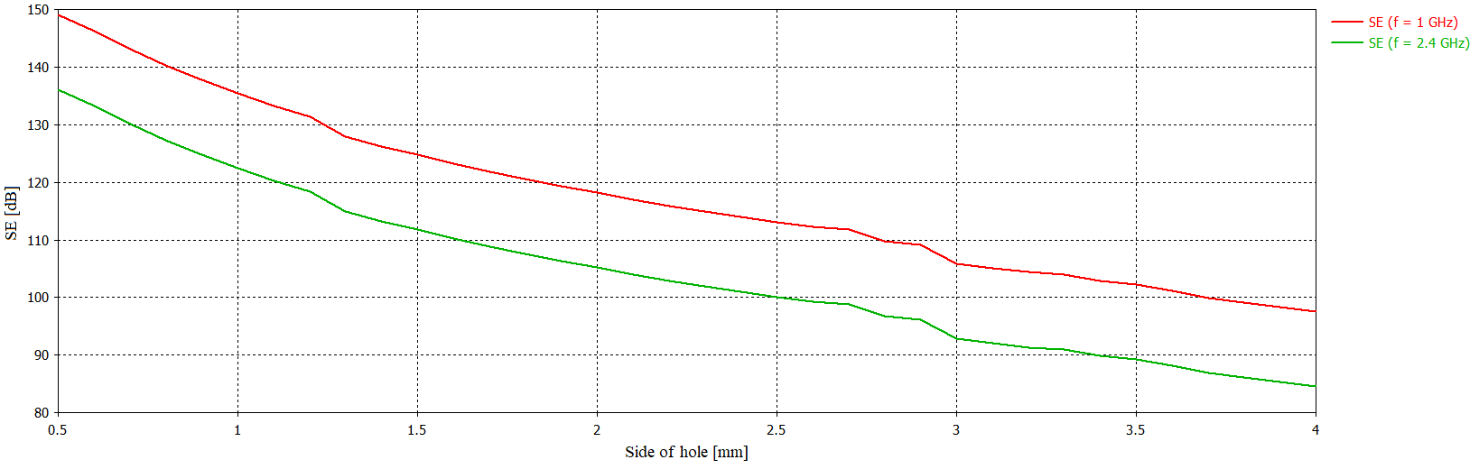
Fig. 34. Dependence of SE on Triangle Hole Size.

Pentagon holes
The version with pentagon holes represents an ideal solution according to the publication [38]; nevertheless, the production process could be more complicated than in previous situations. All sides of the pentagon equal to 5 mm and the distance of opposite corners are 10 mm. The gap is alternately 5 mm or 1.6 mm depending on the angle of rotation of the hole. Because of the complicated hole shape, visibility is worse than previous ones.
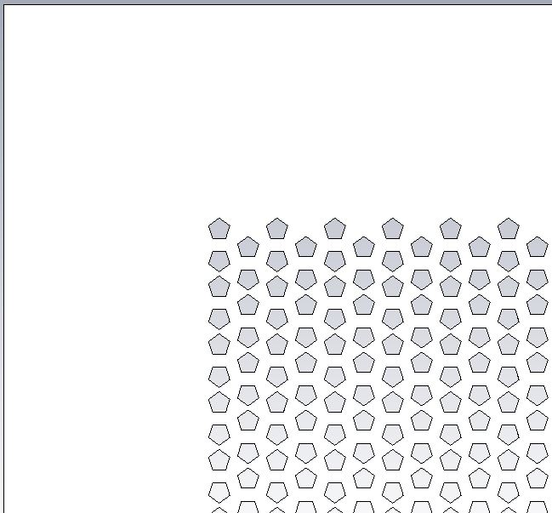
Fig. 35. Shield with Pentagon Holes.

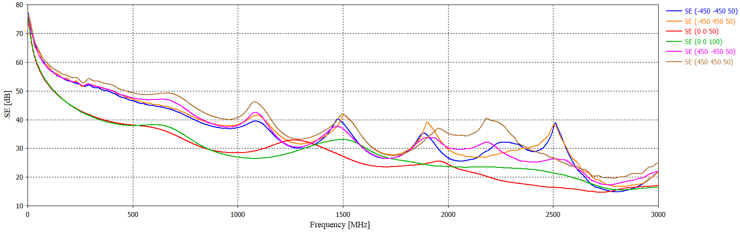
Fig. 36. Shielding Effectiveness of Material with Pentagon Holes.
The results confirm the claim of the publication [38] because this version reaches the best attenuation which is on average 39 dB. The attenuation at the edges of the shield differs by 10 - 14 dB at some frequencies, such as 1323.2 MHz, 1702.6 MHz or 2016.4 MHz. It can be caused by a different distance between the edge of the shield and the last hole in the row. Fig. 37 shows almost perfect electric field scattering behind the shield; it means virtually no field penetrates through the material.
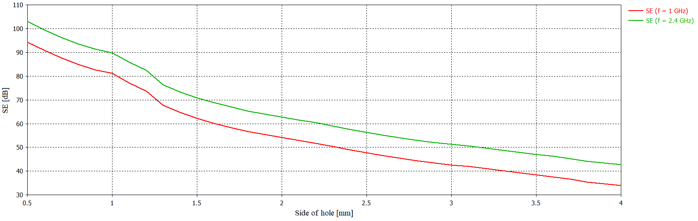
Fig. 37. Dependence of SE on Pentagon Hole Size.

Honeycomb holes
The last version includes hexagonal holes with the side length equal to 5.77 mm. The distance of the opposite corners is approximately 11.55 mm. The gap between the holes is 5 mm in both the x and y-direction. The shape of the aperture allows for an appropriate layout on the surface of the material and therefore also for acceptable visibility.
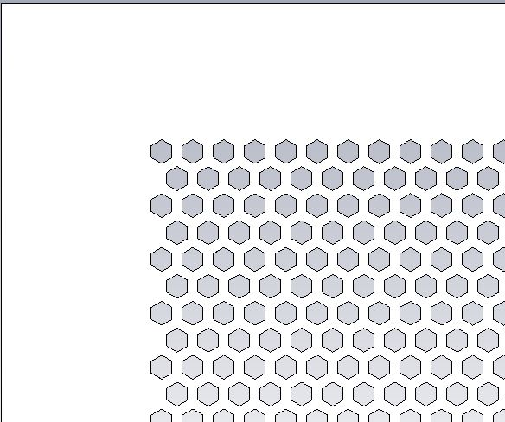
Fig. 38. Shield with Honeycomb Holes.

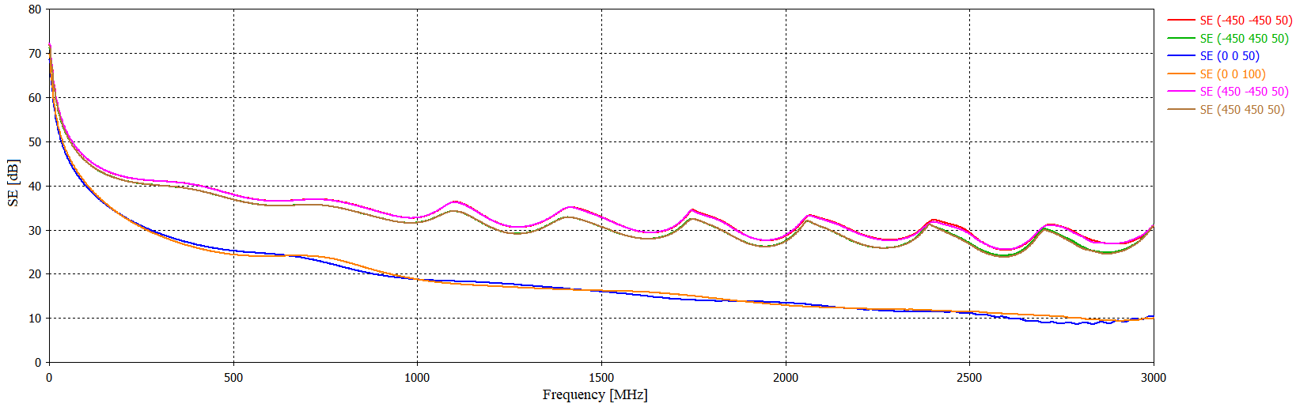
Fig. 39. Shielding Effectiveness of Material with Honeycomb Holes.
The last version reaches one of the worst attenuations, approximately 28 dB, although it could be caused by better visibility in compare with pentagon-shaped holes. The shielding effectiveness detected by field probes in the edges shows the negligible differences approximately 3 - 5 dB at some frequencies. The reason can be in the various distances between borders of the last hole and the shield. Fig. 40 illustrates the electric field penetration through the hexagon shielding grid with a certain attenuation. The field strength behind shielding reaches up to 18 V/m.
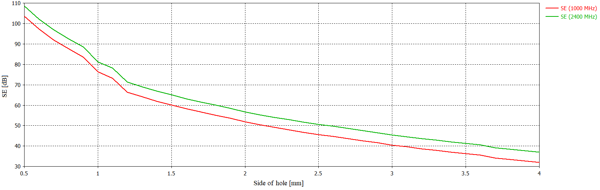
Fig. 40. Dependence of SE on Hexagon Hole Size.

EVOLUTIONARY ALGORITHMS
Publications [67], [68] defines heuristic optimization algorithms as a powerful tool to solve an issue which analytical methods cannot resolve, or they are inappropriately for the problem. Application of these algorithms may reduce user interaction and helps to find a perfect solution which may not be found by conventional methods. The heuristic optimization algorithms consist of a large group of algorithms which can vary on many levels from each other. One group is covering the popular algorithms based on the evolutionary theory proposed by Darwin. Evolutionary algorithms are kind of algorithms based on Darwin and Mendel principles about gene transfer and make space for offspring. Darwin's and Mendel's theory of evolution claims that parents generate offspring whose formation is subject to mutations. Because evolution tries to find the ideal species and the procreation cycle of new offspring would fill the environment, inappropriate children and parents have to die, which is going on generationally. This cycle frees up space for better children who become parents, and it is repeated continuously. This principle can be explained by following steps. [67]
- Parameters definition - The step which sets input and output parameters. It means the phase defines parameters which control and end algorithm. This step also includes purposeful function representing environment which searching maximum and minimum values leading to problem-solving. [67]
- Population settings - The step consists of population definition described by $N×M$ matrix where N is the number of individual's parameter, and M is the number of individuals in the population. The individual represents a vector of numbers containing many randomly set folders; their number corresponds to the number of optimized parameters of the purpose function. [67]
- Evaluation of individuals - The step when algorithm evaluates individuals with using purpose function which assigns to individuals either a direct or modified function value. [67]
- Parents selection - The step includes choice of parents into the next generation according to set criteria. [67]
- Offspring creating - The step involves offspring procreation by defined parents. [67]
- Mutation - The step includes a change of the individual using a random process. [67]
- Evaluation of individual - The step works as the one describes in 3rd step. [67]
- Selection of the best individuals. [67]
- Old generation removal - The step when algorithm removes elderly population. [67]
The experiment is similar to one described in the previous chapter; however, the evolutionary algorithms are applied to the input parameters (Tab. 4) instead of fixed parameters. That leads to automatic settings changing in each cycle without user interaction, and the program can look for the results approaching the desired electric field strength, which allows calculating shielding effectiveness. This way saved the total calculation time and computational requirements. The input parameters include the number of hole edges, the pitch between holes, radius and thickness of aperture, the angle of rotation for all holes, and the second angle rotating only even raw holes relative to the first one. The base of the experiment is Wolfram Mathematica software for scientific, technical, and mathematical calculations that defined parameters and run the CST Studio. CST Microwave Studio uses a specific function called macro, allowing to create a model, set, and run the project via VBA programming language. In other words, Mathematica runs evolutionary algorithms, and CST Studio performs the simulation tasks.

Firefly Algorithm
The Firefly algorithm (FFA) is based on the characteristic behavior pattern of fireflies. The scientists examined these insect’s habits using for communication, partner search and other similar practices which recorded and converted into the mathematical forms. The FFA algorithm is developed on three basic rules, the detailed interpretation of which is given in the publication [69].
- The brightest firefly attracts others regardless of gender.
- Increasing distance between fireflies reduces attractiveness and brightness.
- Brightness can be likened to an objective function.
The publications [69], [70] describes detailed information about Firefly algorithm whose description is not primarily the aim of this thesis.
The first experiment based on Firefly algorithm includes a lot of iteration whereby each new one achieved better results, as Tab. 4 shows. The figures below indicate that the design reaches excellent outcomes although the apertures shapes are slightly different than the one calculated in the previous chapter. The results of shielding efficiency support the decision to use evolutionary algorithms to search for a suitable solution, as there can be found unusual shapes with which the scientists do not typically work [71], [72] and [73].
Tab. 4. Values of Input Parameters for Variable Iteration of Firefly Algorithm.
 | Pitch | Radius | Number of Edges | Angle of Hole Rotation | Angle of Rotation for Even Raw Holes | Thickness
f_1 | 1.231 | 1.503 | 3.587 | 9.674 | 51.426 | 2.644
f_2 | 1.975 | 1.620 | 4.484 | 157.576 | 157.965 | 2.911
f_3 | 1.860 | 1.740 | 3.782 | 233.624 | 77.835 | 2.299
f_4 | 1.661 | 1.643 | 3.885 | 141.700 | 164.324 | 2.554
f_5 | 1.742 | 1.655 | 3.709 | 232.372 | 77.977 | 2.631
f_6 | 1.908 | 1.723 | 4.040 | 222.975 | 91.292 | 2.748
f_7 | 1.894 | 1.533 | 4.278 | 224.216 | 93.040 | 2.694
f_8 | 1.889 | 1.724 | 4.212 | 224.086 | 90.522 | 2.610
f_9 | 1.871 | 1.730 | 4.258 | 222.869 | 92.201 | 2.610
f_10 | 1.891 | 1.757 | 4.249 | 222.099 | 92.832 | 2.630
f_11 | 1.890 | 1.765 | 4.165 | 223.448 | 91.512 | 2.618
Final | 1.889 | 1.766 | 4.161 | 223.410 | 91.902 | 2.618
There are detected probes located around the front sides of the design shielding enclosure and enabling the shielding effectiveness to be calculated. The average attenuation of the design is 90 dB, which is higher than conventional variants. The final form of holes shape offers an exciting solution because it resembles an atypical pentagon but provides sufficient visibility with a uniform ratio between the amount of material and the free space.
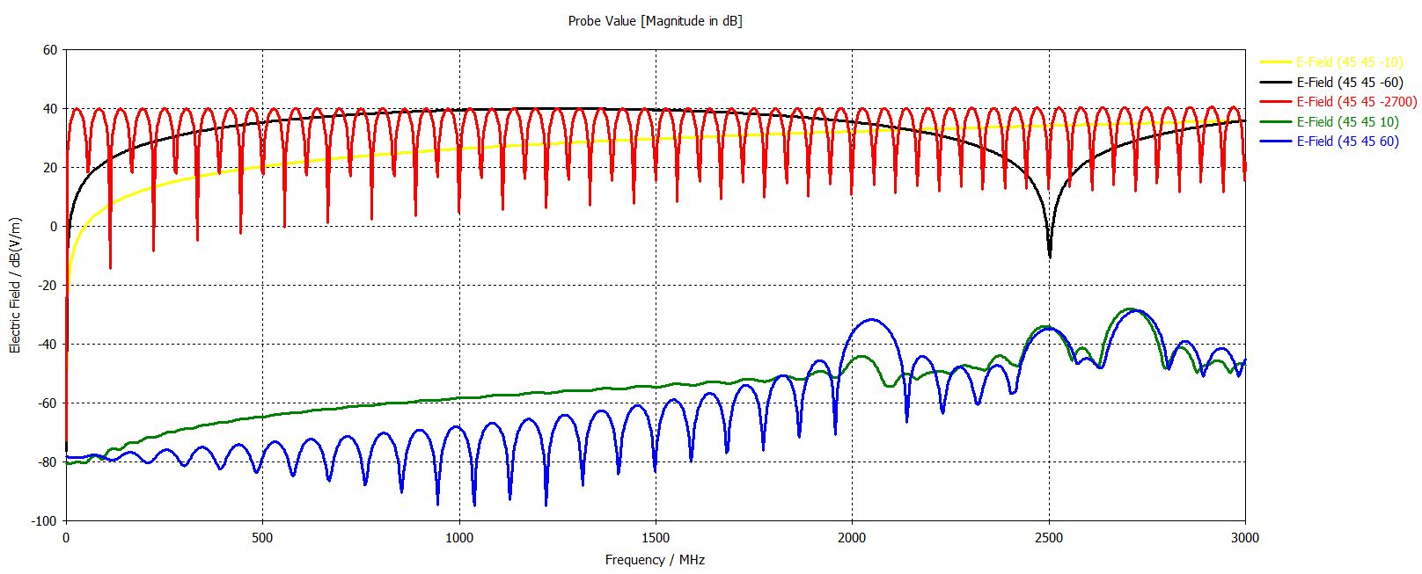
Fig. 41. Electric Field detected by Probes in Center of Shielding Enclosure (Firefly algorithm).
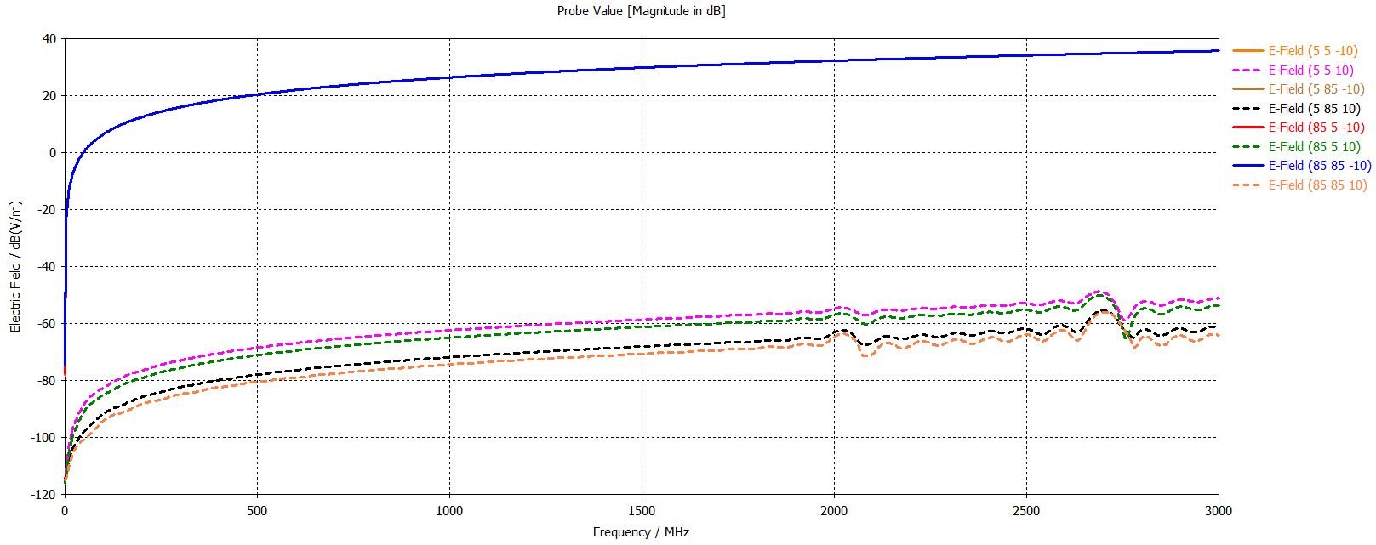
Fig. 42. Electric Field detected by Probes in Edges of Shielding Enclosure (Firefly algorithm).
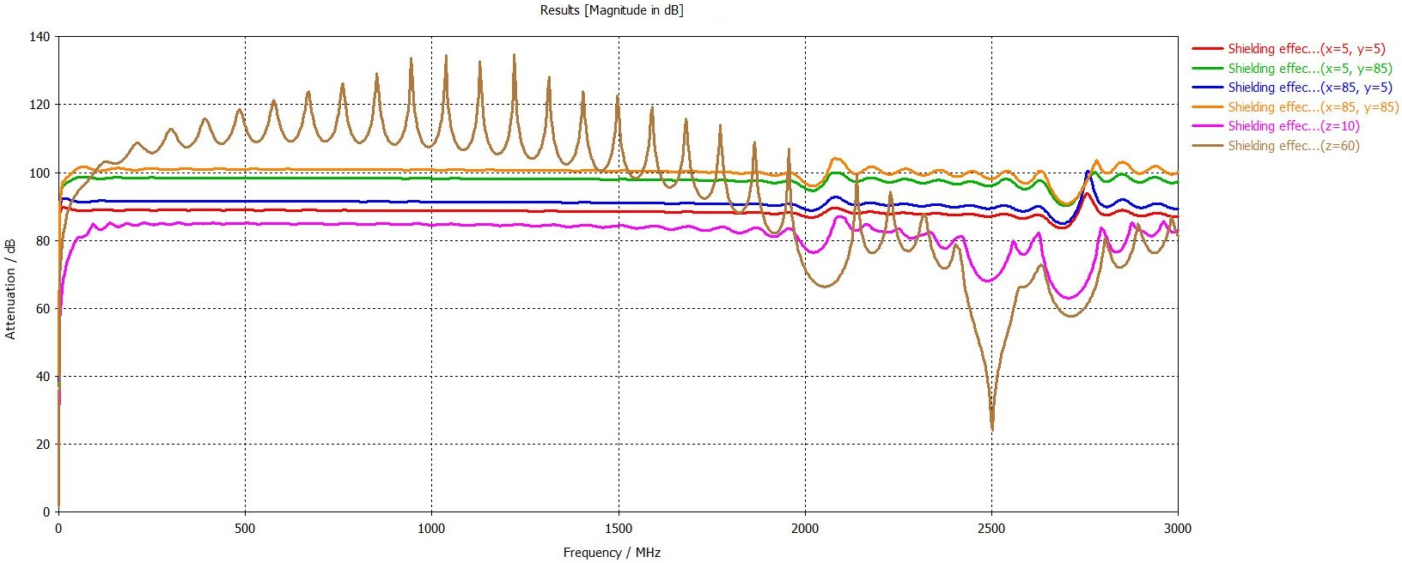
Fig. 43. Shielding Effectiveness of Box Designed by Firefly algorithm.
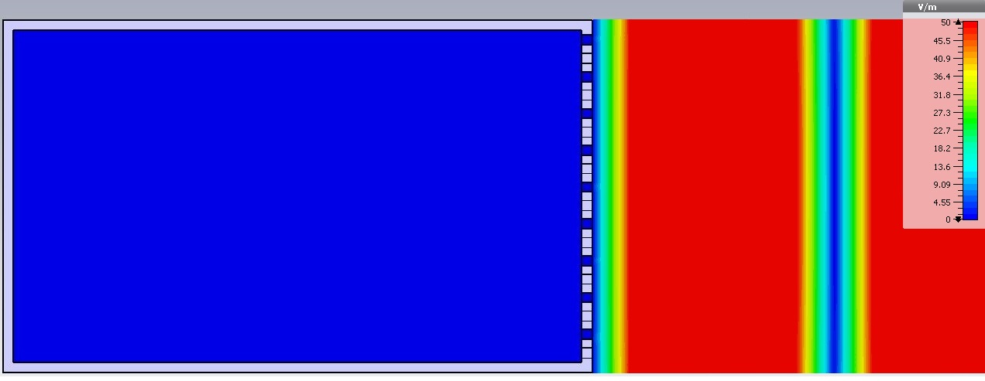
Fig. 44. Electric Field Scattering Inside of Shielding Enclosure in Frequency of 2500 MHz (Firefly algorithm).

Success-History based Adaptive Differential Evolution Algorithm
Success-History based Adaptive Differential Evolution (SHADE) algorithm [74] is based on canonical Differential Evolution (DE) invented by Storn and Price [75]. The DE works with the ideas of evolution using a randomly generated solution set with an explicitly specified size. The principle is to hybridize the individuals in the specific population in a way that finds the best offspring. The crossing process should be repeated until the results are met stopping criterions such as population limits, computational time or generation maximum number. The DE trouble is the time consuming of computational operations; therefore, the self-adaptation is applied into a modern version including SHADE algorithm.
The publications [74], [76] describes detailed information about SHADE algorithm whose description is not the aim of this thesis.
Tab. 5. Values of Input Parameters for Variable Iteration of SHADE Algorithm.
 | Pitch | Radius | Number of Edges | Angle of Hole Rotation | Angle of Rotation for Even Raw Holes | Thickness
f_1 | 4.722 | 2.127 | 3.375 | 278.741 | 289.994 | 1.089
f_2 | 3.888 | 1.527 | 5.337 | 207.261 | 285.973 | 2.949
f_3 | 3.417 | 1.527 | 4.168 | 128.963 | 180.160 | 1.015
f_4 | 2.852 | 1.508 | 3.850 | 134.599 | 173.338 | 2.616
f_5 | 4.418 | 1.591 | 3.146 | 272.824 | 179.569 | 2.422
f_6 | 5.895 | 1.640 | 3.318 | 143.856 | 187.480 | 2.520
f_7 | 5.739 | 1.517 | 3.592 | 315.651 | 97.609 | 2.677
f_8 | 5.935 | 1.576 | 4.013 | 227.994 | 175.565 | 2.692
f_9 | 5.716 | 1.560 | 3.630 | 229.580 | 174.260 | 2.538
Final | 5.746 | 1.552 | 3.518 | 225.987 | 96.303 | 2.864

The second experiment exploits an advanced SHADE algorithm which also works with a large number of iterations. There are almost 5000 iterations; therefore, Tab. 5 depicts just the most significant ones of them. The limitation of this variant is transparency because there is a disproportion between the amount of material and the visible space. Electric field scattering indicates that the design can eliminate radiation penetrating through the grid, in fact, no field can pass as Fig. 48 shows. The average shielding effectiveness is approximately 100 dB.
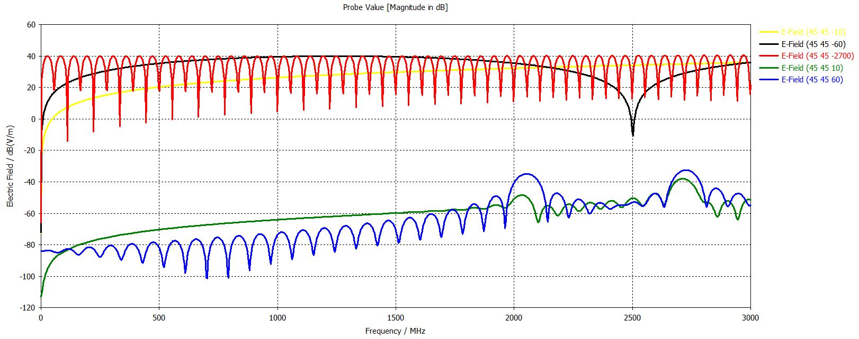
Fig. 45. Electric Field detected by Probes in Center of Shielding Enclosure (SHADE).
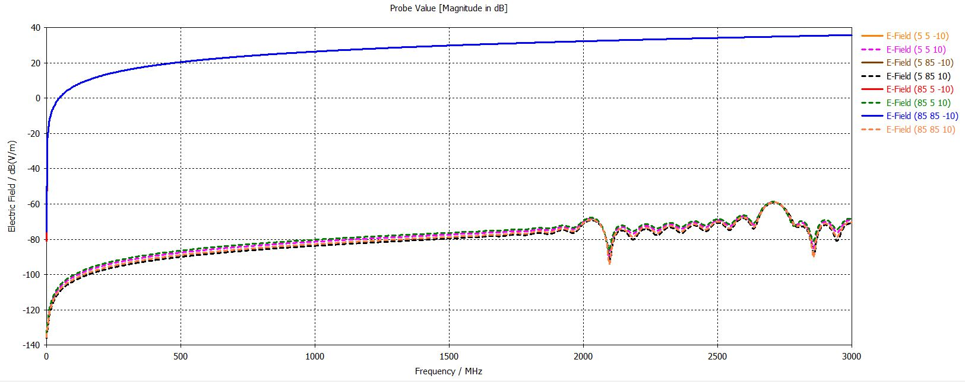
Fig. 46. Electric Field detected by Probes in Edges of Shielding Enclosure (SHADE).
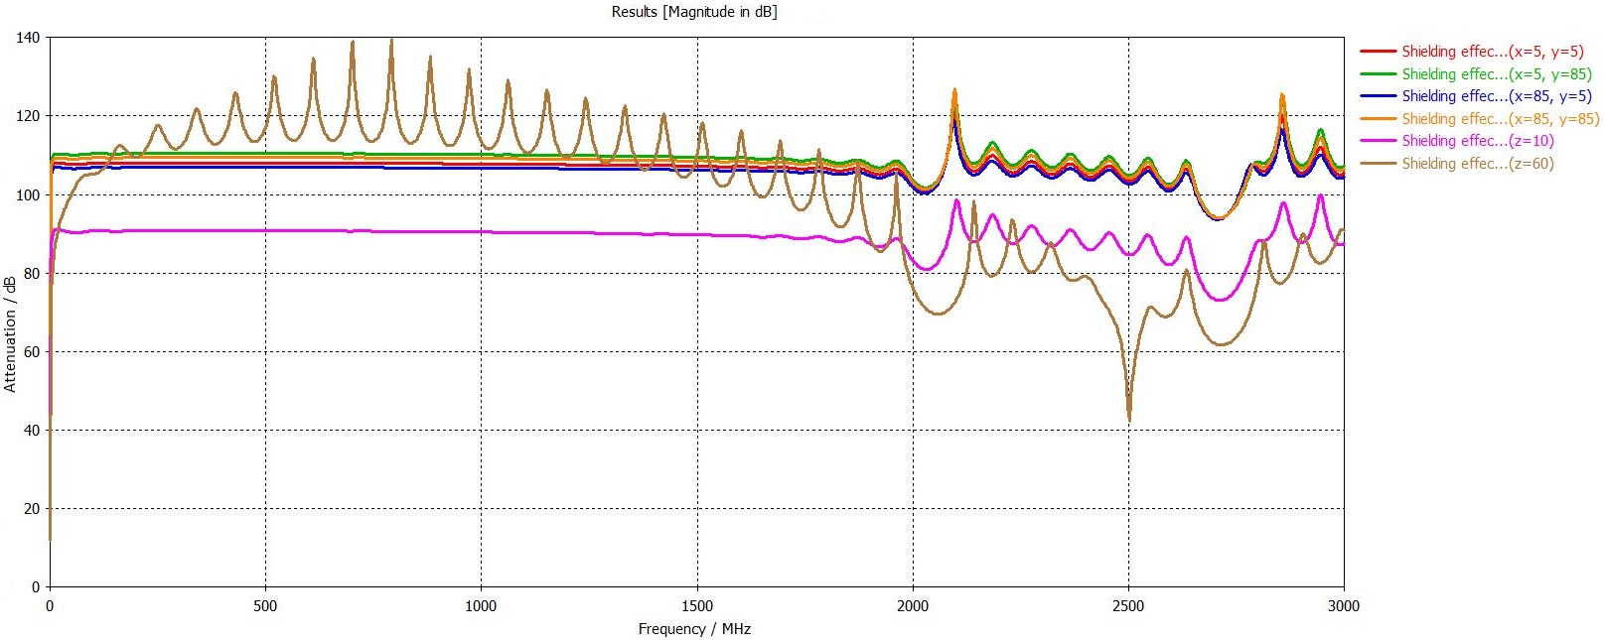
Fig. 47. Shielding Effectiveness of Box Designed by SHADE.
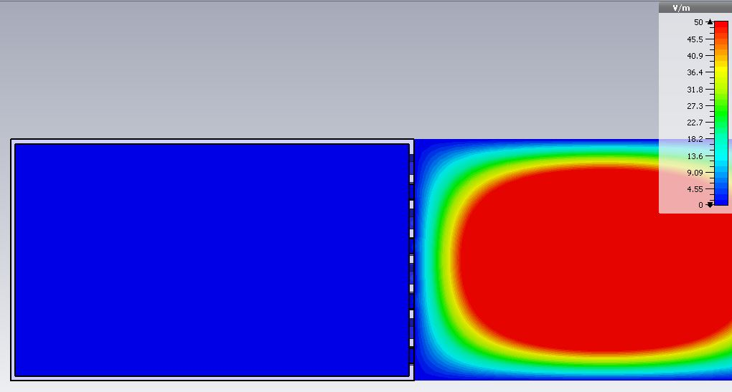
Fig. 48. Electric Field Scattering Inside of Shielding Enclosure in Frequency of 2000 MHz (SHADE).

Heterogeneous Comprehensive Learning Particle Swarm Optimization
This new algorithm is based on the well-known Particle Swarm Optimizer (PSO) optimization method developed by Russell Eberhart and James Kennedy by observing animal behaviors such as flocks of fishes or birds. [77] The principle is to trace the particles or individuals who cooperate via the simple communication rules in order to reach the best results in desired space. Particles remember their best position, which indicates the lowest or highest found value as a result. It depends on the defined optimization problem. In the beginning, the individuals are located in random places in the area and include a velocity vector defining their direction which is initially set to zero. The particle which discoveries the best solution saves the location into shared memory. It means all individuals know this position as the best-found solution. Each assesses the actual value with the best-shared value and if it finds a better result than particle saves it into its own memory. [67], [69] One of the main differences between PSO and Heterogeneous Comprehensive Learning Particle Swarm Optimization (HCLPSO) lies in the number of subpopulations. HCLPSO, unlike its predecessor, uses two subpopulations, one for exploration and one for exploitation whereby both subpopulations work with different equations to calculate particle velocity. [77], [78]
Tab. 6. Values of Input Parameters for Variable Iteration of HCLPSO Algorithm.
 | Pitch | Radius | Number of Edges | Angle of Hole Rotation | Angle of Rotation for Even Raw Holes | Thickness
f_1 | 2.826 | 1.758 | 4.699 | 130.968 | 174.445 | 2.487
f_2 | 1.681 | 1.621 | 3.919 | 120.523 | 66.882 | 2.940
f_3 | 1.123 | 1.721 | 4.172 | 132.318 | 115.337 | 2.457
f_4 | 1.153 | 1.806 | 3.033 | 101.390 | 162.218 | 2.941
f_5 | 1.329 | 1.747 | 3.244 | 152.572 | 52.533 | 1.116
f_6 | 2.253 | 1.781 | 4.242 | 301.313 | 290.969 | 2.873
f_7 | 2.002 | 2.086 | 4.189 | 310.915 | 267.067 | 2.471
f_8 | 1.779 | 1.807 | 3.827 | 319.904 | 350.779 | 2.618
f_9 | 1.681 | 1.896 | 4.477 | 310.717 | 267.639 | 2.802
f_10 | 1.681 | 1.886 | 4.477 | 316.767 | 267.648 | 2.802
f_11 | 2.305 | 1.937 | 4.210 | 315.697 | 183.307 | 2.657
Final | 2.336 | 1.934 | 4.167 | 312.634 | 178.745 | 2.672

The publications [77], [78] describes detailed information about PSO and HCLPSO algorithms whose description is not the aim of this thesis.
The last experiment includes HCLPSO algorithm consisting of about 5000 iterations whereby the significant parameters are in Tab. 6. The aperture shape is similar to one searched by firefly algorithm; nevertheless, the shielding effectiveness is lower than the previous cases. Despite this fact, this design offers an alternative solution to the first version because the transparency is also acceptable. The algorithm once again found a balance between the material and visible space. The average shielding effectiveness moves around 77 dB.
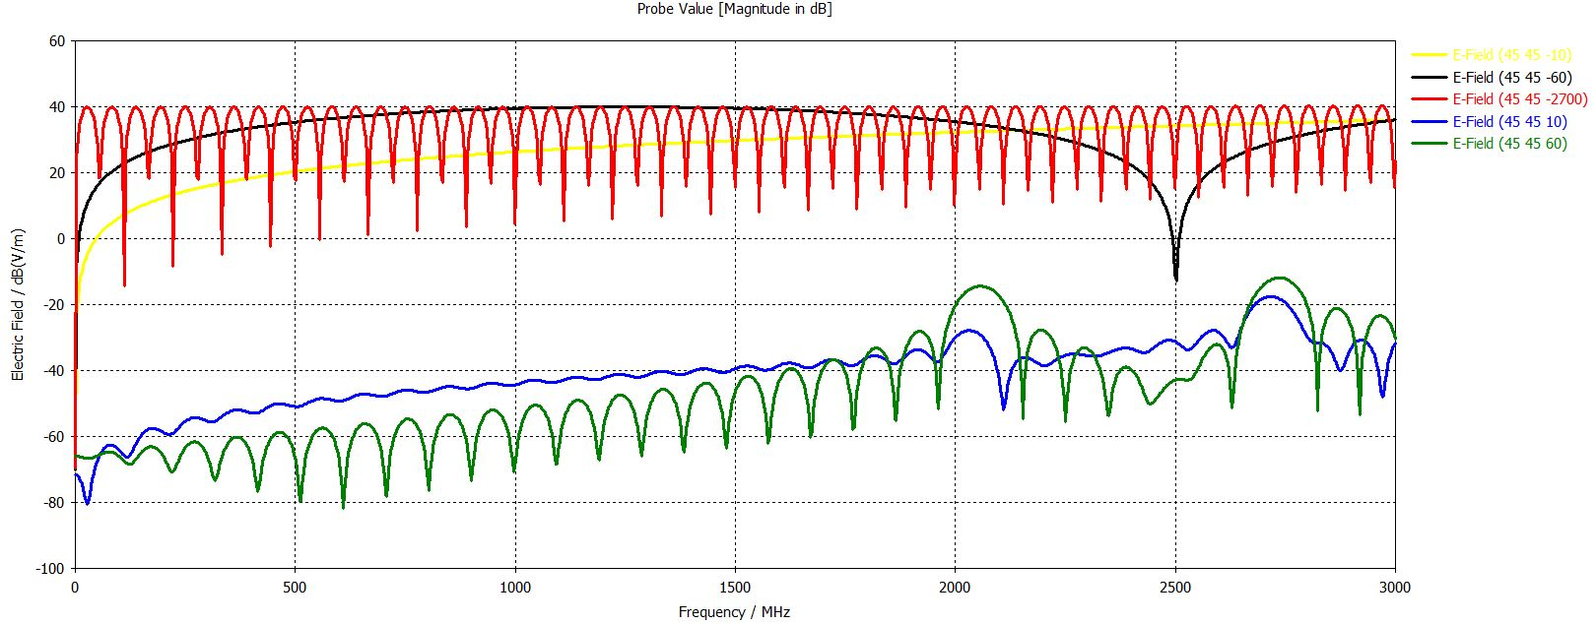
Fig. 49. Electric Field detected by Probes in Center of Shielding Enclosure (HCLPSO).
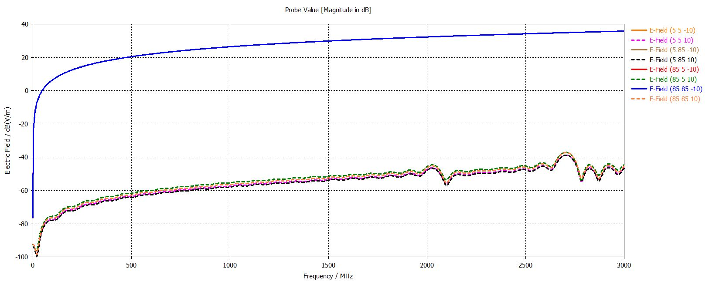
Fig. 50. Electric Field detected by Probes in Edges of Shielding Enclosure (HCLPSO).

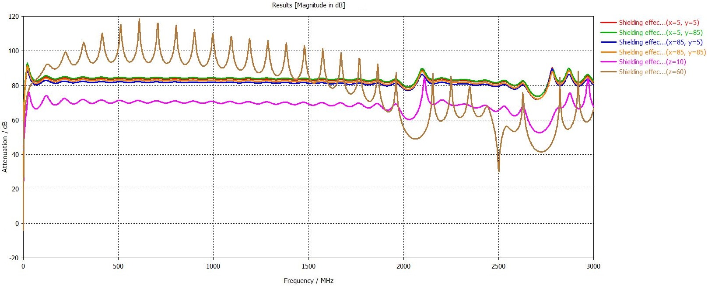
Fig. 51. Shielding Effectiveness of Box Designed by HCLPSO.
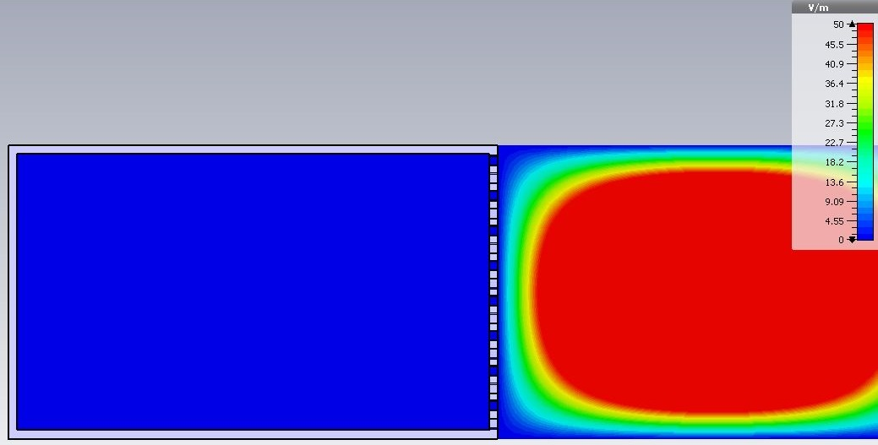
Fig. 52. Electric Field Scattering Inside of Shielding Enclosure in Frequency of 2000 MHz (HCLPSO).

EXPERIMENT
The experiment applies knowledge described in previous chapters and integrates them into the final solution. The base of the final shielding enclosure is especially evolutionary algorithms results which indicated, in case of Firefly algorithm, perfect attenuation with satisfactory visibility. Because the shielding effectiveness of the box frontside was experienced before, this chapter focuses on the backside. It means, the part of the enclosure through which the cabling leads. The proposal is based on the findings published in [7], which introduces the term "pigtail", a mechanically modified outlet with a certain length. This way is also applied in measuring equipment such as GTEM or anechoic chambers thus the facilities with high performance and strict requirements on the shielding effectiveness. The second option is using of grommet, thus a mechanical component designed for specific cable diameters and intended for the electromagnetic protection of passing cables. However, in the author opinion, the first variant is more suitable for this task due to more straightforward implementation.
The design assumes a maximum of four cables passing through the back of the housing, it means, the cover is also adapted for analogue cameras use, which typically contain more outputs than the currently popular IP cameras. Devices for which the shielding enclosure is designed are security cameras in a classical tubular design.
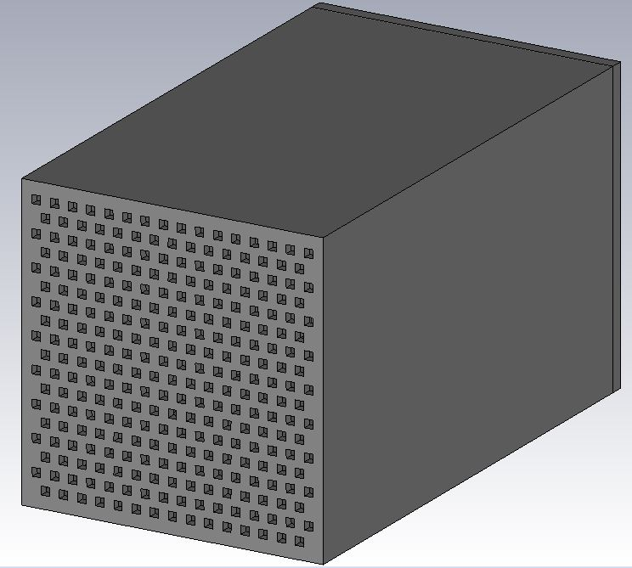
Fig. 53. Front sides of Designed Shielding Box.
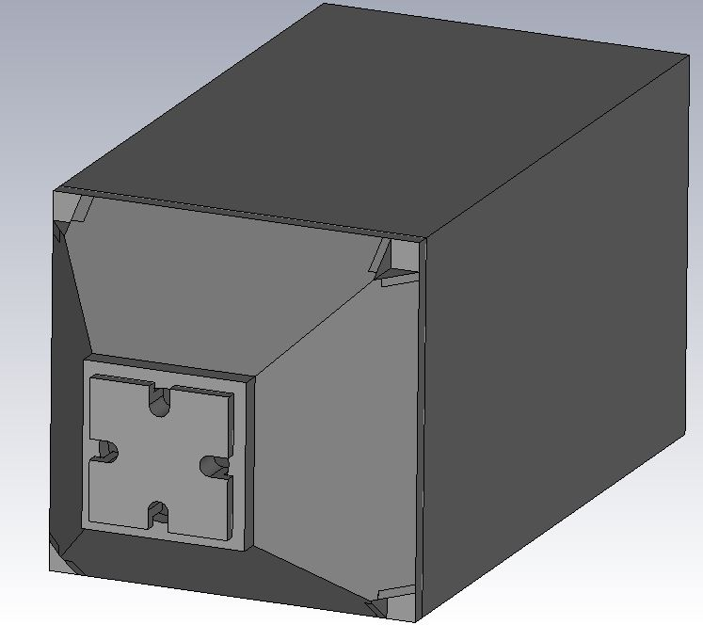
Fig. 54. Pigtail of Designed Shielding Enclosure.
Shielding enclosure backside includes a circular hole with the diameter of 32 mm which is filled with a specially designed plug allowing to connect the cables into the box and provide sufficient shielding effectiveness. The cap consists of the four five-millimeter apertures adapted for conventional cabling applied in security cameras. As Fig. 54 illustrates the plug forehead constitutes a square sheet to protect the free places around the central circular hole.
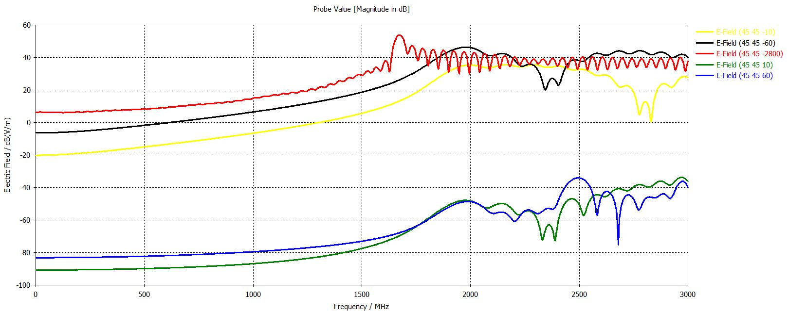
Fig. 55. Electric Field detected by Probes in Center of Pigtail Shield.
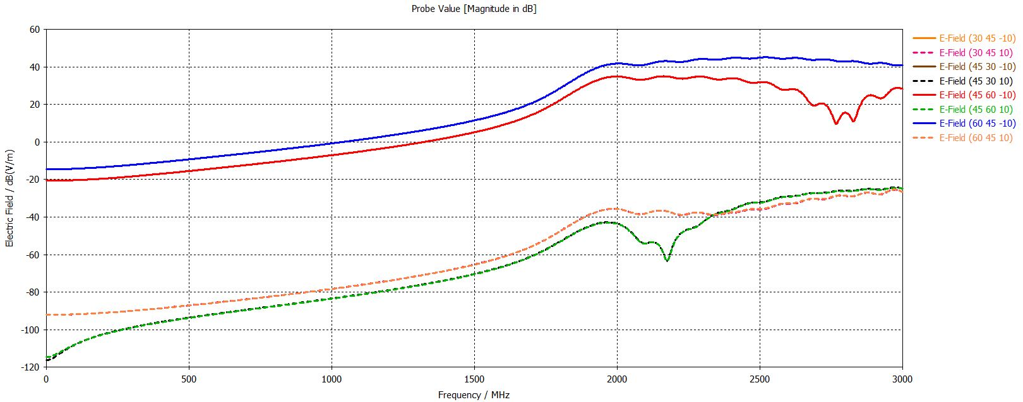
Fig. 56. Electric Field detected by Probes in Edges of Pigtail Shield.
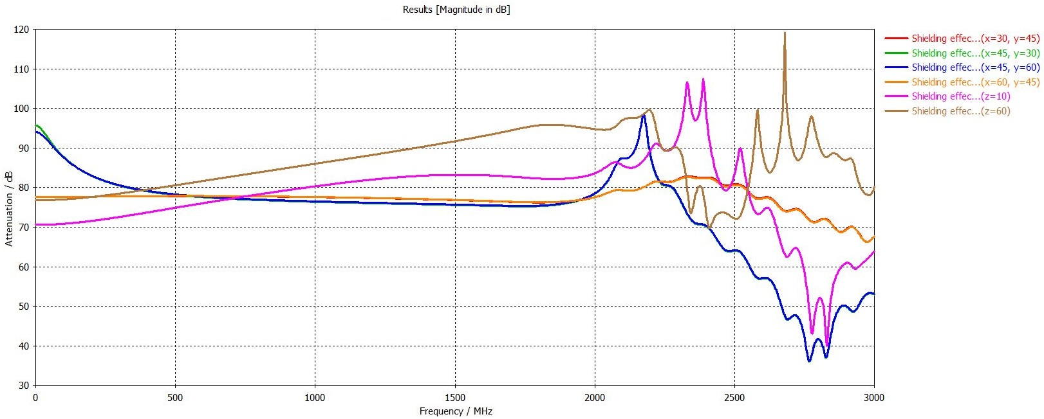
Fig. 57. Shielding Effectiveness of Designed Enclosure in Pigtail Part.
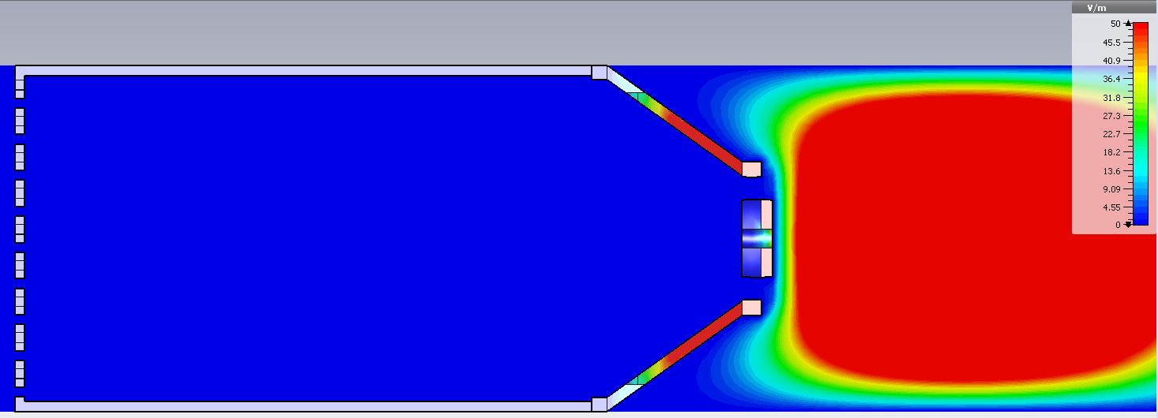
Fig. 58. Electric Field Scattering around Pigtail Shield Frequency of 2000 MHz.
Electric field probes locations are nearby the cables apertures which represent free places thus potential vulnerability of the proposal. The two probes are placed in the center of the central hole to determine the overall enclosure shielding effectiveness. The results indicate that the design can protect device inside with an attenuation of approximately 80 dB. The shielding effectiveness is various in higher frequencies due to the different input waveforms according to which the shielding effectiveness is calculated. This output also confirms the electric field scattering as Fig. 58 shows. The wiring holes represent sensitive parts of the structure as could be expected; however, increasing their resistance can be achieved by using shielded cables.

EXPERIMENTS AND RESULTS
This section describes the experiment regarding the comparison of measurement results and simulation. The product designed by the evolutionary algorithms in the previous chapter was challenging to create due to the financial costs of the prototype and sophisticated production technologies. Therefore, the author decides to design a simple alternative solution with the commercially available products which are more suitable for future work. The metal grid and perforated sheet metal were formed into a shielding cover suitable for wide-angle cameras.
The experiment consists of two-part; the first one includes simulation when the boxes were inserted into the GTEM chamber model, and their shielding effectiveness was calculated. The second part involves the practical measurement in the laboratory and the comparison with the simulation. The practical part of the experiment includes two cameras (KPC S230CWX and Vivotek FD8136B F3). The first step was a test of electromagnetic immunity of the cameras. In the case of the analog camera, the quality of the video immediately dropped in the presence of an electric field, as the following figures show. IP camera was more resistant to electromagnetic fields, and the identification of interference was complicated. However, more detailed observations and tests have led to the assumption that visible image distortion is eliminated by the image compression that most cameras have. This assumption has not yet been verified, due to the complexity of the problem; therefore, it remains the subject of future research in the field. The author would like to reiterate that so far, this is only a hypothesis. The author presented verified signs of IP camera problems in the presence of an electromagnetic field in the publication [44]. Testing took place in a semi-anechoic chamber and resulted in relatively high-intensity acoustic signals in specific frequency bands (489.2 - 800 MHz).
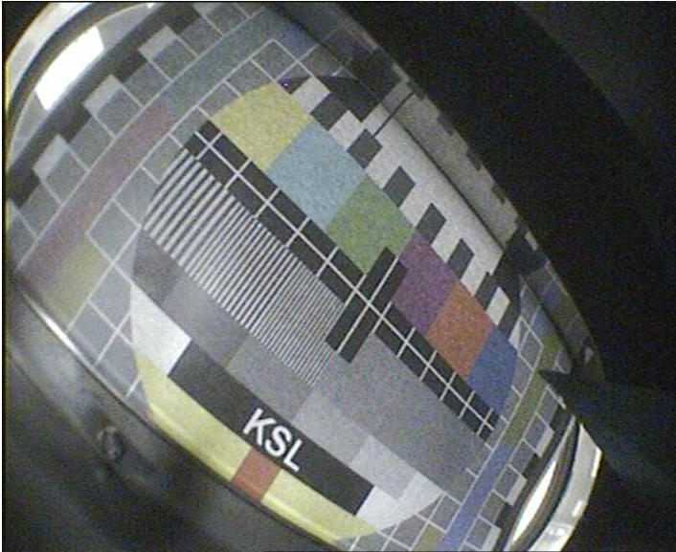
Fig. 59. Camera Streaming in the GTEM Chamber with a Level of 0 V/m.
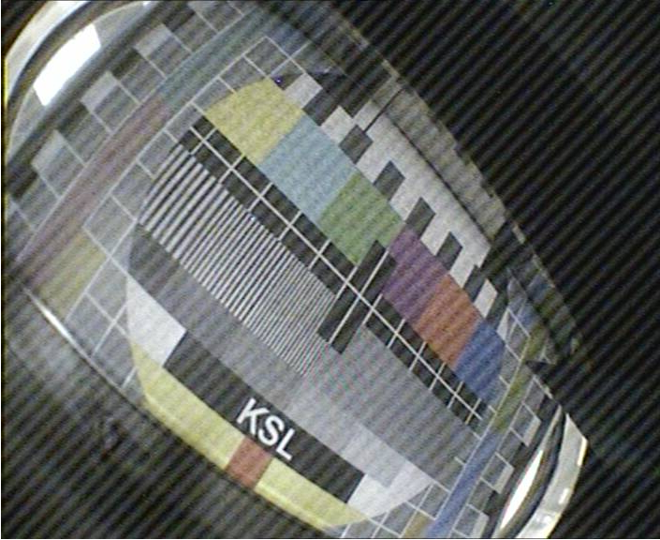
Fig. 60. Camera Streaming in the GTEM Chamber with a Level of 10 V/m.
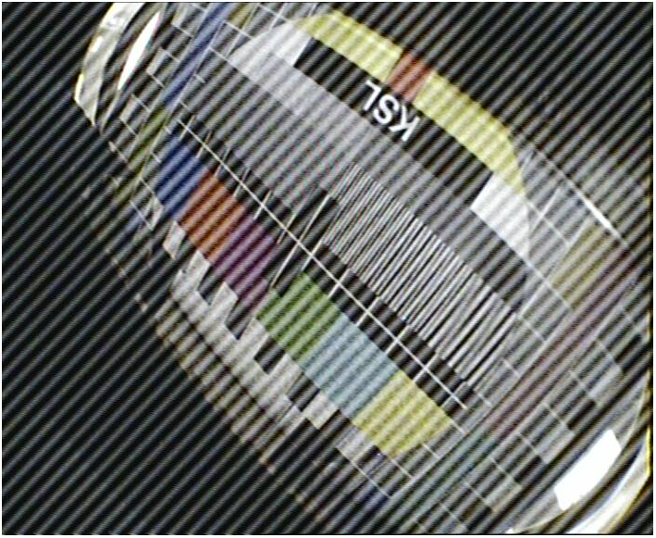
Fig. 61. Camera Streaming in the GTEM Chamber with a Level of 30 V/m.
The shielding boxes were created for small security cameras and because of the narrow inlet opening of the GTEM chamber. The covers are made of stainless steel, which increases the corrosion resistance, but unfortunately reduces the shielding effects.
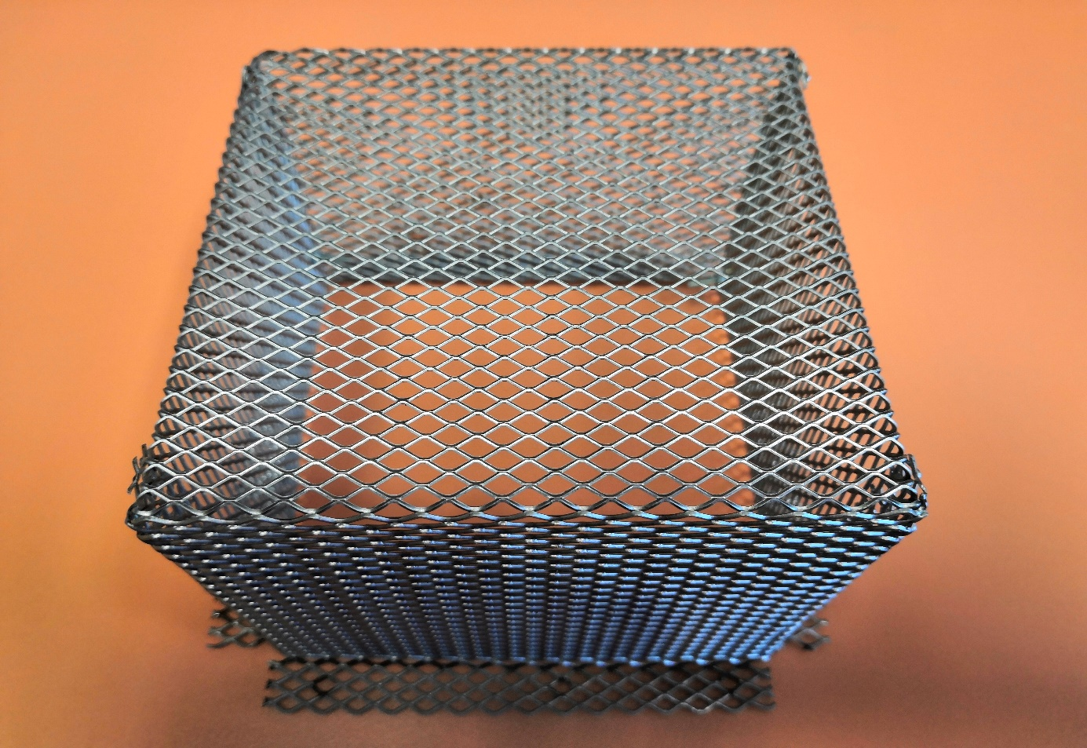
Fig. 62. Designed Shielding Enclosure Variant A for Security Cameras.
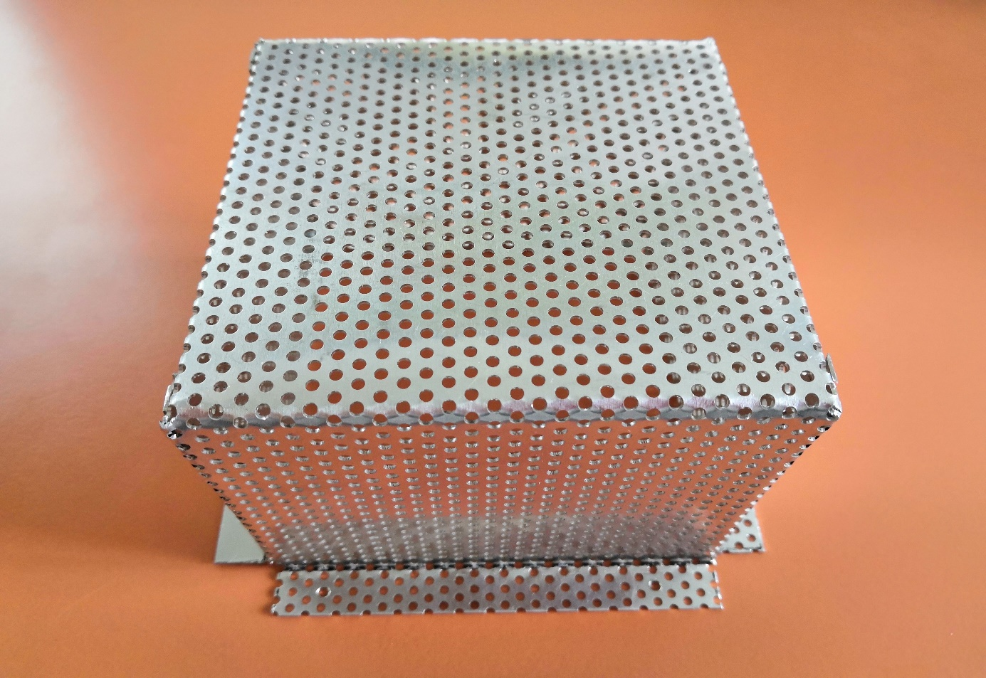
Fig. 63. Designed Shielding Enclosure Variant B for Security Cameras.

Experiment – GTEM Chamber
The parameters of both shields describe Tab. 7 and Tab. 8.
Tab. 7. Parameters of Shielding Enclosure A.
Parameter | Unit [mm]
Box width | 92
Box height | 70
Box base width | 112
Box base thickness | 0.1
Diameter | 0.2
Mesh size (side) | 0.3
Diagonal of mesh | 0.5

Tab. 8. Parameters of Shielding Enclosure B.
Parameter | Unit [mm]
Box width | 92
Box height | 70
Box base width | 112
Box base thickness | 0.1
Mesh diameter | 0.2
Horizontal gap between meshes | 6.5
Vertical gap between meshes | 3
Shift between even and odd lines | 3

The experiment consists of the comparison of simulation and real measurement. It includes creating the GTEM chamber model, which is as close as possible to the actual cell. The location of probe and the EUT were similar; therefore, there are differences between results for the reasons described in the Results section.
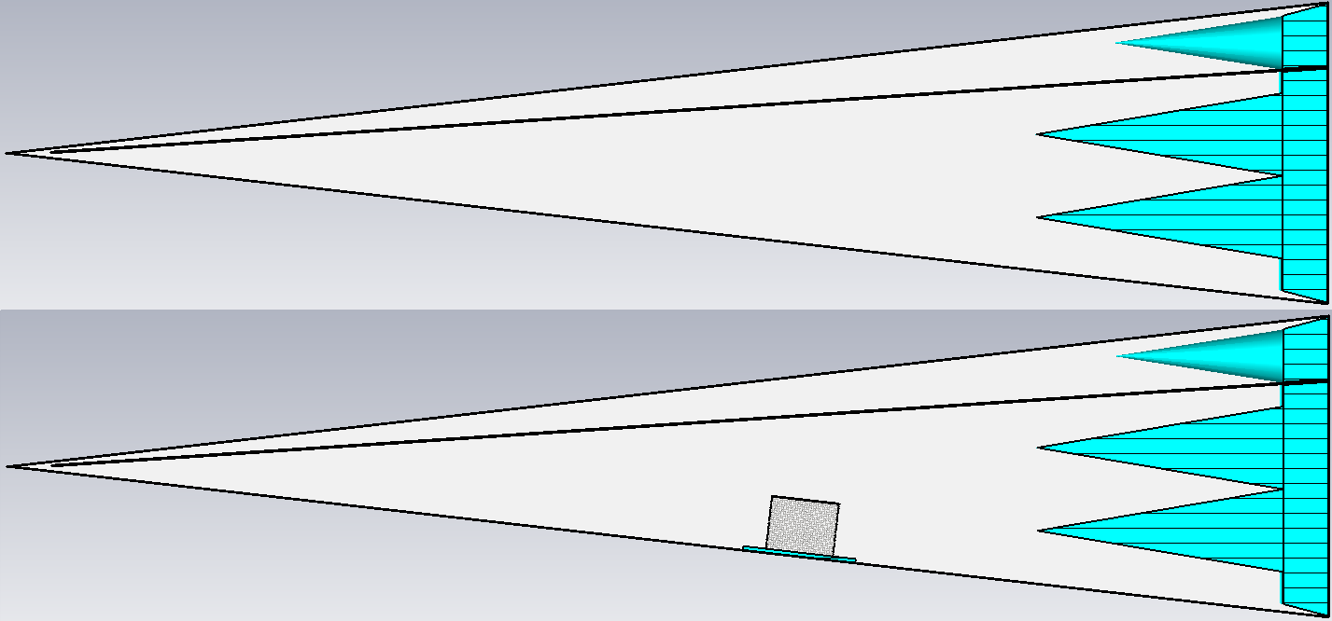
Fig. 64. Model of GTEM Chamber in CST Studio – without/with Shielding Box.

Measuring equipment
- GTEM chamber – EMC-GTEM-250
- Probe - Frankonia EFS-10
- Signal generator - Rohde & Schwarz SMB 100A (100 kHz - 40 GHz)
- Relay Switching Unit - Frankonia FR-RSU
- Amplifiers - Frankonia RF-power amplifier (20 MHz - 1 GHz, 0.8 GHz - 2 GHz, 2 GHz - 6 GHz)

Results – GTEM Chamber
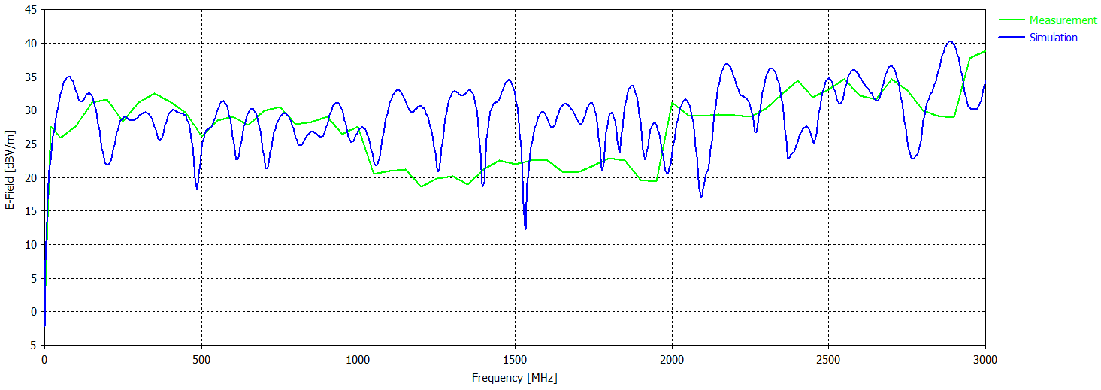
Fig. 65. Comparison of Simulation and Measurement.
The results of the electric field in Fig. 65 indicate the differences; it is because of the measurement devices and the technique used. The first trouble is the feedback of the probe, which provides data with a high degree of uncertainty. The second problem is the amplifier in the frequency range of 0.8 GHz to 2 GHz, which does not provide sufficient input signal amplification as can be seen in Fig. 65. The problem could also be imperfect of the GTEM chamber model, which had to be simplified due to computational complexity. The last limitation is the probe location, which can be a little bit different. The expected difference is approximately 1 cm.
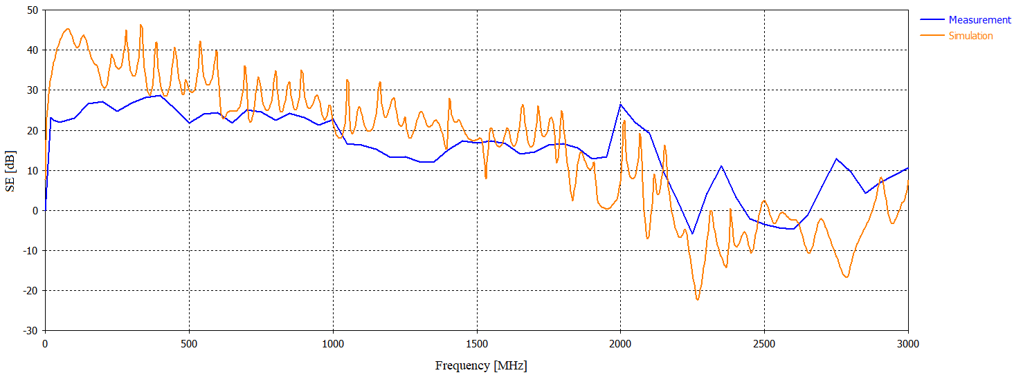
Fig. 66. Shielding Effectiveness Comparison of Measurement and Simulation – Shielding enclosure A.
Fig. 66 illustrates the shielding effectiveness of box A. The results show that the box reaches satisfactory shielding properties at lower frequencies, especially up to 1 GHz, but poor values at higher frequencies. However, there is necessary to consider the limitation mentioned before. The benefit of this variant is almost perfect transparency, unfortunately, at the expense of shielding effectiveness.
The shielding box B reaches similar values as the variant A although the transparency of the cover is considerably worse. The differences in the simulation and measurement are caused by both the limits of the measuring technique and the different sizes of the probe. It is because CST Studio has integrated custom probes that are suitable for similar types of tasks. There is also a slit effect from 2 GHz, and at higher frequencies, there is a periodic decrease and increase in shielding efficiency. A similar event occurred in variant A. Fig. 68 illustrates the shielding effectiveness of both boxes whose significant difference arises at the frequency of 2349.8 MHz. The measurement uncertainty is approximately 0.3 V/m for frequencies up to 1 GHz, 0.1 V/m for frequencies 1 GHz to 2 GHz, and 0.35 V/m for frequencies higher than 2 GHz.
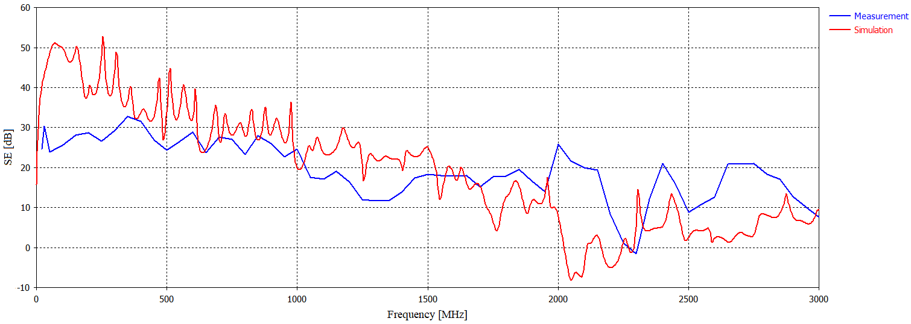
Fig. 67. Shielding Effectiveness Comparison of Measurement and Simulation – Shielding enclosure B.
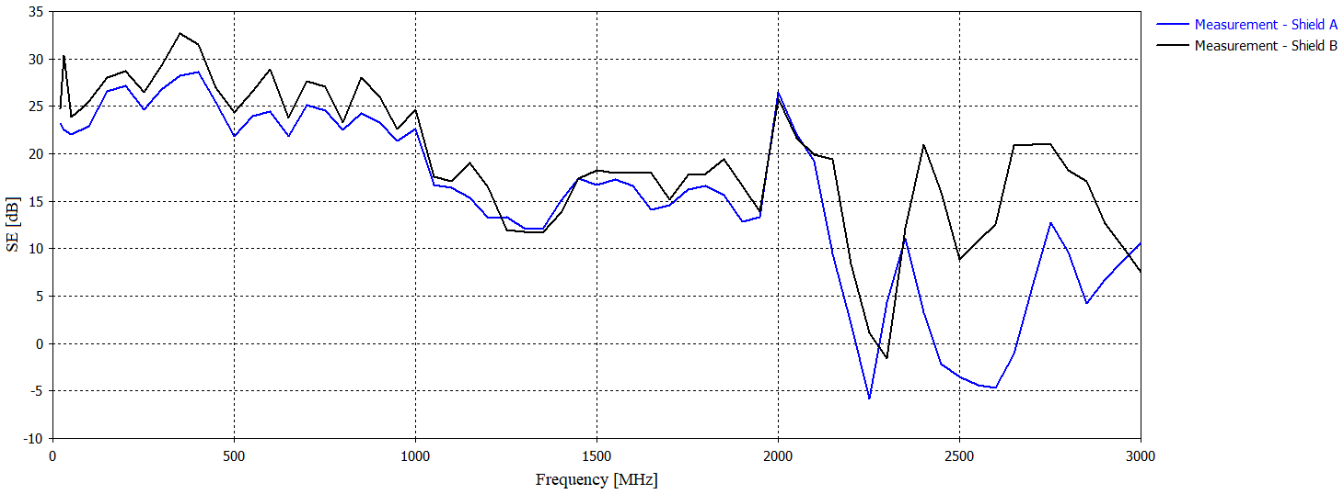
Fig. 68. Comparison of Designed Shields Shielding Effectiveness.
The solution to increasing the durability of the designed enclosures can be a combination with transparent shielding materials, which are usually not highly effective but are suitable for this purpose. The disadvantage of this improvement may be the reduction of transparency and the creation of reflections between different environments, which can also degrade efficiency. Copper grid PET film (transparent) and transparent shielding foil appear to be suitable candidates. The mesh film is based on the PET (polyethylene terephthalate) involves a fine copper mesh protected with a nickel layer. The grid thickness is in the order of microns, which makes it almost invisible. The film includes low resistance to ensure high-frequency EMI shielding. The shielding foil represents another solution for display protection. The foil consists of the polyester film and a transparent conductive coating providing perfect visibility.
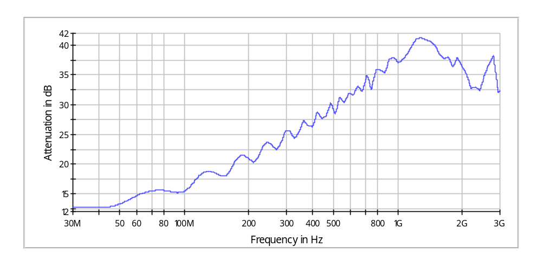
Fig. 69. Shielding Effectiveness of Copper Grid PET Film.
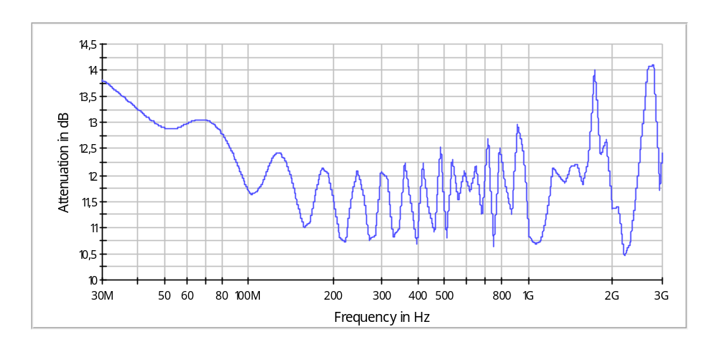
Fig. 70. Shielding Effectiveness of Transparent Shielding Foil.
The last solution is to reduce the transparent parts, for example, by merging the side parts of the cover, which will increase the durability of the cover.

Experiment - Coaxial Line
The second sub-experiment describes the search for a threshold where significant changes occur when the mesh of the shielding grid is disturbed. This topic has already been mentioned in the chapters on the current state and introduction of the experimental part. However, in these cases, mesh quantity on the quality of shielding. This experiment should be based on shielding A, which appears to be better solution. Cover B is similar to the issue mentioned above, and using measuring techniques; it would be more challenging to identify minor changes. A coaxial line terminated with two conductors and a vector analyzer was used for practical measurements. The material was inserted between the conductors, and contact was prevented by a thin sheet of insulating material. Subsequently, minor changes in the structure of the grid, which may occur during the installation of the cover or its use, were tested. The changes in the structure corresponded to those made in the simulation environment. The GTEM chamber model could not be used for this experiment because identification of the changes would be impossible. Hence, a new coaxial line model had to be made, and the results that were the basis for optimization were compared.
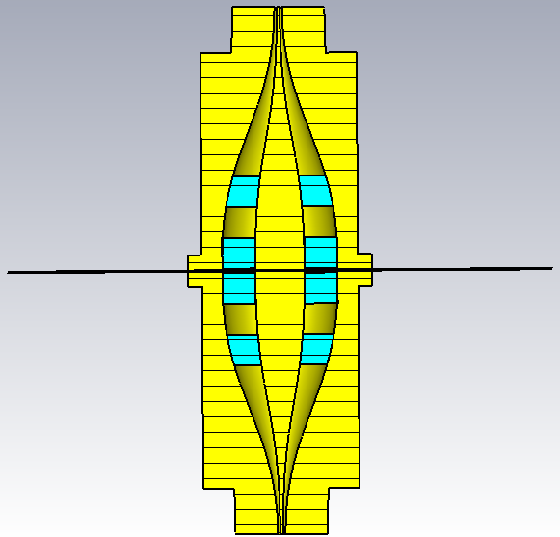
Fig. 71. Model of Coaxial Line with the Sample.

Measuring equipment
- Rohde & Schwarz ZND Vector network analyzers (100 kHz–4.5 GHz)
- Conductors
- RF cables

Results – Coaxial Line
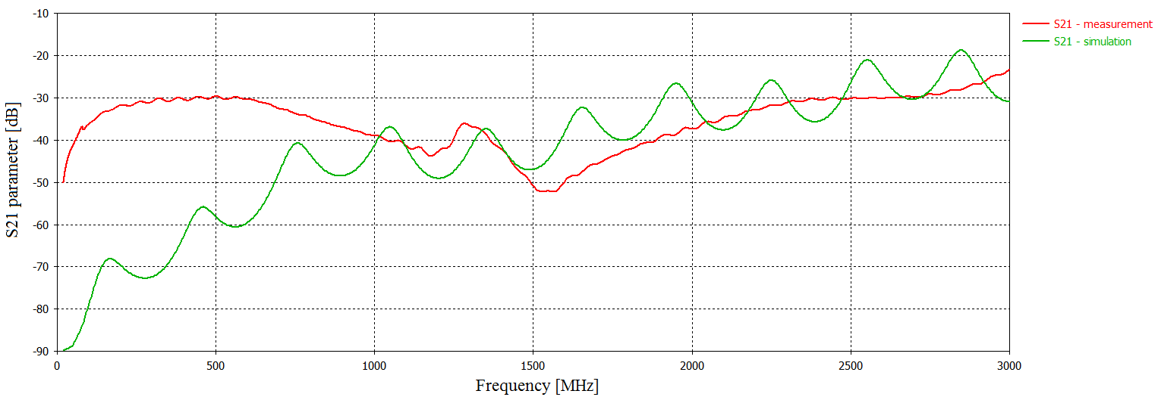
Fig. 72. Comparison of simulation and measurement with Coaxial Line.
The differences caused at lower frequencies are due to coaxial lines, which are designed for operating frequencies above 700 MHz. Differences at higher frequencies can be caused by deviations of technical parameters in simulations from actual values. The expected deviation will be a brass conductor, which has oxidized slightly over the years and was difficult to imitate its current composition.
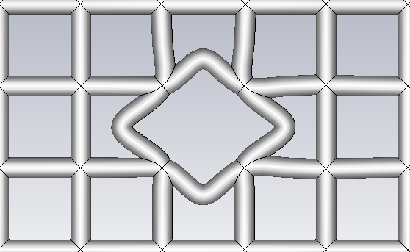
Fig. 73. Illustrative Example of the Grid Disruption in the x-axis and y-axis.
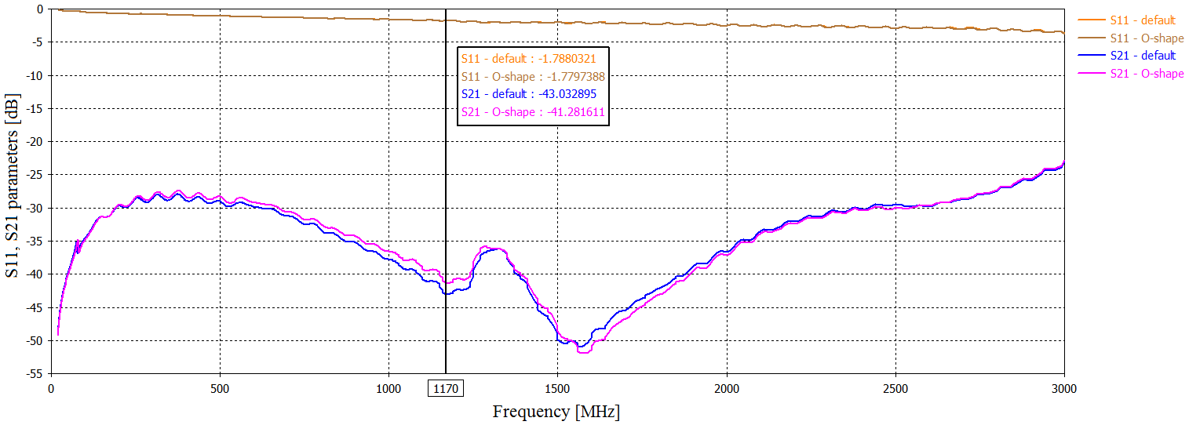
Fig. 74. Measured S11 and S21 Parameters for Maximal Grid Disruption.
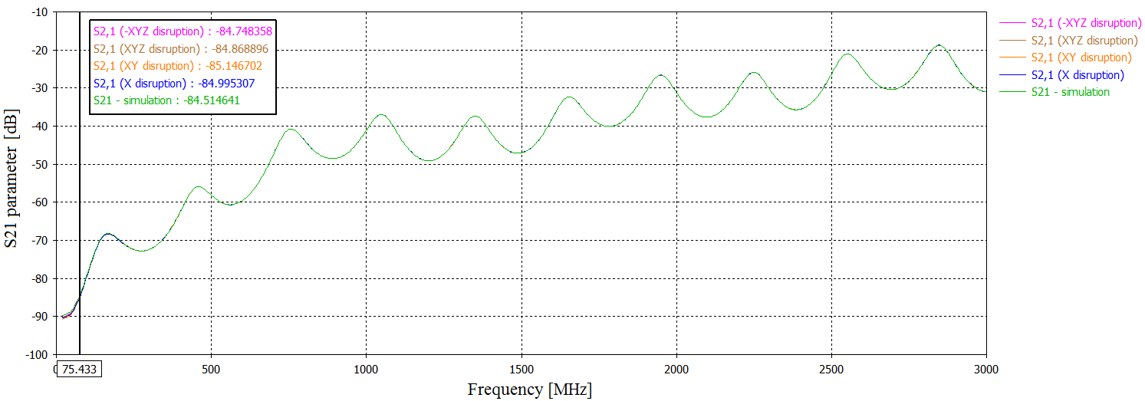
Fig. 75. Simulated S21 parameter for Different Grid Disruptions.
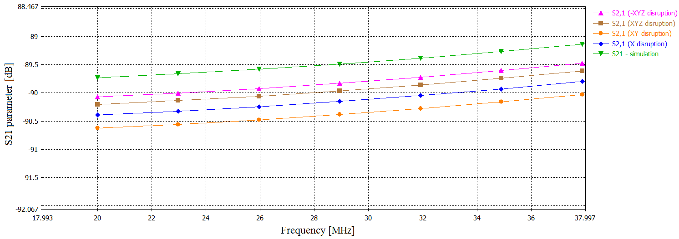
Fig. 76. Detail of Simulated S21 parameter for Different Grid Disruptions
The experiment revealed that structural failure of the shielding grid would cause a negligible decrease in shielding efficiency. Adjusting the mesh size of the original material was complicated, and minor changes were difficult to make. The material was often destroyed. The maximum change to "O" shape in the x, y, and z axes was approximately 3 mm. The simulations did not suffer from the problem of material destruction, and the change of parameters was more straightforward; the limiting factor was the contact of the eye with the adjacent wall of the eye, as shown in Fig. 73. The results show the expected findings; no slight change in the structure of the grid will cause a noticeable decrease in shielding. Concerning earlier chapters, a reduction in effectiveness can be expected with a more significant number of holes; however, the experiment revealed that even more holes have no considerable effect.

CONTRIBUTION OF WORK TO SCIENCE AND PRACTICE
Security cameras represent one of the crucial factors of physical security, and their reliability has a significant impact on maintaining safety. However, the technology developments have resulted in an increase in electromagnetic interference in recent years, which is why the demand for ensuring the reliability of equipment has increased. Therefore, this work focuses on potential ways to improve the EM immunity of cameras, which in some cases may suffer from electromagnetic interference, especially in industrial areas.
The benefit of this thesis lies in evolutionary algorithms application into design development. The algorithms using in the field of shielding is a new matter, which was confirmed by a survey of the current state. The limitation lies in the fact that the outputs can be complex to manufacture, so the scales must be set correctly, eventual what the user needs (transparency, shielding). Input parameters can be adjusted if necessary. However, this innovative approach led to submit an international project regarding the application of evolutionary algorithms to 3D antenna design.
Other advantages of this work are more of a theoretical nature; it is the design of measuring technology in a simulation environment and comparison with reality. In particular, the comparison of the GTEM chamber model with the real one is still a relatively unique matter. Knowledge about the number or size of holes or the effect of faults in the shielding grids can also expand current knowledge in the field of shielding. Currently, there are few publications on electromagnetic shielding of cameras, and this work could help as a basis for future work.

CONCLUSION
This thesis aims at the way how to improve electromagnetic immunity of security cameras. The work is divided into several parts deal with theoretical background, current state, experiment, and finally, results.
The current state discusses the security cameras regarding electromagnetic compatibility. Unfortunately, not many papers are devoted to this topic, although it is an interesting problem from both a scientific and an industrial point of view. Unlike other devices, cameras are exciting products because the creation of a shielding is not fully possible due to the optical path of the lens and sensors. Currently, many materials provide relatively high transparency and, at the same time, acceptable shielding effectiveness. However, these materials often bring a lot of limits in terms of price or lower efficiency. A more efficient solution is offered by classic metallic materials, which unfortunately do not provide the required transparency. The answer can be metal grids, which are a useful compromise and, at the same time, the output of the practical part of this work.
The experimental part begins with the application of evolutionary algorithms to the design of the shielding grid. Based on the input parameters, the algorithm seeks the optimal solution. There are several different algorithms with different successes. The limit of the resulting designs was the complicated production of test prototypes, so for further research, commercially available materials were used, which were used for the creation of new shielding covers. These covers were modeled using the simulation software CST Microwave Studio, and then the results of simulations and practical measurements were compared.
The conclusion of the work is devoted to testing the shielding grid disruption and finding the threshold, after which there is a significant decrease in shielding properties. This experiment was performed in a simulation environment and real laboratory conditions with the help of coaxial lines.
This thesis offers new knowledge in the field of shielding and solutions to increase the resistance of security cameras, which, as confirmed by this work, can be sensitive to electromagnetic fields.

REFERENCES
[1] LIN, James C. Radio-frequency radiation safety and health: Are radio-frequency or mobile-phone electromagnetic fields possibly carcinogenic to humans. URSI Radio Science Bulletin. March 2012, vol. 340, pp.53-54. DOI:10.23919/URSIRSB.2012.7910172.
[2] IEEE Standard for Military Workplaces-Force Health Protection Regarding Personnel Exposure to Electric, Magnetic, and Electromagnetic Fields, 0 Hz to 300 GHz. IEEE Std C95.1-2345-2014. May 2014, pp.1-69. DOI: 10.1109/IEEESTD.2014.6820718.
[3] POPESCU, Mircea, BINDAR, Valerica, CRACIUNESCU, Razvan and Octavian FRATU. Estimate of minimum attenuation level for a TEMPEST shielded enclosure. 2016 International Conference on Communications (COMM) [online]. Bucharest. June 2016, pp. 513-518. ISBN 978-1-4673-8197-0. DOI:10.1109/ICComm.2016.7528278. Available from: http://ieeexplore.ieee.org/document/7528278/
[4] JIEMIN, Zhang and LI YONGMEI. The study of the standards architecture and the standards attributes based on EMC standards and TEMPEST standards in computer system. 8th International Conference on Computer Science & Education [online]. April 2013, pp. 224-227 [viewed 2018-01-08]. DOI: 10.1109/ICCSE.2013.6553914. ISBN 978-1-4673-4463-0. Available from: http://ieeexplore.ieee.org/lpdocs/epic03/wrapper.htm?arnumber=6553914
[5] SVAČINA, Jiří. Electromagnetic compatibility: principles and notes. Brno: VUT v Brně, 2001. ISBN 9788021418738. (in Czech)
[6] KOVÁŘ, Stanislav. Immunity of camera systems against electromagnetic interference. Treatise on doctoral thesis. Zlín, 2017. Faculty of applied informatics in Zlín.
[7] CLAYTON, Paul R. Introduction to electromagnetic compatibility. 2nd ed. Hoboken, New Jersey: Wiley-Interscience, 2006. ISBN 9780471758143.
[8] CSN EN 61000-4-3 Electromagnetic compatibility. Part 4-3: Testing and measurement techniques - Radiated, radio-frequency, electromagnetic field immunity test. Prague: The Czech Office of Standards, Metrology and Testing, 2006. pp. 52.
[9] NAGY, Michal. Hardening Security Camera Construction Against Electromagnetic Interference. Zlín, 2013. Diploma thesis. Tomas Bata University. Supervisor: Ing. Petr Skočík.
[10] MAININI, Kevin. Reducing Radio Frequency Susceptibilities in Commercial-Off-the-Shelf Camera Equipment for use in Electromagnetic Compatibility Testing [online]. Johnson City, 2015 [viewed 2017-12-10]. Electronic Theses and Dissertations. East Tennessee State University. Available from: https://dc.etsu.edu/cgi/viewcontent.cgi?article=3858&context=etd
[11] SAINI, Parveen and Manju ARORA. Microwave Absorption and EMI Shielding Behavior of Nanocomposites Based on Intrinsically Conducting Polymers, Graphene and Carbon Nanotubes. DE SOUZA GOMES, Ailton, ed. New Polymers for Special Applications [online]. InTech, 2012, 2012-09-12 [viewed 2017-12-29]. DOI: 10.5772/48779. ISBN 978-953-51-0744-6. Available from: http://www.intechopen.com/books/new-polymers-for-special-applications/microwave-absorption-and-emi-shielding-behavior-of-nanocomposites-based-on-intrinsically-conducting-
[12] MODAK, Prerana, Subhash B. KONDAWAR and D.V. NANDANWAR. Synthesis and Characterization of Conducting Polyaniline/Graphene Nanocomposites for Electromagnetic Interference Shielding. Procedia Materials Science [online]. 2015, 10, 588-594 [viewed 2017-12-29]. ISSN 22118128. DOI: 10.1016/j.mspro.2015.06.010. Available from: http://linkinghub.elsevier.com/retrieve/pii/S2211812815002485
[13] NHAN, Hoang Ngoc, Miane JEAN-LOUIS and Wojkiewicz JEAN-LUC. Modeling of Electromagnetic Shielding Effectiveness of Multilayer Conducting Composites in the Microwave Band. In: 2006 First International Conference on Communications and Electronics [online]. IEEE, 2006, 2006, s. 482-485 [viewed 2018-01-30]. DOI: 10.1109/CCE.2006.350874. ISBN 1-4244-0568-8. Available from: http://ieeexplore.ieee.org/document/4156525/
[14] FENICAL, Gary. The Basic Principles of Shielding. In Compliance Magazine [online]. March 2014 [viewed 2018-01-09]. Available from: https://incompliancemag.com/article/the-basic-principles-of-shielding/
[15] LIANG, Ranran, Wenjuan CHENG, Hong XIAO, Meiwu SHI, Zhanghong TANG and Ni WANG. A calculating method for the electromagnetic shielding effectiveness of metal fiber blended fabric. Textile Research Journal [online]. February 2017 [viewed 2018-01-09]. DOI: 10.1177/0040517517693980. ISSN 0040-5175. Available from: http://journals.sagepub.com/doi/10.1177/0040517517693980
[16] PARKER, S. L., I. D. FLINTOFT, A. C. MARVIN, et al. Predicting shielding effectiveness of populated enclosures using absorption cross section of PCBs. In: 2016 International Symposium on Electromagnetic Compatibility - EMC EUROPE [online]. IEEE, September 2016, pp. 324-328 [viewed 2018-01-09]. DOI: 10.1109/EMCEurope.2016.7739305. ISBN 978-1-5090-1416-3. Available from: http://ieeexplore.ieee.org/document/7739305/
[17] SARTO, Maria Sabrina, Sandra GRECO and Alessio TAMBURRANO. Shielding Effectiveness of Protective Metallic Wire Meshes: EM Modeling and Validation. IEEE Transactions on Electromagnetic Compatibility [online]. June 2014, 56(3), 615-621 [viewed 2018-01-09]. DOI: 10.1109/TEMC.2013.2292715. ISSN 0018-9375. Available from: http://ieeexplore.ieee.org/document/6710176/
[18] CSN EN 61000-2-4 Electromagnetic compatibility - Part 2: Environment - Section 4: Compatibility levels in industrial plants for low-frequency conducted disturbances. Prague: The Czech Office of Standards, 2009, pp. 76.
[19] CSN EN 55011. Industrial, scientific and medical equipment – Radio-frequency disturbance characteristics – Limits and methods of measurement. Prague: The Czech Office of Standards, Metrology and Testing, 2010, pp. 52.
[20] PAVLÍK, Marek, Iraida KOLCUNOVÁ and Lukáš LISOŇ. Measuring of the shielding effectiveness of electromagnetic field of brick wall in the frequency range from 1 GHz to 9 GHz. Proceedings of the 2014 15th International Scientific Conference on Electric Power Engineering [online]. May 2014, pp. 261-265. DOI: 10.1109/EPE.2014.6839488
[21] ZBROJOVSKÝ, Ján and Marek PAVLÍK. Measuring and simulation of the shielding effectiveness of electromagnetic field of brick wall in the frequency range from 0.9 GHz to 5 GHz. 18th International Scientific Conference on Electric Power Engineering [online]. May 2017, pp. 1-4. DOI: 10.1109/EPE.2017.7967307
[22] PAVLÍK, Marek, Iraida KOLCUNOVÁ and Lukáš LISOŇ. Measuring the shielding effectiveness and reflection of electromagnetic field of building material. 16th International Scientific Conference on Electric Power Engineering [online]. May 2015, pp. 56-59. DOI: 10.1109/EPE.2015.7161186
[23] CSN EN 61000-4-4 Electromagnetic compatibility. Part 4-4: Testing and measurement techniques – Electrical fast transient/burst immunity test. Prague: The Czech Office of Standards, Metrology and Testing, 2013. pp. 44.
[24] MIL-STD-461G: Requirements for the control of electromagnetic interference characteristics of subsystems and equipment. Virginia: U.S. Department of Defense, 2015.
[25] MIL-HDBK-235-1C: Military operational electromagnetic environment profiles. Virginia: U.S. Department of Defense, 2010.
[26] MIL-STD-464C: Electromagnetic environmental effects requirements for systems. Virginia: U.S. Department of Defense, 2010.
[27] EWING, Paul D. et al. Electromagnetic compatibility testing for conducted susceptibility along interconnecting signal lines [online].Washington, DC: Division of Engineering Technology, Office of Nuclear Regulatory Research, U.S. Nuclear Regulatory Commission, 2002.
[28] GERKE, Daryl and Bill KIMMEL. Military Shielding. In Compliance Magazine [online]. February 2013 [viewed 2018-01-09]. Available from: https://incompliancemag.com/article/military-shielding/
[29] FENICAL, Gary. A Primer on Automotive EMC for Non-EMC Engineers. In Compliance Magazine [online]. March 2014 [viewed 2018-01-09]. Available from: https://incompliancemag.com/article/a-primer-on-automotive-emc-for-non-emc-engineers/
[30] WANG, Yangyong and Xinli JING. Intrinsically conducting polymers for electromagnetic interference shielding. Polymers for Advanced Technologies [online]. 2005, 16(4), 344-351 [viewed 2017-12-29]. DOI: 10.1002/pat.589. ISSN 1042-7147. Available from: http://doi.wiley.com/10.1002/pat.589
[31] O'CONNOR, Ashleigh. Spray Coating to Shield Electromagnetic Interference. In Compliance Magazine [online]. September 2016 [viewed 2018-01-09]. Available from: https://incompliancemag.com/spray-coating-to-shield-electromagnetic-interference/
[32] XU, Sixing, Wei LIU, Xia LIU, Xuanlin KUANG and Xiaohong WANG. A MXene based all-solid-state microsupercapacitor with 3D interdigital electrode. In: 2017 19th International Conference on Solid-State Sensors, Actuators and Microsystems (TRANSDUCERS) [online]. IEEE, 2017, 2017, s. 706-709 [viewed 2018-01-24]. DOI: 10.1109/TRANSDUCERS.2017.7994146. ISBN 978-1-5386-2732-7. Available from: http://ieeexplore.ieee.org/document/7994146/
[33] IEEE Standard Method for Measuring the Shielding Effectiveness of Enclosures and Boxes Having all Dimensions between 0.1 m and 2 m. IEEE Std 299.1-2013. January 2014, pp.1-96. DOI: 10.1109/IEEESTD.2014.6712029
[34] FENG, Chao and Zhongxiang SHEN. A Hybrid FD–MoM Technique for Predicting Shielding Effectiveness of Metallic Enclosures With Apertures. IEEE Transactions on Electromagnetic Compatibility [online]. October 2005, 47(3), 456-462 [viewed 2018-01-09]. DOI: 10.1109/TEMC.2005.851726. ISSN 0018-9375. Available from: http://ieeexplore.ieee.org/document/1516216/
[35] YAN, Jiexiong, John DAWSON and Andy MARVIN. Effect of power state on absorption cross section of personal computer components: Applications to enclosure shielding. In: 2017 International Symposium on Electromagnetic Compatibility - EMC EUROPE [online]. IEEE, 2017, 2017, s. 1-5 [viewed 2018-01-24]. DOI: 10.1109/EMCEurope.2017.8094782. ISBN 978-1-5386-0689-6. Available from: http://ieeexplore.ieee.org/document/8094782/
[36] RENGARAJAN, S.R. and Y. RAHMAT-SAMII. The field equivalence principle: illustration of the establishment of the non-intuitive null fields. IEEE Antennas and Propagation Magazine [online]. 42(4), 122-128 [viewed 2018-01-24]. DOI: 10.1109/74.868058. ISSN 10459243. Available from: http://ieeexplore.ieee.org/document/868058/
[37] SCHIPPER, Hans and Frank LEFERINK. Shielding effectiveness measurements of materials and enclosures using a dual vibrating intrinsic reverberation chamber. In: 2015 IEEE International Symposium on Electromagnetic Compatibility (EMC) [online]. IEEE, 2015, 2015, s. 23-28 [viewed 2018-01-30]. DOI: 10.1109/ISEMC.2015.7256126. ISBN 978-1-4799-6616-5. Available from: http://ieeexplore.ieee.org/document/7256126/
[38] ILGAR, Tunc Murat, Metehan BULUT and Birsen SAKA. Shielding effectiveness for metallic enclosures with various aperture shapes. In: 2015 1st URSI Atlantic Radio Science Conference (URSI AT-RASC) [online]. IEEE, 2015, 2015, s. 1-4 [viewed 2018-01-24]. DOI: 10.1109/URSI-AT-RASC.2015.7303047. ISBN 978-9-0900-8628-6. Available from: http://ieeexplore.ieee.org/document/7303047/
[39] KAZEROUNI, Zahra and Hadi ALIAKBARIAN. Wideband full wave shielding effectiveness simulation of structures with wire grid meshes. In: 2017 International Symposium on Electromagnetic Compatibility - EMC EUROPE [online]. IEEE, 2017, 2017, pp. 1-4 [viewed 2018-01-09]. DOI: 10.1109/EMCEurope.2017.8094742. ISBN 978-1-5386-0689-6. Available from: http://ieeexplore.ieee.org/document/8094742/
[40] LEFERINK, Frank, Hans BERGSMA a Wim VAN ETTEN. Shielding effectiveness measurements using a reverberation chamber. In: 2006 17th International Zurich Symposium on Electromagnetic Compatibility [online]. IEEE, 2006, 2006, pp. 505-508 [viewed 2018-01-13]. DOI: 10.1109/EMCZUR.2006.214982. ISBN 3-9522990-3-0. Available from: http://ieeexplore.ieee.org/document/1629672/
[41] BOGORAD, Alexander L., Matthew P. DEETER, Kevin A. AUGUST, Graham DOORLEY, Justin J. LIKAR and Roman HERSCHITZ. Shielding Effectiveness and Closeout Methods for Composite Spacecraft Structural Panels. IEEE Transactions on Electromagnetic Compatibility [online]. August 2008, vol. 50, issue 3, pp. 547-555. doi: 10.1109/TEMC.2008.926875
[42] PEROTONI, Marcelo Bender, Luiz Alberto ANDRADE and Cynthia JUNQUEIRA. Design, Prototyping and Measurement of a Cascaded 6-GHz Frequency Selective Surface Array. Journal of Aerospace Technology and Management [online]. 2016, 8(2), 137-142 [viewed 2018-01-21]. DOI: 10.5028/jatm.v8i2.629. ISSN 2175-9146. Available from: http://www.jatm.com.br/ojs/index.php/jatm/article/view/629
[43] POSPISILIK, Martin, Tomas RIHA, Milan ADAMEK and Rui Miguel Soares SILVA. DSLR Camera Immunity to Electromagnetic Fields – Experiment Description. WSEAS Transactions on Circuits and Systems [online]. 2015, 14, 10 [viewed 2017-03-01]. Available from: http://www.wseas.org/multimedia/journals/circuits/2015/b105801-436.pdf
[44] KOVAR, Stanislav, Jan VALOUCH. Electromagnetic susceptibility of IP camera. In: Przegląd Elektrotechniczny. Vol 2016, No 5. Poland, Warszawa, 2016. pp. 204-208. DOI:10.15199/48.2016.05.40. ISSN 0033-2097. 5 p.
[45] CSN EN 50130-4 Alarm system. Part 4: Electromagnetic compatibility - Product family standard: Immunity requirements for components of fire, intruder, hold up, CCTV, access control and social alarm systems. Praha: The Czech Office of Standards, Metrology and Testing, 2012. pp. 28.
[46] CSN EN 61000-4-1 Electromagnetic compatibility. Part 4-1: Testing and measurement techniques - Overview of IEC 61000-4 series. Prague: The Czech Office of Standards, Metrology and Testing, 2007. pp. 24.
[47] CSN EN 61000-4-2 Electromagnetic compatibility. Part 4-2: Testing and measurement techniques – Electrostatic discharge immunity test. Prague: The Czech Office of Standards, Metrology and Testing, 2009. pp. 32.
[48] CSN EN 61000-4-5 Electromagnetic compatibility. Part 4-5: Testing and measurement techniques – Surge immunity test. Prague: The Czech Office of Standards, Metrology and Testing, 2015. pp. 68.
[49] CSN EN 61000-4-6 Electromagnetic compatibility. Part 4-6: Testing and measurement techniques – Immunity to conducted disturbances, induced by radio-frequency fields. Prague: The Czech Office of Standards, Metrology and Testing, 2014. pp. 84.
[50] CSN EN 61000-4-7 Electromagnetic compatibility. Part 4-7: Testing and measurement techniques - General guide on harmonics and interharmonics measurements and instrumentation, for power supply systems and equipment connected thereto. Prague: The Czech Office of Standards, Metrology and Testing, 2003. pp. 40.
[51] CSN EN 61000-4-8 Electromagnetic compatibility. Part 4-8: Testing and measurement techniques – Power frequency magnetic field immunity test. Prague: The Czech Office of Standards, Metrology and Testing, 2010. pp. 44.
[52] CSN EN 61000-4-9 Electromagnetic compatibility. Part 4-9: Testing and measurement techniques – Impulse magnetic field immunity test. Prague: The Czech Office of Standards, Metrology and Testing, 2017. pp. 52.
[53] CSN EN 61000-4-10 Electromagnetic compatibility. Part 4-10: Testing and measurement techniques – Damped oscillatory magnetic field immunity test. Prague: The Czech Office of Standards, Metrology and Testing, 2017. pp. 44.
[54] CSN EN 61000-4-11 Electromagnetic compatibility. Part 4-11: Testing and measurement techniques - Voltage dips, short interruptions and voltage variations immunity tests. Prague: The Czech Office of Standards, Metrology and Testing, 2005. pp. 28.
[55] CSN EN 61000-4-12 Electromagnetic compatibility. Part 4-12: Testing and measurement techniques - Ring wave immunity test. Prague: The Czech Office of Standards, Metrology and Testing, 2007. pp. 32.
[56] CSN EN 61000-4-14 Electromagnetic compatibility. Part 4-14: Testing and measurement techniques - Voltage fluctuation immunity test. Prague: The Czech Office of Standards, Metrology and Testing, 2000. pp. 16.
[57] WILSON, P.F., M.T. MA and J.W. ADAMS. Techniques for measuring the electromagnetic shielding effectiveness of materials. I. Far-field source simulation. IEEE Transactions on Electromagnetic Compatibility [online]. 30(3), 239-250 [viewed 2018-01-30]. DOI: 10.1109/15.3302. ISSN 00189375. Available from: http://ieeexplore.ieee.org/document/3302/
[58] IEEE Standard Method for Measuring the Effectiveness of Electromagnetic Shielding Enclosures. IEEE Std 299-2006 (Revision of IEEE Std 299-1997). February 2007, pp.1-52. DOI: 10.1109/IEEESTD.2007.323387
[59] OTT, Henry W. Electromagnetic compatibility engineering. Hoboken, N.J.: John Wiley, c2009. ISBN 978-0-470-18930-6.
[60] QUACH, Alvin. Complementary Metal-Oxide Semiconductor Sensors [online]. University of California Santa Barbara, 2010 [cit. 2017-03-05]. Available at: http://www.writing.ucsb.edu/faculty/holms/technology_report_Alvin%20Quach2.pdf
[61] THEUWISSEN, Albert J.P. CMOS image sensors: State-of-the-art. Solid-State Electronics [online]. 2008, 52(9), 1401-1406 [cit. 2017-03-05]. DOI: 10.1016/j.sse.2008.04.012. ISSN 00381101. Available at: http://linkinghub.elsevier.com/retrieve/pii/S0038110108001317
[62] POKORNÝ, Pavel. Theoretical basics of digital video signal capture and compression. In: LUKÁŠ, Luděk, et al., ed. Security technology, systems and management. Zlín: Radim Bačuvčík - VeRBuM, 2015, pp. 29-45. ISBN 978-80-87500-19-4.
[63] RHEE, Eugene and Changjae KIM. Feature Analysis of Electromagnetic Interference Measurement Facilities. International Journal of Digital Content Technology and its Applications [online]. 2013-6-30, 7(10), 155-162 [viewed 2017-04-01]. DOI: 10.4156/jdcta.vol7.issue10.16. ISSN 1975-9339. Available from: http://www.aicit.org/jdcta/global/paper_detail.html?jname=JDCTA&q=3345
[64] Voyantic RFID Immunity Test System for Medical Electrical Equipment. Voyantic [online]. © 2017 [viewed 2017-12-20]. Available from: http://voyantic.com/solutions/laboratory-measurement-solutions/voyantic-rfid-immunity-test-system-for-medical-electrical-equipment
[65] MUNTEANU, Irina and Ilari HANNINEN. Recent advances in CST STUDIO SUITE for antenna simulation. In: 2012 6th European Conference on Antennas and Propagation (EUCAP) [online]. IEEE, 2012, 2012, s. 1301-1305 [cit. 2018-06-21]. DOI: 10.1109/EuCAP.2012.6206600. ISBN 978-1-4577-0920-3. Available at: http://ieeexplore.ieee.org/document/6206600/
[66] SYMS, R. R. A. a J. R. COZENS. Optical guided waves and devices. New York: McGraw-Hill, c1992. ISBN 0077074254.
[67] ZELINKA, Ivan, OPLATKOVA, Zuzana, OSMERA, Pavel, ŠEDA, Milos and Frantisek VCELAR. Evolutionary computational principles and applications. Praha: BEN - expert literature, 2009. ISBN 978-80-7300-218-3. (in Czech)
[68] PEARL, Judea. Heuristics: intelligent search strategies for computer problem solving. Reading, Mass.: Addison-Wesley Pub. Co., c1984. ISBN 0201055945.
[69] YANG, Xin-She, CUI, Zhihua, XIAO, Renbin, GANDOMI, Amir Hossein and Mehmet KARAMANOGLU. Swarm intelligence and bio-inspired computation: theory and applications. Boston: Elsevier, 2013. Elsevier insights. ISBN 978-0-12-405163-8.
[70] MERUGUMALLA, Manoj Kumar and Prema Kumar NAVURI. PSO and firefly algorithms based control of BLDC motor drive. In: 2018 2nd International Conference on Inventive Systems and Control (ICISC) [online]. IEEE, 2018, 2018, pp. 994-999 [viewed 2018-07-06]. DOI: 10.1109/ICISC.2018.8398951. ISBN 978-1-5386-0807-4. Available from: https://ieeexplore.ieee.org/document/8398951/
[71] ROBINSON, Jacob, Seelig SINTON and Yahya RAHMAT-SAMII. Particle swarm, genetic algorithm, and their hybrids: optimization of a profiled corrugated horn antenna. In: IEEE Antennas and Propagation Society International Symposium (IEEE Cat. No.02CH37313) [online]. IEEE, 2002, pp. 314-317 [viewed 2018-07-06]. DOI: 10.1109/APS.2002.1016311. ISBN 0-7803-7330-8. Available from: http://ieeexplore.ieee.org/document/1016311/
[72] LOHN, Jason D., Gregory S. HORNBY and Derek S. LINDEN. An Evolved Antenna for Deployment on Nasa’s Space Technology 5 Mission. O’REILLY, Una-May, Tina YU, Rick RIOLO a Bill WORZEL, ed. Genetic Programming Theory and Practice II [online]. New York: Springer-Verlag, 2005, s. 301-315 [viewed 2018-07-06]. Genetic Programming. DOI: 10.1007/0-387-23254-0_18. ISBN 0-387-23253-2. Available from: http://link.springer.com/10.1007/0-387-23254-0_18
[73] FOUTO, Artur, M. Alexandra GOMES and Afzal SULEMAN. Multidisciplinary Optimization Strategies Using Evolutionary Algorithms with Application to Aircraft Design. In: 50th AIAA/ASME/ASCE/AHS/ASC Structures, Structural Dynamics, and Materials Conference [online]. Reston, Virigina: American Institute of Aeronautics and Astronautics, 2009, 2009-05-04 [viewed 2018-07-06]. DOI: 10.2514/6.2009-2205. ISBN 978-1-60086-975-4. Available from: http://arc.aiaa.org/doi/10.2514/6.2009-2205
[74] VIKTORIN, Adam, Michal PLUHACEK and Roman SENKERIK. Network Based Linear Population Size Reduction in SHADE. In: 2016 International Conference on Intelligent Networking and Collaborative Systems (INCoS) [online]. IEEE, 2016, 2016, pp. 86-93 [viewed 2018-07-06]. DOI: 10.1109/INCoS.2016.50. ISBN 978-1-5090-4124-4. Available from: http://ieeexplore.ieee.org/document/7695154/
[75] STORN, Rainer and Kenneth PRICE, 1995. Differential Evolution—a simple and efficient adaptive scheme for global optimization over continuous spaces. International Computer Science Institute, Berkeley [online]. B.m.: CA, 1995, Tech. Rep. TR-95--012. Available from: http://www1.icsi.berkeley.edu/~storn/code.html
[76] TANABE, Ryoji and Alex FUKUNAGA. Success-history based parameter adaptation for Differential Evolution. In: 2013 IEEE Congress on Evolutionary Computation [online]. IEEE, 2013, 2013, pp. 71-78 [viewed 2018-07-06]. DOI: 10.1109/CEC.2013.6557555. ISBN 978-1-4799-0454-9. Available from: http://ieeexplore.ieee.org/document/6557555/
[77] KADAVY, Tomas, Michal PLUHACEK, Adam VIKTORIN and Roman SENKERIK. Hypersphere Universe Boundary Method Comparison on HCLPSO and PSO. MARTÍNEZ DE PISÓN, Francisco Javier, Rubén URRACA, Héctor QUINTIÁN and Emilio CORCHADO, ed. Hybrid Artificial Intelligent Systems [online]. Cham: Springer International Publishing, 2017, 2017-06-02, pp. 173-182 [viewed 2018-07-06]. Lecture Notes in Computer Science. DOI: 10.1007/978-3-319-59650-1_15. ISBN 978-3-319-59649-5. Available from: http://link.springer.com/10.1007/978-3-319-59650-1_15
[78] LYNN, Nandar and Ponnuthurai Nagaratnam SUGANTHAN. Heterogeneous comprehensive learning particle swarm optimization with enhanced exploration and exploitation. Swarm and Evolutionary Computation [online]. 2015, 24, pp. 11-24 [viewed 2018-07-06]. DOI: 10.1016/j.swevo.2015.05.002. ISSN 22106502. Available from: http://linkinghub.elsevier.com/retrieve/pii/S2210650215000401

LIST OF ABBREVIATIONS
EMC |  | Electromagnetic compatibility
EMI |  | Electromagnetic interference
EMS |  | Electromagnetic susceptibility
SE |  | Shielding effectiveness
CCTV |  | Closed Circuit Television
EUT |  | Equipment under test
CMOS |  | Complementary Metal Oxide Semiconductor
CCD |  | Charge Coupled Device
RGB |  | Color model – red, green, blue.
CMYK |  | Color model – cyan, magenta, yellow and key (black)
GTEM |  | Gigahertz Transverse Electromagnetic
TV |  | Television
ISM |  | Industrial, scientific, and medical radio bands
ERP |  | Effective radiated power
EFT/B |  | Electrical Fast Transient/Burst
RF |  | Radio Frequency
ACS |  | Absorption Cross Section
PCB |  | Printed Circuit Board
FD |  | Finite-Difference
MoM |  | Method of Moments
ICP |  | Intrinsically Conducting Polymer
ITO |  | Indium Tin Oxide
SHADE |  | Success-History based Adaptive Differential Evolution
DE |  | Differential Evolution
PSO |  | Particle Swarm Optimizer
HCLPSO |  | Heterogeneous Comprehensive Learning Particle Swarm Optimization
TD |  | Time Domain
FD |  | Frequency Domain
FIT |  | Finite Integration Technique
TLM |  | Transmission Line Matrix
FEM |  | Finite Element Method
FPBA |  | Fast Perfect Boundary Approximation
VBA |  | Visual Basic for Application
VB |  | Visual Basic
PET |  | PolyEthylene Terephthalate
TEMPEST |  | Telecommunications Electronics Material Protected from Emanating Spurious Transmissions

LIST OF TABLES
Tab. 1. Field Strength Levels Classification regarding CSN EN 61000-4-3 European Standard. [8] 8
Tab. 2. Electromagnetic environment for ground systems. [26] 9
Tab. 3. Conductive Materials including Relative Conductivity and Permeability. [28] 10
Tab. 4. Values of Input Parameters for Variable Iteration of Firefly Algorithm. 48
Tab. 5. Values of Input Parameters for Variable Iteration of SHADE Algorithm. 52
Tab. 6. Values of Input Parameters for Variable Iteration of HCLPSO Algorithm. 55
Tab. 7. Parameters of Shielding Enclosure A. 66
Tab. 8. Parameters of Shielding Enclosure B. 66

LIST OF FIGURES
Fig. 1. Measurement Results in the Tested Spectrum. [9] 12
Fig. 2. Final Design of Shielding Enclosure. [9] 12
Fig. 3. Shielding Effectiveness Comparison of Empty Enclosure and Enclosure with PCBs. [16] 13
Fig. 4. Shielding Effectiveness Calculated for Various Apertures. [38] 14
Fig. 5. Shielding Effectiveness Calculated for Various Number of Apertures. [37] 15
Fig. 6. Shielding effectiveness of material in a uniform plane wave which is normal to surface. [7] 21
Fig. 7. Principle of Attenuation Caused by Multiplied Reflection. [7] 22
Fig. 8. Multiple Reflections Principle within Barrier Including Transmission and Reflection Coefficients. [7] 24
Fig. 9. CMOS Sensor. [60] 25
Fig. 10. Bayer Filter. [60] 26
Fig. 11. Pixel Sensor Array. [60] 27
Fig. 12. a) Passive Pixel Sensor, b) Active Pixel Sensor. [61] 27
Fig. 13. Charged-Coupled Device. [60] 28
Fig. 14. Image Exposure. [62] 28
Fig. 15. Image Capturing. [62] 29
Fig. 16. CCD Sensor Pixel Array. [60] 30
Fig. 17. GTEM Structure. [5] 31
Fig. 18. Cutting of GTEM Chamber. [5] 31
Fig. 19. Cross Section of GTEM chamber. [5] 32
Fig. 20. Design, Dimension and Absorption Properties of Absorbent Material in Range from 80 MHz to 40 GHz. [5] 33
Fig. 21. Illustrative Image of Semi-anechoic Chamber. [64] 33
Fig. 22. Illustrative Layout of Shielding Material, Wave Plane and Measuring Probes. 37
Fig. 23. Boundary Conditions with Open Space for Wave Plane. 37
Fig. 24. Shielding Effectiveness in Center of Materials. 38
Fig. 25. Shielding Effectiveness in Edge of Materials. 38
Fig. 26. Shield with Circular Holes. 39
Fig. 27. Shielding Effectiveness of Material with Circular Holes. 39
Fig. 28. Dependence of SE on Circular Hole Size. 40
Fig. 29. Shield with Square Holes. 40
Fig. 30. Shielding Effectiveness of Material with Square Holes. 41
Fig. 31. Dependence of SE on Square Hole Size. 41
Fig. 32. Shield with Triangle Holes. 42
Fig. 33. Shielding Effectiveness of Material with Triangle Holes. 42
Fig. 34. Dependence of SE on Triangle Hole Size. 43
Fig. 35. Shield with Pentagon Holes. 43
Fig. 36. Shielding Effectiveness of Material with Pentagon Holes. 44
Fig. 37. Dependence of SE on Pentagon Hole Size. 44
Fig. 38. Shield with Honeycomb Holes. 45
Fig. 39. Shielding Effectiveness of Material with Honeycomb Holes. 45
Fig. 40. Dependence of SE on Hexagon Hole Size. 46
Fig. 41. Electric Field detected by Probes in Center of Shielding Enclosure (Firefly algorithm). 49
Fig. 42. Electric Field detected by Probes in Edges of Shielding Enclosure (Firefly algorithm). 50
Fig. 43. Shielding Effectiveness of Box Designed by Firefly algorithm. 50
Fig. 44. Electric Field Scattering Inside of Shielding Enclosure in Frequency of 2500 MHz (Firefly algorithm). 51
Fig. 45. Electric Field detected by Probes in Center of Shielding Enclosure (SHADE). 53
Fig. 46. Electric Field detected by Probes in Edges of Shielding Enclosure (SHADE). 53
Fig. 47. Shielding Effectiveness of Box Designed by SHADE. 54
Fig. 48. Electric Field Scattering Inside of Shielding Enclosure in Frequency of 2000 MHz (SHADE). 54
Fig. 49. Electric Field detected by Probes in Center of Shielding Enclosure (HCLPSO). 56
Fig. 50. Electric Field detected by Probes in Edges of Shielding Enclosure (HCLPSO). 57
Fig. 51. Shielding Effectiveness of Box Designed by HCLPSO. 57
Fig. 52. Electric Field Scattering Inside of Shielding Enclosure in Frequency of 2000 MHz (HCLPSO). 58
Fig. 53. Front sides of Designed Shielding Box. 59
Fig. 54. Pigtail of Designed Shielding Enclosure. 59
Fig. 55. Electric Field detected by Probes in Center of Pigtail Shield. 60
Fig. 56. Electric Field detected by Probes in Edges of Pigtail Shield. 60
Fig. 57. Shielding Effectiveness of Designed Enclosure in Pigtail Part. 61
Fig. 58. Electric Field Scattering around Pigtail Shield Frequency of 2000 MHz. 61
Fig. 59. Analog Camera Streaming in the GTEM Chamber with a Level of 0 V/m. 63
Fig. 60. Analog Camera Streaming in the GTEM Chamber with a Level of 10 V/m. 63
Fig. 61. Analog Camera Streaming in the GTEM Chamber with a Level of 30 V/m. 64
Fig. 62. Designed Shielding Enclosure Variant A for Security Cameras. 65
Fig. 63. Designed Shielding Enclosure Variant B for Security Cameras. 65
Fig. 64. Model of GTEM Chamber in CST Studio – without/with Shielding Box. 67
Fig. 65. Comparison of Simulation and Measurement. 67
Fig. 66. Shielding Effectiveness Comparison of Measurement and Simulation – Shielding enclosure A. 68
Fig. 67. Shielding Effectiveness Comparison of Measurement and Simulation – Shielding enclosure B. 69
Fig. 68. Comparison of Designed Shields Shielding Effectiveness. 69
Fig. 69. Shielding Effectiveness of Copper Grid PET Film. 70
Fig. 70. Shielding Effectiveness of Transparent Shielding Foil. 70
Fig. 71. Model of Coaxial Line with the Sample. 71
Fig. 72. Comparison of simulation and measurement with Coaxial Line. 72
Fig. 73. Illustrative Example of the Grid Disruption in the x-axis and y-axis. 72
Fig. 74. Measured S11 and S21 Parameters for Maximal Grid Disruption. 73
Fig. 75. Simulated S21 parameter for Different Grid Disruptions. 73
Fig. 76. Detail of Simulated S21 parameter for Different Grid Disruptions 73
Fig. 77. Detail View on the Shielding Box A with Base and Grommet. 92
Fig. 78. Upper View on the Shielding Box A with Base and Grommet. 92
Fig. 79. Detail View on the Base and Grommet of Shielding Box A. 93
Fig. 80. Detail View on the Base and Grommet. 94
Fig. 81. Detail View on the Shielding Box A. 95
Fig. 82. Detail View on the Shielding Box B. 95
Fig. 83. The View through the Shield A. 96
Fig. 84. The View through the Shield B. 96

ATTACHMENT
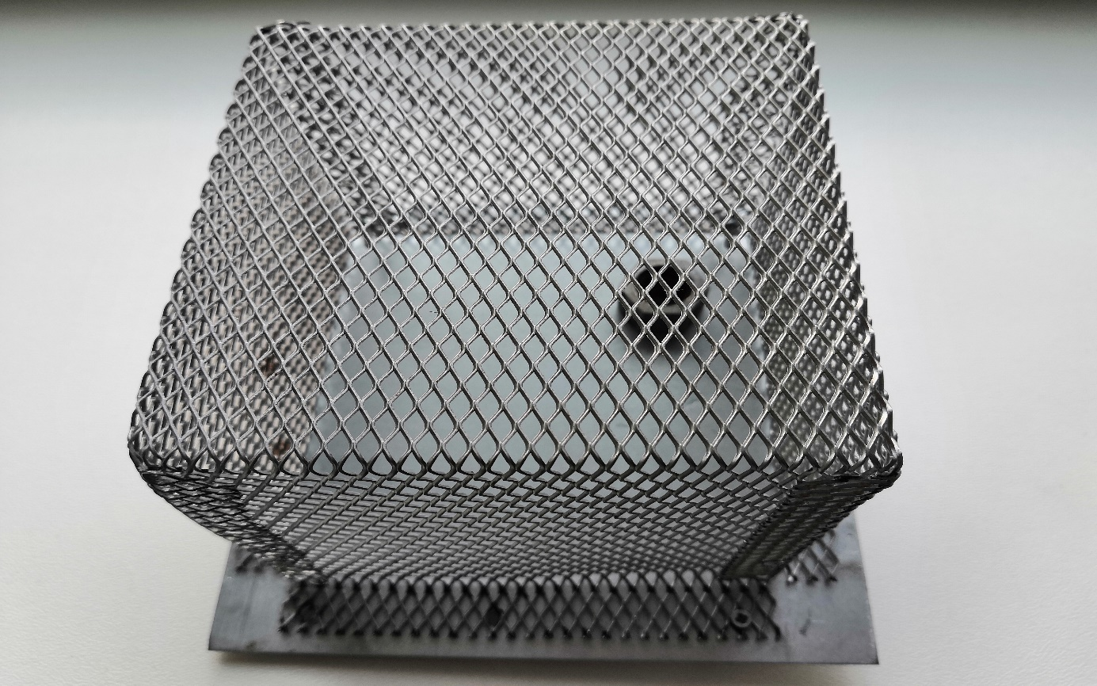
Fig. 77. Detail View on the Shielding Box A with Base and Grommet.
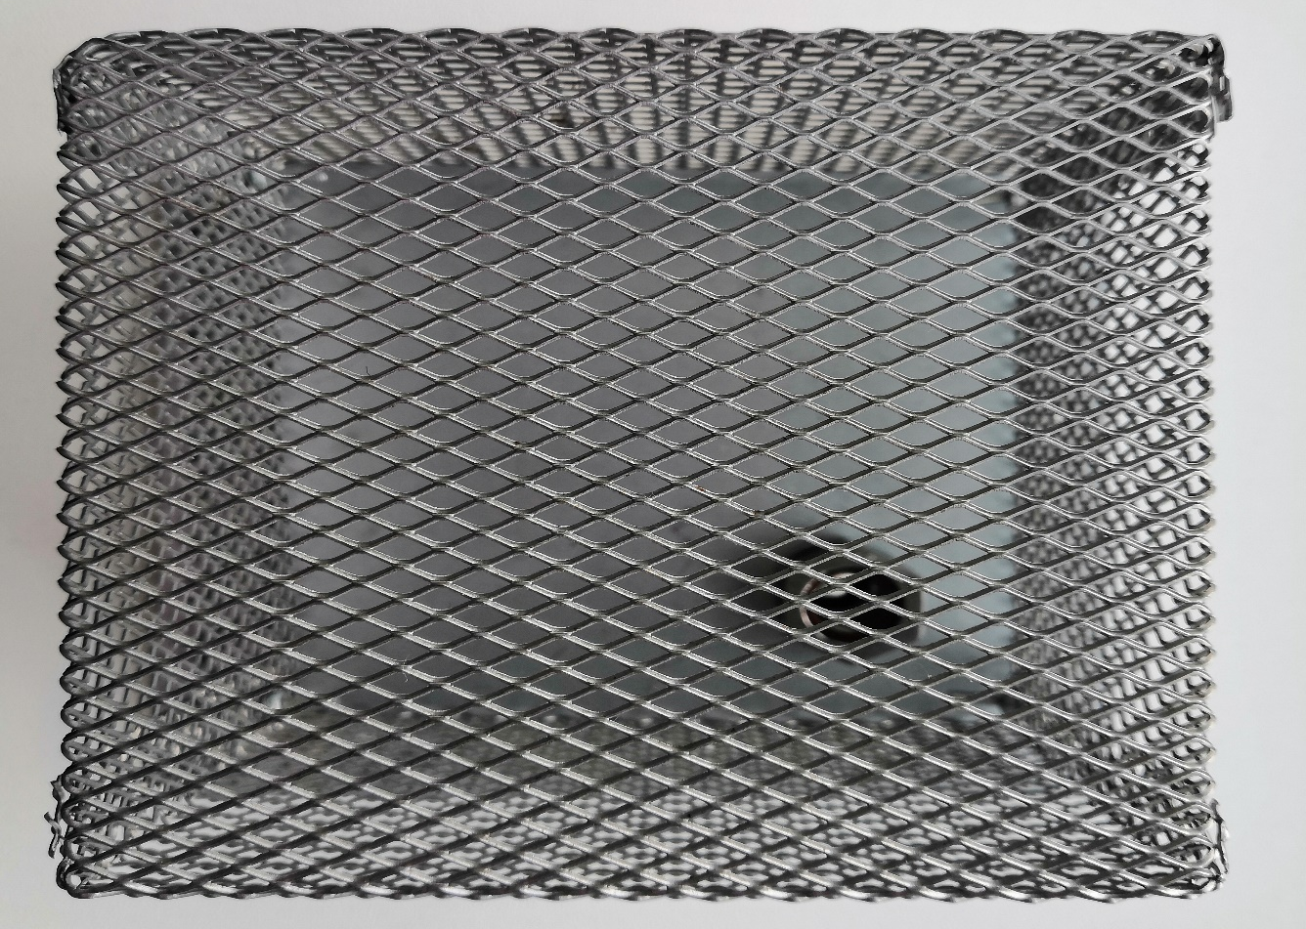
Fig. 78. Upper View on the Shielding Box A with Base and Grommet.
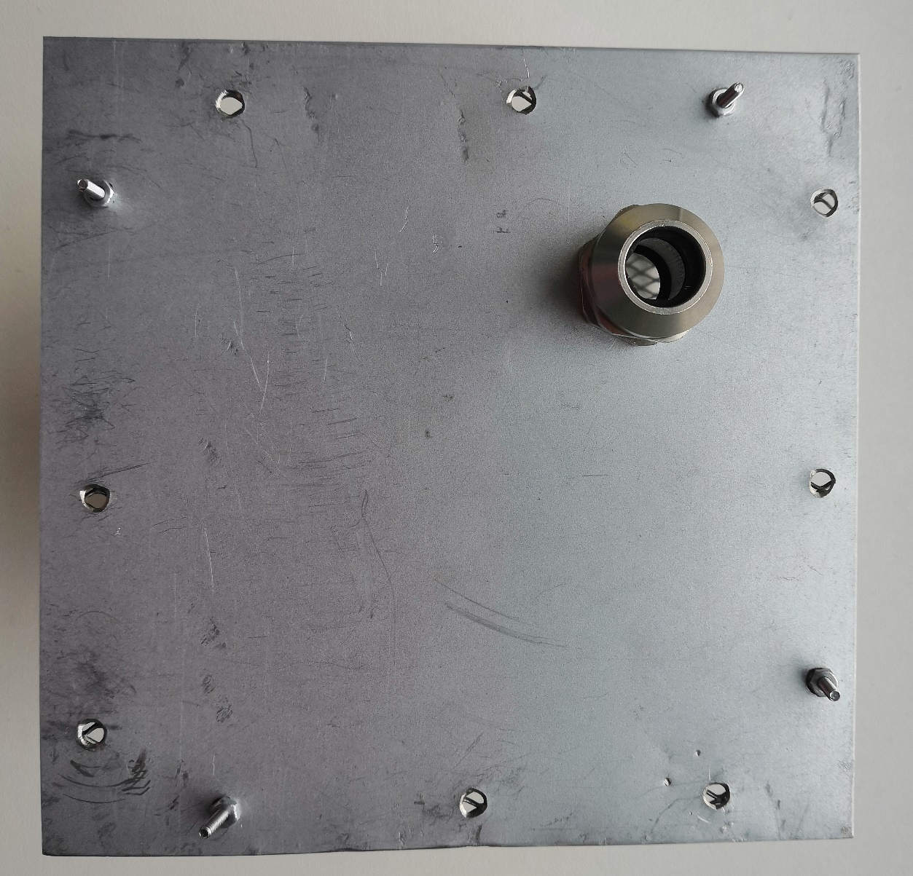
Fig. 79. Detail View on the Base and Grommet of Shielding Box A.

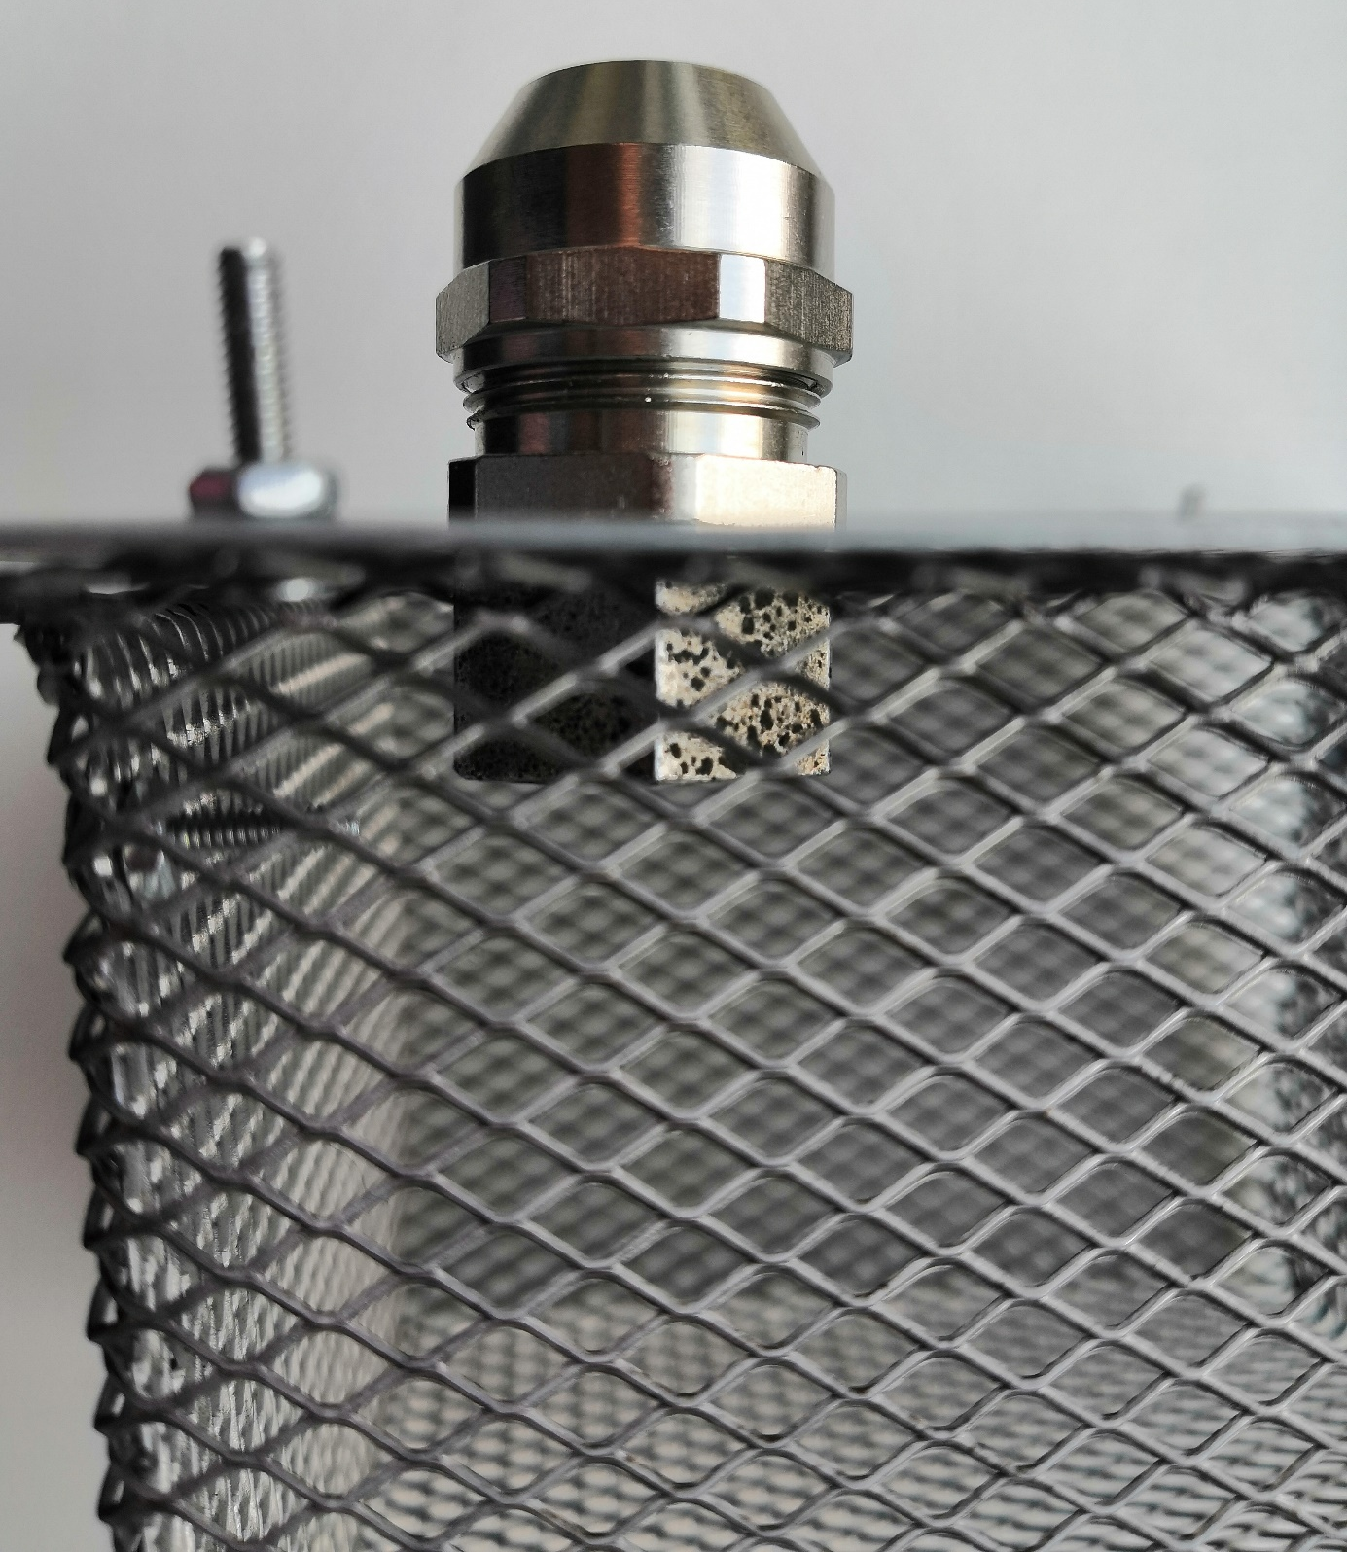
Fig. 80. Detail View on the Base and Grommet.
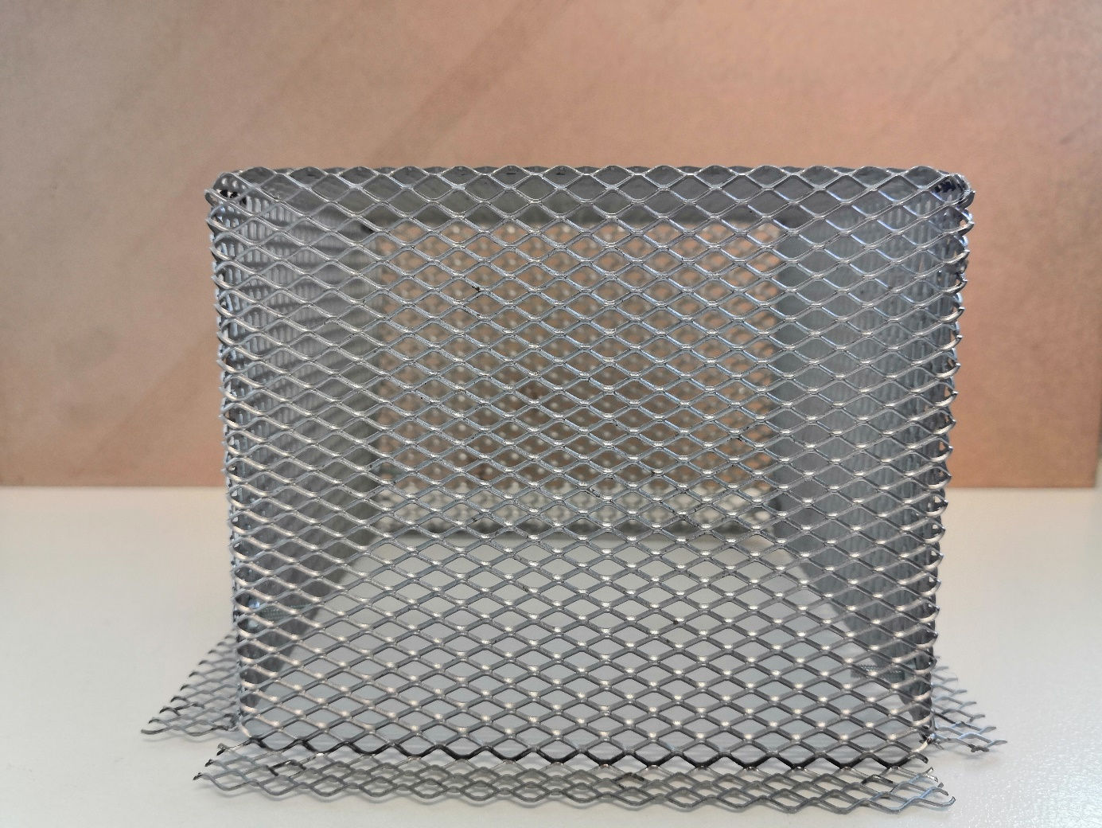
Fig. 81. Detail View on the Shielding Box A.
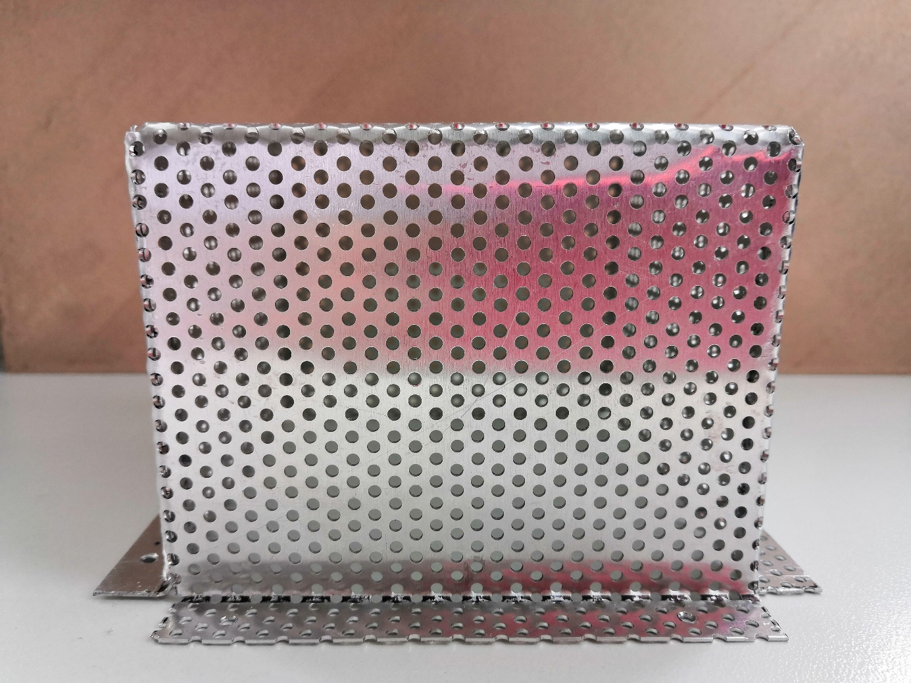
Fig. 82. Detail View on the Shielding Box B.
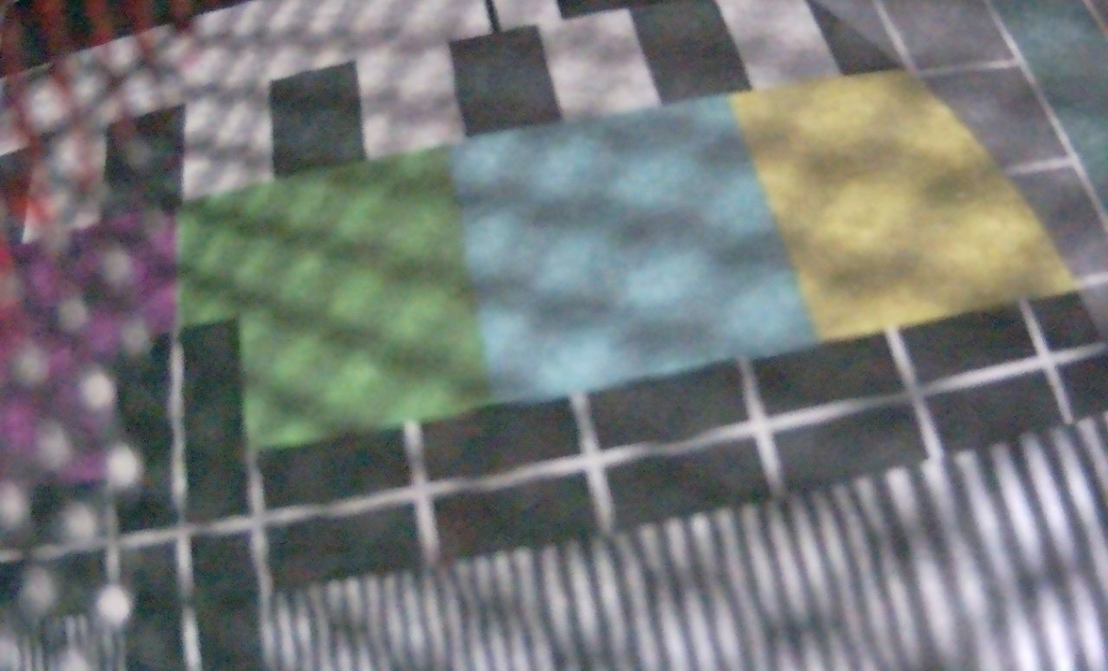
Fig. 83. The View through the Shield A.
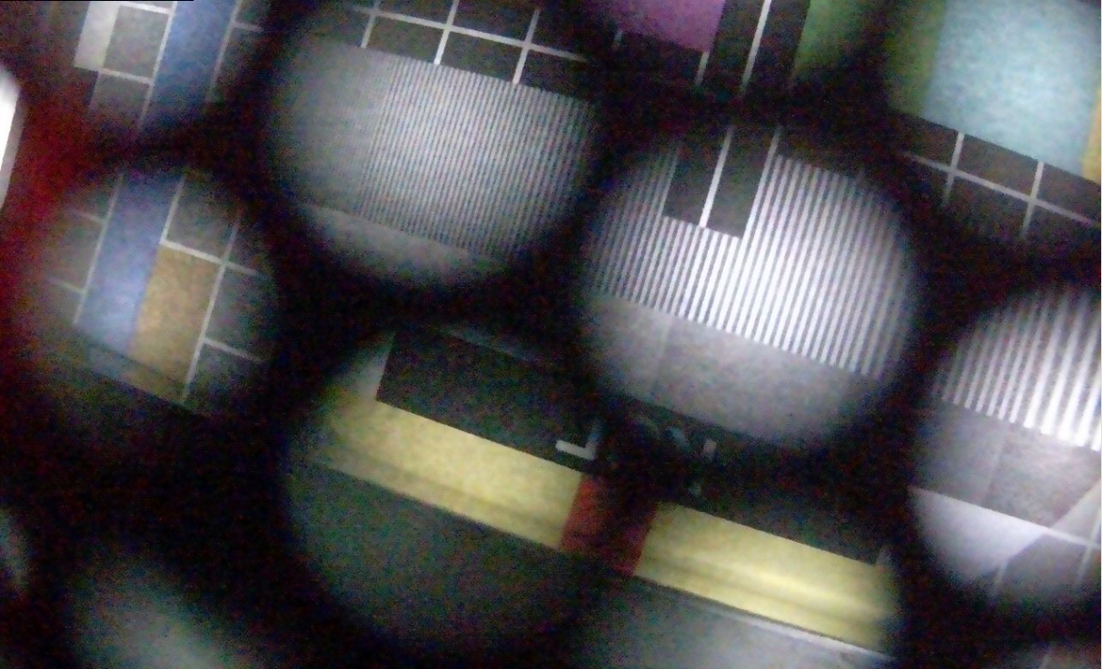
Fig. 84. The View through the Shield B.

BIBLIOGRAPHY OF AUTHOR
KOVAR Stanislav, Jan VALOUCH, Hana URBANCOKOVA and Milan ADAMEK. Electromagnetic interference of CCTV. In: The International Conference on Information and Digital Technologies 2015. Slovakia, Žilina, 2015. p. 161-166. ISBN 978-1-4673-7185-8. 6 p.

KOVAR, Stanislav, Jan VALOUCH, Hana URBANCOKOVA and Milan ADAMEK. Comparison of Security Devices in Terms of Interception. In: The Tenth International Conference on Emerging Security Information, Systems and Technologies (SECURWARE) 2016. Nice, France, 2016. pp. 141-145. ISBN: 978-1-61208-493-0. 5 p.

KOVAR, Stanislav, Jan VALOUCH. Electromagnetic susceptibility of IP camera. In: Przegląd Elektrotechniczny. Vol 2016, No 5. Poland, Warszawa, 2016. pp. 204-208. DOI:10.15199/48.2016.05.40. ISSN 0033-2097. 5 p.

KOVAR, Stanislav, Jan VALOUCH, Hana URBANCOKOVA and Milan ADAMEK. Immunity of Web Camera against Electrostatic Discharge. In: International Journal of Applied Engineering Research. Vol 11, No 9 (2016). India, 2016. pp. 6342-6344. ISSN 0973-4562. 3 p.

KOVAR, Stanislav, Ivan SPANO, Gianluca GATTO, Jan VALOUCH a Milan ADAMEK. SAR evaluation of wireless antenna on implanted cardiac pacemaker. Journal of Electromagnetic Waves and Applications [online]. 2017, 1-9 [viewed 2017-03-30]. DOI: 10.1080/09205071.2017.1301831. ISSN 0920-5071. Available from: https://www.tandfonline.com/doi/full/10.1080/09205071.2017.1301831

KOVAR, Stanislav, Jan VALOUCH, Hana URBANCOKOVA and Milan ADAMEK. Impact of Security Cameras on Electromagnetic Environment in Far and Near-Field. In: International Conference on Information and Digital Technologies 2016. Poland, Rzeszów, 2016. pp. 156-159. ISBN 978-1-4673-8860-3. 4 p.

KOVAR, Stanislav, Hana URBANCOKOVA, and Jan VALOUCH: Calculation of Shielding Effectiveness of Materials for Security Devices. In: MATEC Web of Conferences. 2017, 125. DOI: 10.1051/matecconf/201712502036. ISSN 2261-236x.

KOVAR Stanislav, Vaclav MACH, Jan VALOUCH, and Milan ADAMEK: Design of Shielding Enclosure to Protect Security Devices. In: PIERS-2017 - 39th Progress In Electromagnetics Research Symposium. Singapore, Singapore, 2017.

KOVAR Stanislav, Tomas MARTINEK, Vaclav MACH, and Martin POSPISILIK: Composite Material to Protect Security Devices against Electromagnetic Interference. In: PIERS-2017 - 39th Progress In Electromagnetics Research Symposium. Singapore, Singapore, 2017.

KOVAR, Stanislav, Vaclav MACH, Jan VALOUCH and Milan ADAMEK. Electromagnetic Compatibility of Arduino Development Platform in Near and Far-Field. In: International Journal of Applied Engineering Research. Vol. 12, No 15 (2017). India, 2017. pp. 5047-5052. ISSN 0973-4562. 6 p.

KOVAR, Stanislav, Hana URBANCOKOVA, Jan VALOUCH, Milan ADAMEK and Vaclav MACH. Helical Antenna Design for Image Transfer. In: International Journal of Applied Engineering Research. Vol. 12, No 14 (2017). India, 2017. pp. 4741-4746. ISSN 0973-4562. 6 p.

KOVAR, Stanislav, Jan VALOUCH, Tomas KADAVY, Martin POSPISILIK and Milan ADAMEK. Enclosure shielding effectiveness calculation using SHADE algorithm. In: 2018 19th International Scientific Conference on Electric Power Engineering (EPE) [online]. IEEE, 2018, 2018, pp. 1-4 [viewed 2018-07-02]. DOI: 10.1109/EPE.2018.8396021. ISBN 978-1-5386-4612-0. Available from: https://ieeexplore.ieee.org/document/8396021/

KADAVÝ, Tomáš, Stanislav KOVAR, Roman SENKERIK a Michal PLUHACEK. On the design of a front-face grid for shielding enclosure using evolutionary computations. In: 2019 Photonics and Electromagnetics Research Symposium - Fall, PIERS - Fall 2019 - Proceedings [online]. Rome: Institute of Electrical and Electronics Engineers Inc., 2019, p. 443-450. [viewed 2020-06-27]. Available from: https://ieeexplore.ieee.org/stamp/stamp.jsp?tp=&arnumber=9021341.

KOVAR, Stanislav, Petr VYTOPIL, Jan VALOUCH, Martin POSPISILIK a Milan ADAMEK. Electromagnetically shielded protection design for security camera lenses. In: Proceedings - 2018 2nd European Conference on Electrical Engineering and Computer Science, EECS 2018 [online]. Bern: Institute of Electrical and Electronics Engineers Inc., 2018, P. 352-355. [viewed 2020-06-27]. Available from: https://ieeexplore.ieee.org/stamp/stamp.jsp?tp=&arnumber=8910130.

KOVAR, Stanislav, Martin POSPISILIK, Jan VALOUCH and Milan ADAMEK. Shielding effectiveness of liquid electrolyte. In: 2019 Photonics and Electromagnetics Research Symposium - Fall, PIERS - Fall 2019 - Proceedings [online]. Rome: Institute of Electrical and Electronics Engineers Inc., 2019, pp. 1100-1104. [viewed 2020-06-27]. Available from: https://ieeexplore.ieee.org/stamp/stamp.jsp?tp=&arnumber=9021676.

CURRICULUM VITAE

PERSONAL INFORMATION | Kovář Stanislav
 | Ratiboř 545, 756 21 Ratiboř (Czech Republic)
 | (+422) 737 716 526
 | skovar@fai.utb.cz
 | Gender Male | Date of birth 07/03/1990 | Nationality Czech Republic

WORK EXPERIENCE

2017–now | Researcher
2017–now | Tomas Bata University, CEBIA-Tech, Zlín (Czech Republic)

EDUCATION, TRAINING AND COURSESY

2014–now | University/College III. degree
2014–now | Tomas Bata University; The Faculty of Applied Informatics; Security Technologies, Systems and Management, Zlín (Czech Republic)

2012–2014 | University/College II. degree
2012–2014 | Tomas Bata University; The Faculty of Applied Informatics; Security Technologies, Systems and Management, Zlín (Czech Republic)

2009–2012 | University/College I. degree
2009–2012 | Tomas Bata University; The Faculty of Applied Informatics; Security Technologies, Systems and Management, Zlín (Czech Republic)

2005–2009 | Secondary School
2005–2009 | Secondary School of Electrical Engineering, Frenštát pod Radhoštěm (Czech Republic)
INTERNSHIPS AND RESEARCH FELLOWSHIPS
2018 | University of Twente, Enschede (Netherland)
2017 | Instituto Politécnico de Beja, Beja (Portugal)
2016 | University of Cagliari, Cagliari (Italy)
2015 | Instituto Politécnico de Beja, Beja (Portugal)
2015 | Politecnico di Torino, Torino (Italy)
2018 - now | IEEE member, IEEE Young Professionals

